Day in the Life of the Hudson River 10/22/19 Data
BROOLYN BRIDGE PARK (WEST), MANHATTAN
RIVER MILE: East River 2.3
Hudson River Salt Front: ~RM 53
Manhattan International High School- Athena Theodoris
Lower East Side Ecology Center, Kellan Stanner and team
65 students 12th grade, 4 adults
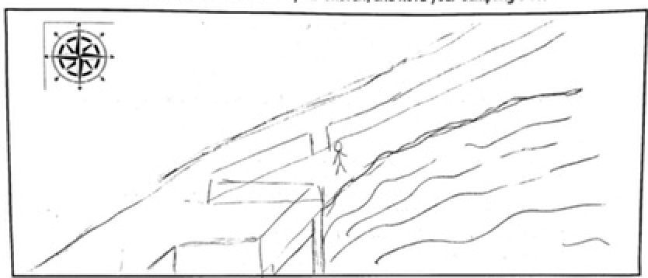
Latitude 40.7076 N & Longitude – 73.99982 W
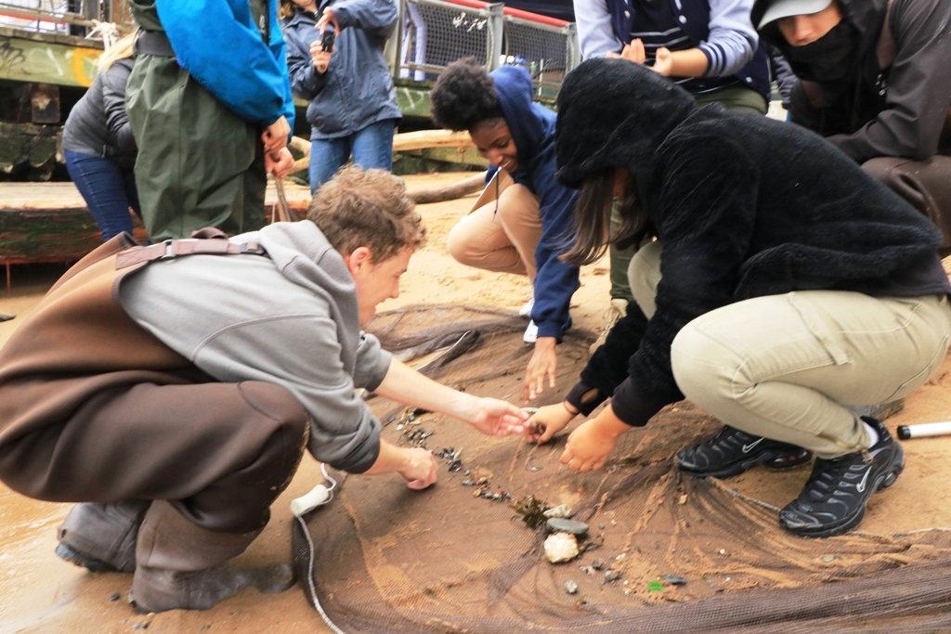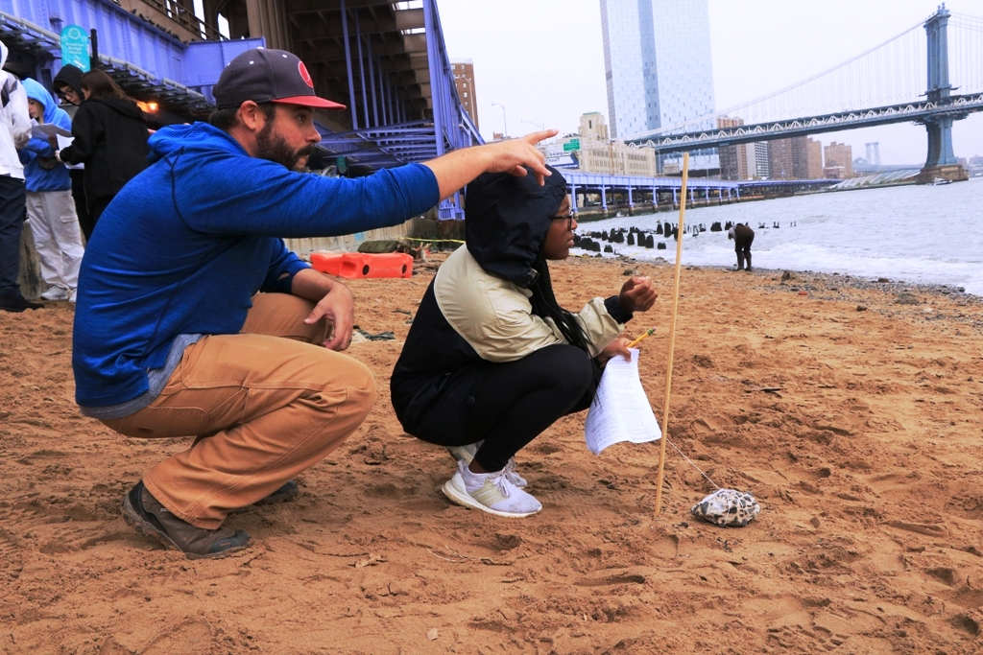

Location: Brooklyn Promenade- Brooklyn Bridge, Manhattan, NY
Area: Beach under the Brooklyn Bridge with pier- 125 feet north of Dover street, west side of the East river. Pier and path for recreational walking, jogging, bike riding, and fishing. Surrounding land is a sandy beach with water. Water used for fishing and boating; beach is open to the public but no swimming; lots of rocks and sand; near parking lot.
Surrounding Land Use: 60% Urban Residential; 30% Industrial/Commercial; 10% Beach
Sampling Site: Sandy, beach, covered in vegetation, pier; banks altered; bulkhead with timbers; debris in area such as broken concrete, docking; riprap; pipe entering river (south CSO ~40 meters- not visible).
Water: Choppy, 4 feet deep
River Bottom: Sandy, rocky (pebbles and stones)
Plants: None
ITEM | Time | Reading |  | Comments
Physical
Air Temperature: | 11:20 AM  12:15 PM  12:29 PM | 15 º C  15 º C  15.8 º C | º F  º F
Wind Speed: | 12:35 PM | Beaufort: 2 | 6.2 mph | north
Weather Today: | 12:30 PM Rain and Overcast (76-100%)
Weather Previous:
Water Temperature –  37 ft deep | 11:51 AM  12:35 PM | 16.8, 16.6 º C  16.1, 16.1 º C | Avg 16.7 º C  16.1 º C
Turbidity -  Long site tube | 12:43 PM | 55.1 cm  55 cm  65.6 cm | Average 58.6 cm | A bit cloudy with particles inside
Chemical
Salinity- refractometer | 12:12 PM | 25 ppt  26 ppt  27 ppt | Average 26 ppt
DO – | Time | Temp | ppm DO | % saturation
DO – | 12:42 PM  12:44 PM  12:46 PM | 16.3 C  16.3 C  16.3 C | 9  9  7 | 90  90  70
pH - pH strips | 12:05 AM | 5, 5, 5
Fish – Seine  Length of seine: 10’  12:48 PM | Number | Name | Length of longest
Fish – Seine  Length of seine: 10’  12:48 PM | 1  1  1  1 | Striped Bass  Atlantic Silverside  Bay Anchovy  Herring | 12.5 cm  9.5 cm  7 cm  6 cm
Fish – Seine  Length of seine: 10’  12:48 PM | TOTAL: 4 | Diversity: 4
Macroinvertebrates- hand net in tide pool | Number | Name | Length of longest
Macroinvertebrates- hand net in tide pool | 2 | Leidyi Comb Jelly | 6.5 cm
Macroinvertebrates- hand net in tide pool | TOTAL: 2 | Diversity: 1
Tides- Dock to Water | Time | Rising, Falling, Still | Height (cm) | Rate of Tidal Change (cm/min)
 | 12:31 PM  12:34 PM  12:37 PM  12:40 PM  12:45 PM  12:46 PM  12:49 PM |  | 24 cm  26 cm  28 cm  30 cm  32 cm  34 cm  36 cm
Current- | cm/second | Rising, Falling, Unchanged | Height (cm) | Rate of Change (cm/min)
Boats Commercial | Time | Color | Direction | Loaded or Light
 | 11:35 AM  11:38 AM | White  Red/yellow | North  Southbound | Loaded  Loaded
Boats Recreational | Time | Color | Direction | Loaded or Light
 | 11:39 AM | White | North | Loaded
Other Observations | Lots of bits of brick in watershed.  Sky very cloudy and cool temperatures  Lots of birds

