Day in the Life of the Hudson River 10/22/19
RANDALL’S ISLAND, MANHATTAN
RIVER MILE: (Harlem River) 1
Salt Front: ~ RM 53
Dwight School- Emma Ryan, Shalini Bhavani, Michelle Watch
70 students 7th grade, 10 adults
Randall’s Island- Chris Girgenti, Jacqueline Wu and staff
Latitude 40.789126 N & Longitude – 73.932872 W
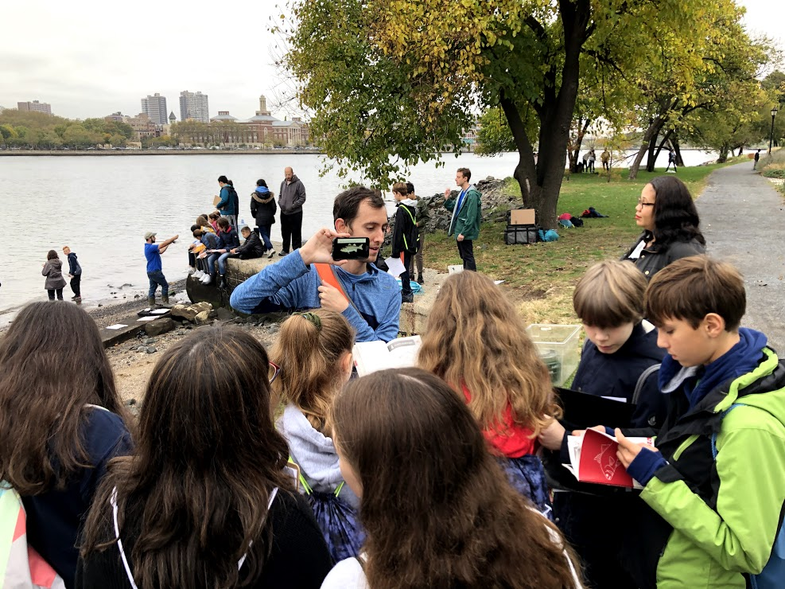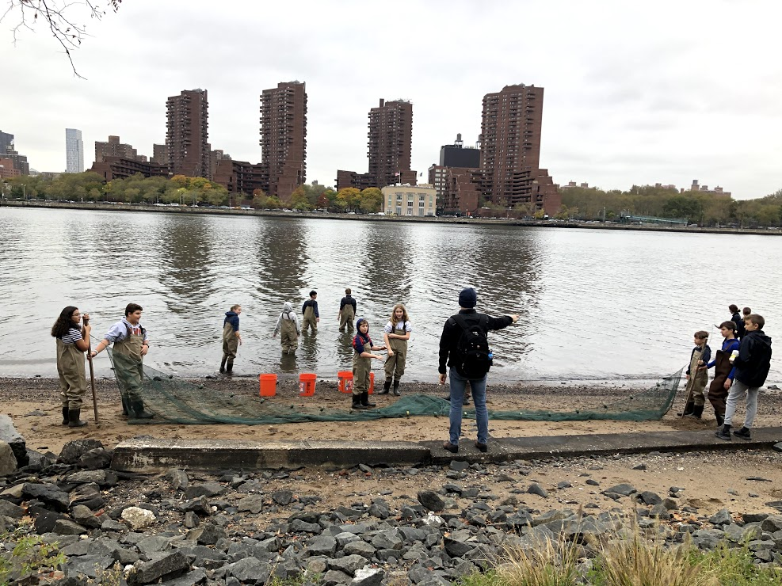
Location: Randall’s Island Park, Harlem River, Manhattan, NY
Area: Randall’s Island Park, Harlem River Waterfront (North of 103rd St. bridge/Ward’s Island Bridge), sandy adjacent to shore, increasingly muddy with depth; sporadic rocks
Surrounding Land Use: 50% Urban/Residential, 40% Parkland, 10% Beach
Sampling Site: Grassy, beach, banks altered, wood bulkhead, concrete bulkhead, riprap, pipe entering water
Shoreline: 90% Sandy; 10% Rocky
Water: calm
River Bottom: 60% Rocky, 40% Sandy
Plants in water: no plants in water area

ITEM | Time | Reading |  | Comments
Physical
Air Temperature | 10:00 AM  11:00 AM  11:20 AM | 15 º C  13 º C  13 º C
Wind Speed: | 9:58 AM | Beaufort 1 | 0.6 mph
Weather today | Overcast, rain
Weather past 3 days: | Rainy, warm one day
Tides- | Time | Rising, Falling, Unchanged | Water Height (cm) | Rate of Tidal Change (cm/min)
HT 5:25 AM (137 cm)  LT 11:26 AM (21 cm) | NR
Current- | Time | ft/second | North/South | Ebb/Flood/Still
 | 10:00 AM  10:30 AM  12:10 PM | 3  0.15  0.41 | South  South  North | Ebb  Ebb  Flood
Water Temperature- | 11:00 AM  11:30 AM  12:00 PM | 16.4 º C, 16.3 º C, Avg: 16.35 º C  16.4 º C, 16.4 º C, Avg: 16.4 º C  16.4 º C, 16.5 º C, Avg: 16.45 º C
Turbidity- long sight tube | 11:00 AM | 28 cm, 22 cm, 25 cm, Avg: 25 cm |  | Brownish with low visibility
Chemical
Salinity- Hydrometer | 11:00 AM  11:30 AM  12:00 PM | 24,000 ppm, 22,000 ppm, 22,000 ppm  20,000 ppm, 21,000 ppm, 21,000 ppm  16,000 ppm, 11,000 ppm, 15,000 ppm |  | Avg: 22,333 ppm  20,666 ppm  14,000 ppm
DO – | Time | Temp | ppm DO | % saturation
 | 11:00 AM  11:30 AM  12:00 PM | 16.5 º C  16.4 º C  16.4 º C | 10.46  7.52  7.64 | 105  66  66
pH – | 11:00 AM  11:30 AM  12:00 PM | 6.5, 6.8, 6.9  6.5, 6.9, 6.8  6.8, 6.8, 6.9
Nitrates- Estuary wide kit | 11:00 AM | 5 ppm, 5 ppm, 5 ppm |  | *Estuary wide kits have low resolution.
Phosphates- Estuary wide kit | 11:00 AM | 4 ppm, 2 ppm, 0 ppm |  | *Estuary wide kits have low resolution.
Biological
Fish | Number | Name | Length of longest
Seine 1  2  3  4  5  6  7 | 55  20  1  12  12  1  20  1  349  1  28 | Atlantic Silversides  Atlantic Silversides  Northern pipefish  Atlantic Silversides  Atlantic Silversides  Striped Bass  Atlantic Silversides  Winter Flounder  Atlantic Silversides  Winter Flounder  Atlantic Silversides | 10 cm  10 cm  10 cm  9 cm  10 cm  10 cm  10 cm  9 cm  10 cm  10 cm  14 cm | Totals:  Atlantic Silversides 496  Northern Pipefish 1  Striped Bass 1  Winter flounder 2
Fish Totals | TOTAL: 500 | Diversity: 4
Macroinvertebrates | Number | Name | Length of longest
Seine 1  2  3  4  5  6  7 | 3  1  1  4  5  5  0  4  1  1 | Blue Crab  Moon Jelly  Comb Jelly  Blue carb  Comb Jelly  Comb Jelly  NA  Blue Crab  Comb Jelly  Blue Crab | 4 cm carapace  4 cm carapace
Macroinvertebrate Totals | TOTAL: 35 | Diversity: 3
Sediment Core | Time | Oxidized Top | Grain Size | Other Features
19 cm water depth  40.7888800, -739329306  Core Length was not recorded | 10:00 AM | No | Abundant: sandy, pebbles  Common: gravel  Rare: clay, mud | Common: brick, coal, slag  Rare: leaves, macroinvertebrates
Boats | Time | Name/Color | North/South | Loaded/Light
Commercial  Commercial  Commercial  Recreational | 10:20 AM  11:10 AM  11:20 AM  11:30 AM | NYPD blue and white  Circle Line white/green  FDNY red/grey  Black | North  North  South  South | Light  Light  Light  Light
Observations

