Day in the Life of the Hudson River 10/22/19
GOVERNOR’S ISLAND NEW YORK HARBOR
RIVER MILE: -1
Salt Front: ~RM 53
The Harbor School - Roy Arezzo,
DEC - Chris Bowser
40 students 10th & 11th grade
Latitude 40.69092 N & Longitude – 74.02026 W
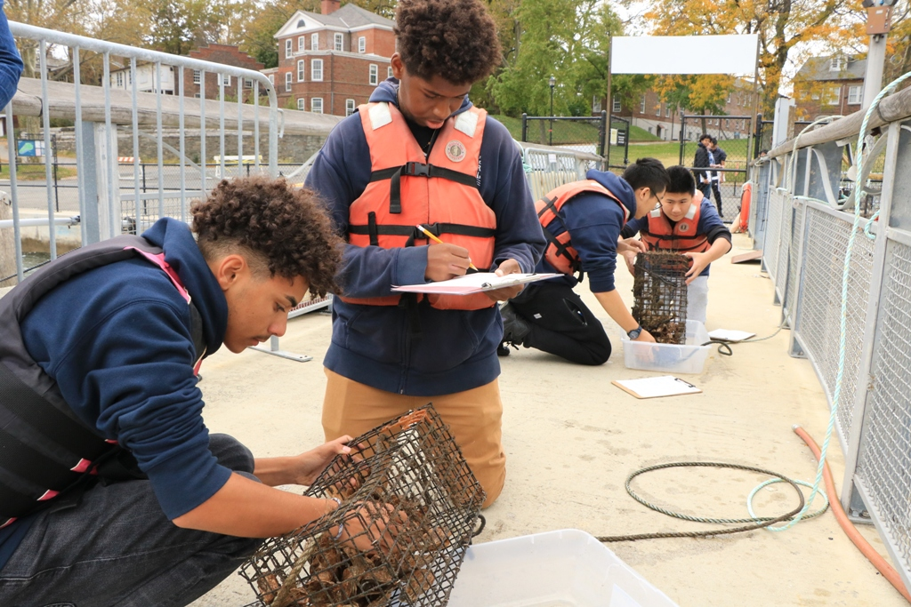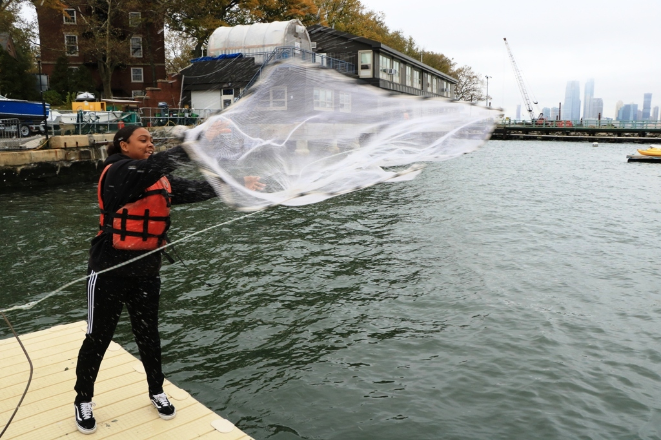
Location: Pier 101, northeast side Governor’s Island, New York
Area: Upper NY Harbor Area; east side of the harbor; pier along waterfront of island
Surrounding Land Use: 100% converted to public access programs (education, boating, recreation)
Sampling Site: Pier
Shoreline: Bulkhead
Plants in area: no plants in water area
Water: 12-15 foot depth

ITEM | Time | Reading |  | Comments
Physical
Air Temperature | 10-11 AM  1-3 PM | 15 º C  15 º C | 60 º F  60 º F
Wind Speed: | 10-11 AM  1-3 PM | 4 mph  6 mph | Beaufort 2  Beaufort 2
Weather today | Overcast 100%, damp, mild, breezy, stratus clouds
Weather the past 3 days: | NA
Tides- | Time | Rising, Falling, Unchanged | Height (cm) | Rate of Tidal Change (cm/min)
 | 9:40 AM  3:15 PM | Low tide  High tide
Current- | cm/second | Knots | North/South | Ebb/Flood/Still
10-11 AM  1-3 PM |  | 1 knot  1.4 knots | South  North | Ebb  Flood
Water Temperature | 10-11 AM  1-3 PM | 16 º C  17 º C | 61 º F  62.6 º F
Turbidity - long sight tube | 10-11 AM  1-3 PM | 91.5 cm  104 cm
Chemical
Salinity- Hydrometer | Time  10-11 AM  1-3 PM | Chloride ppm Cl⁻ | Total Sal. Ppm  19000 ppm  22000 ppm
DO – chemets kit | Time | Temp | ppm DO | % saturation
 | 10-11 AM  1-3 PM | 16 º C  17 º C | 5.8 ppm  6 ppm | 59%  62%
pH – API Test Kit | 10-11 AM  1-3 PM | 7.8  7.9
Chlorophyll | 10-11 AM  1-3 PM | .2 on chlorophyll chart  .2 on chlorophyll chart | Filter 120 mL of water
Fish | Number | Name | Length of longest
Cast net |  |  |  | Caught no fish
Fish Totals | TOTAL: | Diversity:
Macroinvertebrates | Number | Name | Length of longest
Macroinvertebrate Totals | TOAL: | Diversity:
Observations | Checked and monitored oyster cages

