Day in the Life of the Hudson River 10/22/19
GREAT KILLS PARK STATEN ISLAND
RIVER MILE: -11.2
Salt Front: ~RM 53
Curtis High School- Dave Scheffler
38 students 11th -12th grade, 3 adults
Steve Stan
Latitude 40.545446 N & Longitude – 74.122115 W
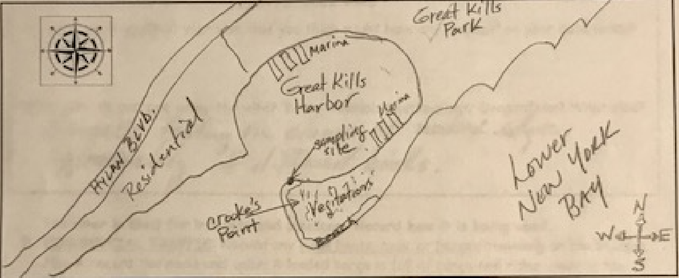
Location: Great Kills Gateway National Recreation Area, Staten Island, New York
Area: Open Beach
Surrounding Land Use: 30% Beach (urban park); 70% Forested
Sampling Site: Beach and riprap, sandy and rocky.
River Bottom: Sandy and muddy
Shoreline: 80% Sandy; 20% Muddy
Plants in area: 20% seaweed
Water: 80 cm deep

ITEM | Time | Reading |  | Comments
Physical
Air Temperature | 11:01 AM  11:51 AM | 14.5 º C  17.8 º C | 58.4 º F  62.7 º F
Wind Speed: | 11:51 AM | Beaufort 2 | 6 m/s | East
Weather today | 10:45 AM Overcast (100%); 11:30 AM Rain; 5 minutes of sprinkle
Weather the past 3 days:
Tides- Tide stick | Time | Rising, Falling, Unchanged | Height (cm) | Rate of Tidal Change (cm/min)
 | 10:45 AM  12:00 PM | Falling  Falling | 80 cm  150 cm | NA  0.93 cm/min
Current- | cm/second | Knots | North/South | Ebb/Flood/Still
 | NA | NA | North | Flood
Water Temperature | Time | º C | º F | Average
 | 11:03 AM  11:35 AM  11:48 AM | 16 º C, 13 º C, 15 º C  16 º C, 15º C, 15.5º C  16 º C | 61º F, 55º F, 59º F  61º F, 59º F, 60º F  61 º F | 14.75 º C, 58.75 º F  15.5 º C, 60 º F
Turbidity - long sight tube | 11:35 AM | 25.2 cm, 25.3 cm, 19.2 cm  Avg: 25.23 cm |  | Brown, muddy
Chemical
Salinity- Refractometer | Time  10:51 AM | Chloride ppm Cl⁻ | Total Sal. ppm  32000 ppm | Salinity matches NYHOPS model for 10/22/19  http://hudson.dl.stevens-tech.edu/maritimeforecast/maincontrol.shtml
DO – | Time | Temp | ppm DO | % saturation
NA
pH – Meter | 11:21 AM | 8.2, 8.1, 8.2
Fish | Number | Name | Length of longest
Seine 12’ &  Rod and Reel | 6  18  1  1 | Atlantic Silverside  Atlantic Silverside  Skate  Summer Flounder | 2.75 inches  3 inches  14.5 inches  24 inches | Pull 1  Pull 2  Rod and Reel  Rod and Reel
Fish Totals | TOTAL: 26 | Diversity: 3
Macroinvertebrates | Number | Name | Length of longest
 | 2  3 | Blue Crab  Mud Crab | Females  Males
Macroinvertebrate Totals | TOAL: 5 | Diversity: 2
Sediment Core | Time | Oxid Top | Grain Size | Other Items
Length: 45 cm | 10:34 AM | No | Abundant: Mud, Sand | Common: pieces of drift wood, dead oyster shells  Abundant: Zebra mussels, living vegetation
Boats  Commercial  Recreational  Recreational  Recreational | Time  11:30 AM  NA  NA  NA | Loaded/Unloaded  NA  Light  Light  Light | North/South  North  North  North  North | Name/Color  NYPD Rescue, Gray  50’ rec Fishing; White  40’ rec Fishing; White  21’ rec Fishing; White
Observations | Clam shells, oyster shells, crab molts, crab shells; seagulls were feeding on clams at water’s edge. Approximately 8 species of birds.

