Day in the Life of the Hudson River 10/12/17 Data
RIVER MILE -4.1
(Salt Front ~ RM 53)
Austen House, Buono Beach, Staten Island, NY
Mary Leou, Christina Edsall
Wallerstein Collaborative for Urban Environmental Education/NYU (6 Adults)
Michele Rieb & Deborah Esposito and (39) IS 27 students
40.6153115 N and ~74.0625551 W
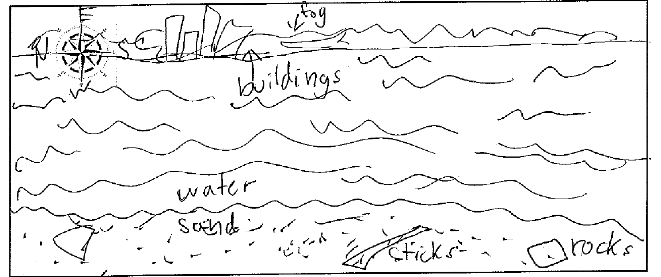
Location: Buono Beach at Alice Austen House, north shore of Staten Island
Area: Waterfront walkway and beach area. Mainly sand with vegetation
Surrounding Land Use: 60% urban/residential, Industrial/Commercial 40% beach
Shoreline: 40% sandy beach with 60% rocky and RipRap
Sampling Site: sandy, rocky bottom
Plants in area: None

ITEM | Time | Reading 1 | Reading 2 |  | Comments
Physical
Air Temperature | 10:52 AM  12:55 PM | 59ºF  60 | 15ºC  15.5
Wind Speed | High winds
Cloud Cover | 10:00 AM - noon | Overcast
Weather today | 1:00 PM light mist
Weather recently | Rain on Sunday (this is Tuesday)
Water description | Calm – green and murky
Water Temperature –  1 ft. depth | 10:54 AM  12:54 PM | 61 ºF  59 ºF | 16.1ºC  15ºC
Turbidity – 60cm site tube | 10:18 AM | 58 cm  54 cm  56 cm |  |  | Average  56 cm
Chemical | Time | DO | Temp |  | % Sat
DO  Chemets Kit | 10:25 AM  12:30 PM | 6ppm  5.5 ppm | 16.1ºC  15 |  | 60%  55%
pH –  - Test Strip  - Color Match Kit | 10:44 AM  12:33 PM | 6.4  7 | 6.6  7.2 |  | Average  6.5  7.1
Salinity | Time
hydrometer | 10:19 AM  12:03 PM | 17, 16 ppt  15, 15 ppt | Average 16.5 ppt  Average 15 ppt
Commercial Vessel | 10:48 AM  10:58 AM  12:52 PM | Tour  Pilot #2  Cargo | White  B&W  Red | North  North  North | Light  Light  Loaded
Recreational Vessel | 11:01 AM | Yacht | White | South
Other Observations | -Driftwood, Japanese knotweed, seeds, rocks, trash on beach  - plants and waterfowl

