Day in the Life of the Hudson River 10/22/19
PIER 1 LIGHTHOUSE MUSEUM, STATEN ISLAND
RIVER MILE: -4.5
Salt Front: ~ RM 53
Curtis High School- Edita O’Brien
30 students 11th-12th grade, 2 adults
Latitude 40.640951 N & Longitude – 74.07346 W
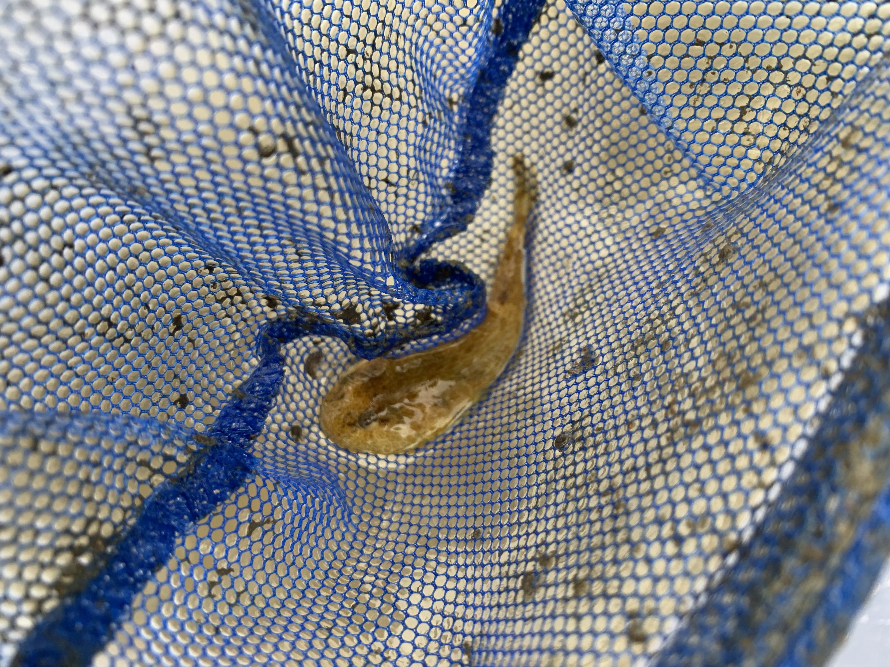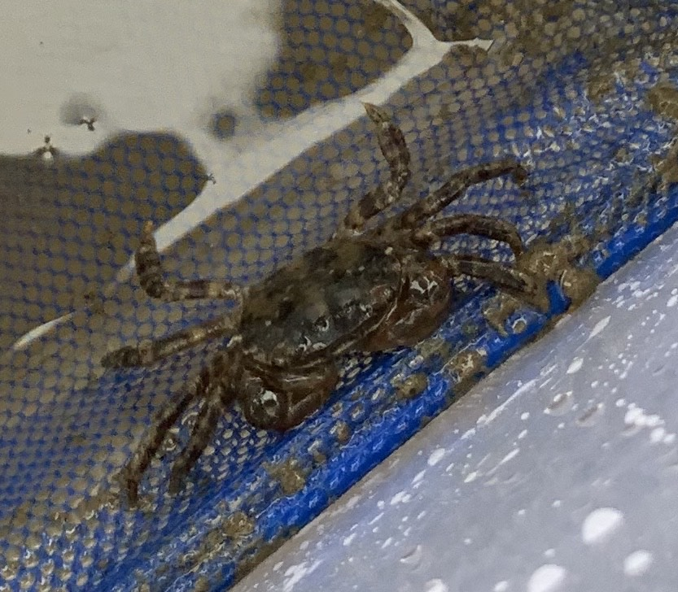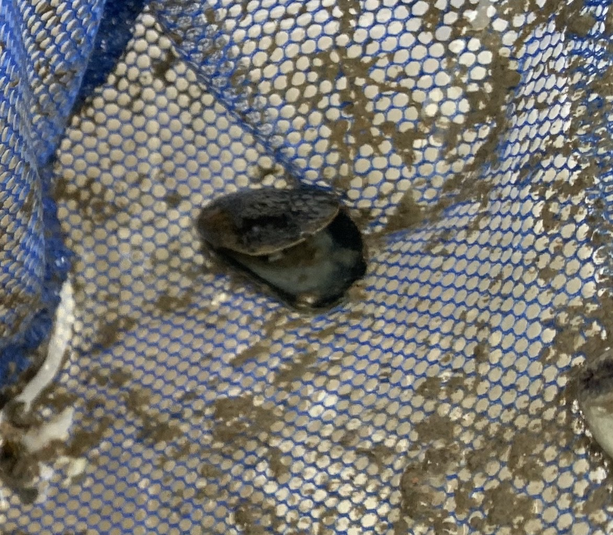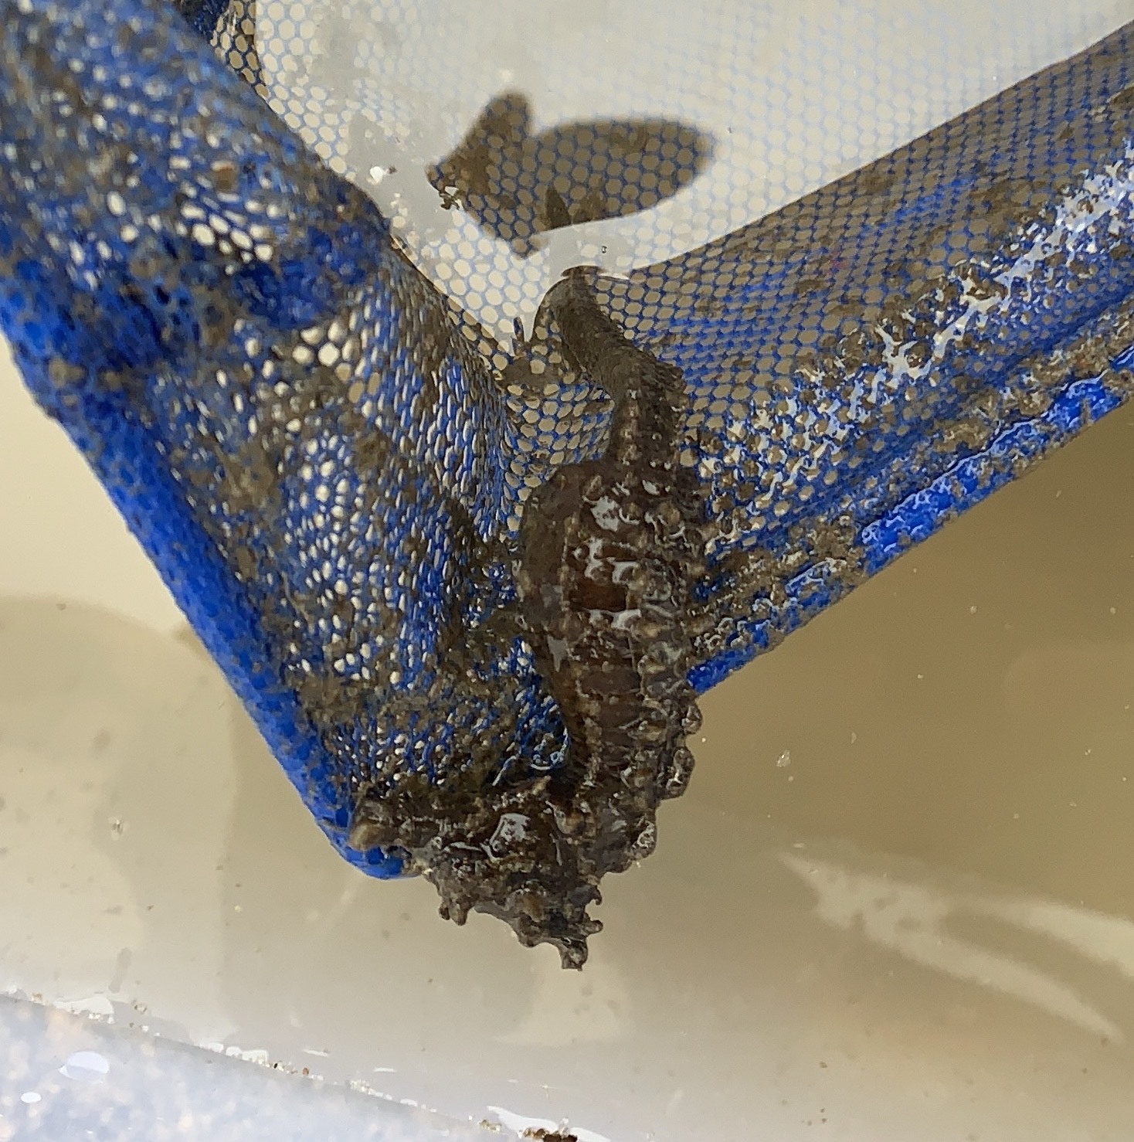
Location: Pier 1 Lighthouse Museum, Staten Island, NY
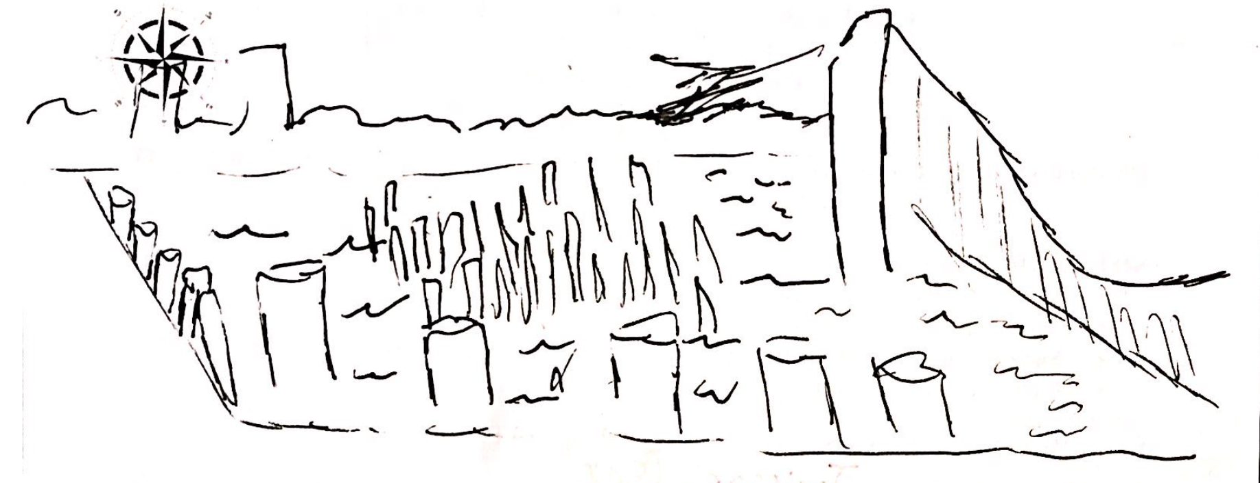
Area: Pier with parking lot
Surrounding Land Use: 50% Industrial/Commercial, 50% Industrial/Commercial
Sampling Site: Wood bulkhead, concrete bulkhead, banks altered, riprap
Shoreline: 20% sandy, 30% muddy, 50% rocky
Water: 250 cm, choppy, green and murky
River Bottom: Rocky
Plants in water: no plants in water area

ITEM | Time | Reading |  | Comments
Physical
Air Temperature | 10:29 AM  11:11 AM  12:14 PM | 59 º F  58 º F  58 º F | 15 º C  14 º C  14 º C
Wind Speed: | 12:15 PM | Beaufort 3 | 8.4 mph | Northeast
Weather today | Overcast (100%), Low temperatures, strong winds
Weather the past 3 days: | Rained on Sunday
Tides- | Time | Rising, Falling, Unchanged | Height (cm) | Rate of Tidal Change (cm/min)
LT ~9:28 AM  HT ~3:03 PM | 10:23 AM  11:05 AM  12:09 PM | NA  Unchanged  Rising | 355 cm  355 cm  370 cm
Current- | Time | cm/second | North/South | Ebb/Flood/Still
 | 10:23 AM  12:12 PM | 2.6  5.6 | North  North | Still  Flood
Water Temperature | 10:32 AM  10:33 AM  10:58 AM  11:05 AM  12:07 PM | 18 º C  17 º C, 18 º C, 18 º C  17 º C, 16.5 º C  16 º C  19 º C
Turbidity- Secchi Disk | 10:35 AM  12:21 PM  NR | 166cm, 152 cm, 162 cm  162 cm  66 cm, 52 cm |  | Greenish water
Chemical
Salinity- Hydrometer | 10:27 AM  10:33 AM  11:01 AM  11:02 AM  11:04 AM | 17,000 ppm, 18,000 ppm, 17,000 ppm  20,000ppm, 19,000ppm, 18,000 ppm  18,000 ppm, 17,000 ppm, 17,000 ppm  18,000 ppm, 15,000 ppm, 16,000 ppm  20,000ppm, 18,000 ppm, 18,000 ppm |  | Averages: 17,333 ppm  19,000 ppm  17,333 ppm  16,333 ppm  18,666 ppm
DO – drop count kit | Time | Temp | ppm DO | % saturation
 | 11:02 AM  11:21 AM  NR | 18 º C  18 º C  16 º C | 10.6  12.5  10 | 115  120  100
pH – pH pen | 10:37 AM  11:07 AM  11:10 AM  11:11 AM | 7.8, 8.9, 9.0, 8.6  8.8, 8.8, 8.8  8.9, 8.8, 8.8  8.8, 8.8, 8.8
Nitrates- test strips | 10:40 AM  11:14 AM | 0 ppm  0 ppm
Biological
Fish- Fish Traps | Number | Name | Length of longest
11:13 AM | 1  1  8  5 | Lined Seahorse  Mummichog  Skillet fish  Young of year fish* | 10 cm  4 cm  5 cm  3 cm | *Identified 5 as tadpoles and  *8 as suckers. Used image to ID skilletfish
Fish Totals | TOTAL: 10 | Diversity: 3
Macroinvertebrates | Number | Name | Length of longest
 | 1  1  1 | Asian shore Crab  Mud snail  Ribbed Mussels | 4 cm
Macroinvertebrate Totals | TOTAL: 3 | Diversity: 3
Sediment Core | Time | Oxid Top | Grain Size | Other Features
 | NR | NR | Abundant: pebbles, gravel  Rare: sand | Abundant: macroinvertebrates  Common: freshwater mussels  Rare: oyster shells, brick
Boats | Time | Name/Color | North/South | Loaded/Light
Commercial  Recreational  Commercial  Commercial | 10:18 AM  11:05 AM  11:06 AM  11:07 AM | SI Ferry, Orange  SI Ferry, Orange  Cargo boat, black  Cargo boat | -  North  South  South | -  Light  Loaded  Loaded
Observations | Some bricks in the area, scattered trees, trash and litter in the water, birds and seagulls  “I can hear the wind and boat engines. I smell the seawater. The weather is windy, humid and chilly. The weather (wind) could affect our first measurements.”

