Day in the Life of the Hudson River 10/22/19 Data
RIVER MILE -5.3
Salt Front ~ RM 53
Canarsie Pier, Jamaica Bay, Brooklyn, NY
Teacher Kara MacDevitt, International High School at Lafayette, 9th graders – 81 students, 8 teachers
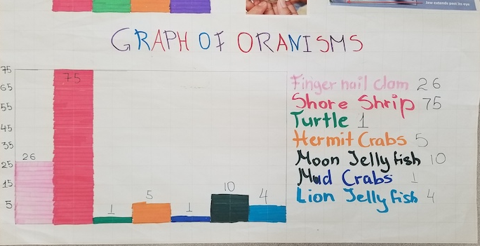
1 NYSDEC SCA member assistants
GPS Latitude N 40.37’49.0” - W-73.53’00.98”
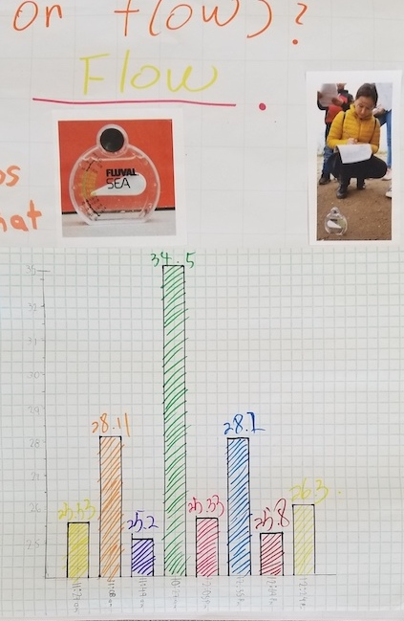
Location: NW beach at Canarsie Pier, Jamaica Bay
Area: Pier and beach area along the bay
Surrounding Land Use: Beach – 50%; Pier/Urban/residential 50%
Sampling Site: mainly sandy beach (99%), rip rap, pipe entering water
Shoreline: beach and pier
Plants in area: 50% sea lettuce
Water: Choppy
River Bottom : sandy

ITEM | Time |  | Reading 1 | Wind Speed mph | Wind Direction
Physical
Air Temperature | 10:28 AM  10:53 AM  11:16 AM  11:33 AM  11:55 AM  12:10 PM  12:16 PM  12:28 PM |  | 15 C – 60 F  18 C  15 C - 60 F  15 C - 60 F  15 C- 60 F  15 C- 60 F  15 C- 60 F  15 C- 60 F | 9 mph  10 mph  10 mph  14.6 mph  11 mph  11 mph  11 mph  10 mph | E  E  E  E  E  E  E  E
Wind Speed | ABOVE
Cloud Cover | Full sampling time |  | Overcast | 100%
Weather today | Misty wet
Weather recently
Water Temperature | 11:00 AM  11:15 AM  12:00 PM | 16.2 C  15 C  15 C |  | 60 F  60 F
Water calm
Turbidity – long sight tube | 10:13 AM  10:50 AM  11:11 AM  11:35 AM  12:11 PM  12:28 PM  12:30 PM  12:43 PM | 28.66 cm  29.66 cm  30 cm  30.67 cm  35.3 cm  31.6 cm  31.6 cm  39.67 cm |  |  | Dark blue green water
DO | 11:38 AM  11:46 AM  12:04 PM  12:25PM  12:43 PM | 15 C |  | 10 ppm  10 ppm  10 ppm  6 ppm  6 ppm | 88%  88%  88%  53%  53%
pH – | 11:38 AM  11:46 AM  12:04 PM  12:25PM  12:43 PM | 8.5  8.5  8.5  6  6
Salinity – hydrometer | 10:27 AM  11:08 AM  11:27  11:49  12:09 PM  12:24 PM  12:39 PM | 34.5 ppt (avg)  28.11  25.53  25.2  25.8  26.3  28.2
Fish Catch  seine net |  | Species |  | Number Caught
All groups |  | Atlantic Silverside |  | 36
 |  | Bay Anchovy |  | 4
 |  | Mummichog |  | 1
 |  | Striped Killifish |  | 1
 |  | DIVERSITY 4 |  | TOTAL 42
11:30 AM Macros |  | Mud Crab |  | 1 | *Also found a trutle
 |  | Hermit Crab |  | 5
 |  | Moon Jellies |  | 10
 |  | Lion’s Mane Jelly |  | 4
 |  | Shore Shrimp (paleomonetes) |  | 75
 |  | Fingernail clams |  | 26
 |  | DIVERSITY 6 |  | TOTAL 121
Water Currents | Distance | Cm/sec |  | Kts | Direction
Separately | 91.44 cm  183 cm. | 3.048 cm/sec  6.096 cm/sec |  | 0.06  0.12 | NE – Ebb  NE - Ebb
 | GROUP # | Compass Direction |  | Ebb/Flood/Still
GROUP | Group 1  Group 2  Group 3  Group 4  Group 5  Group 6  Group 7  Group 8 | SW  SW  SW  SW  NE  NE  SE  SE |  | Ebb  Ebb  Ebb  Ebb  Ebb  Ebb  Ebb  Ebb
Tides | Time | Water Height Inches |  | Ebb/Flood/Still
 | 10:27 AM  11:08 AM  11:27  11:49  12:09 PM  12:24 PM  12:39 PM | 14 inches  22 inches  32 inches |  | Flood  Flood  Flood  Flood  Flood  Flood  Flood
Sediment Core | Length | Rare |  | Common | Description
 | NR | Gravel |  | Gravel  Pebbles | Sand
Boats | N/R | Tugboat  Barge  Speedboat  Sailboat |  | Orange  White  White  White
Other Items | Shells & shell pieces | Coal |  | Crab molts | Area overgrown
 | Sea gulls | Turtle |  | Water chestnut seeds | Shells and shell pieces
 | Plovers | Butterfly |  | Brick | Dragonflies

