Day in the Life of the Hudson River 10/22/19 Data
FORT WADSWORTH, STATEN ISLAND
RIVER MILE: -7
Salt Front: ~RM 53
St. Clare School- Mary Lee
75 students 7th grade, 30 adults
NY Park Rangers- Kathy Garofalo, Hudson Valley SCA - Aaron Donato, New York City DEP-Robert Bauman, Coast Guard
Latitude 40.5993813 N & Longitude – 74.0536311 W

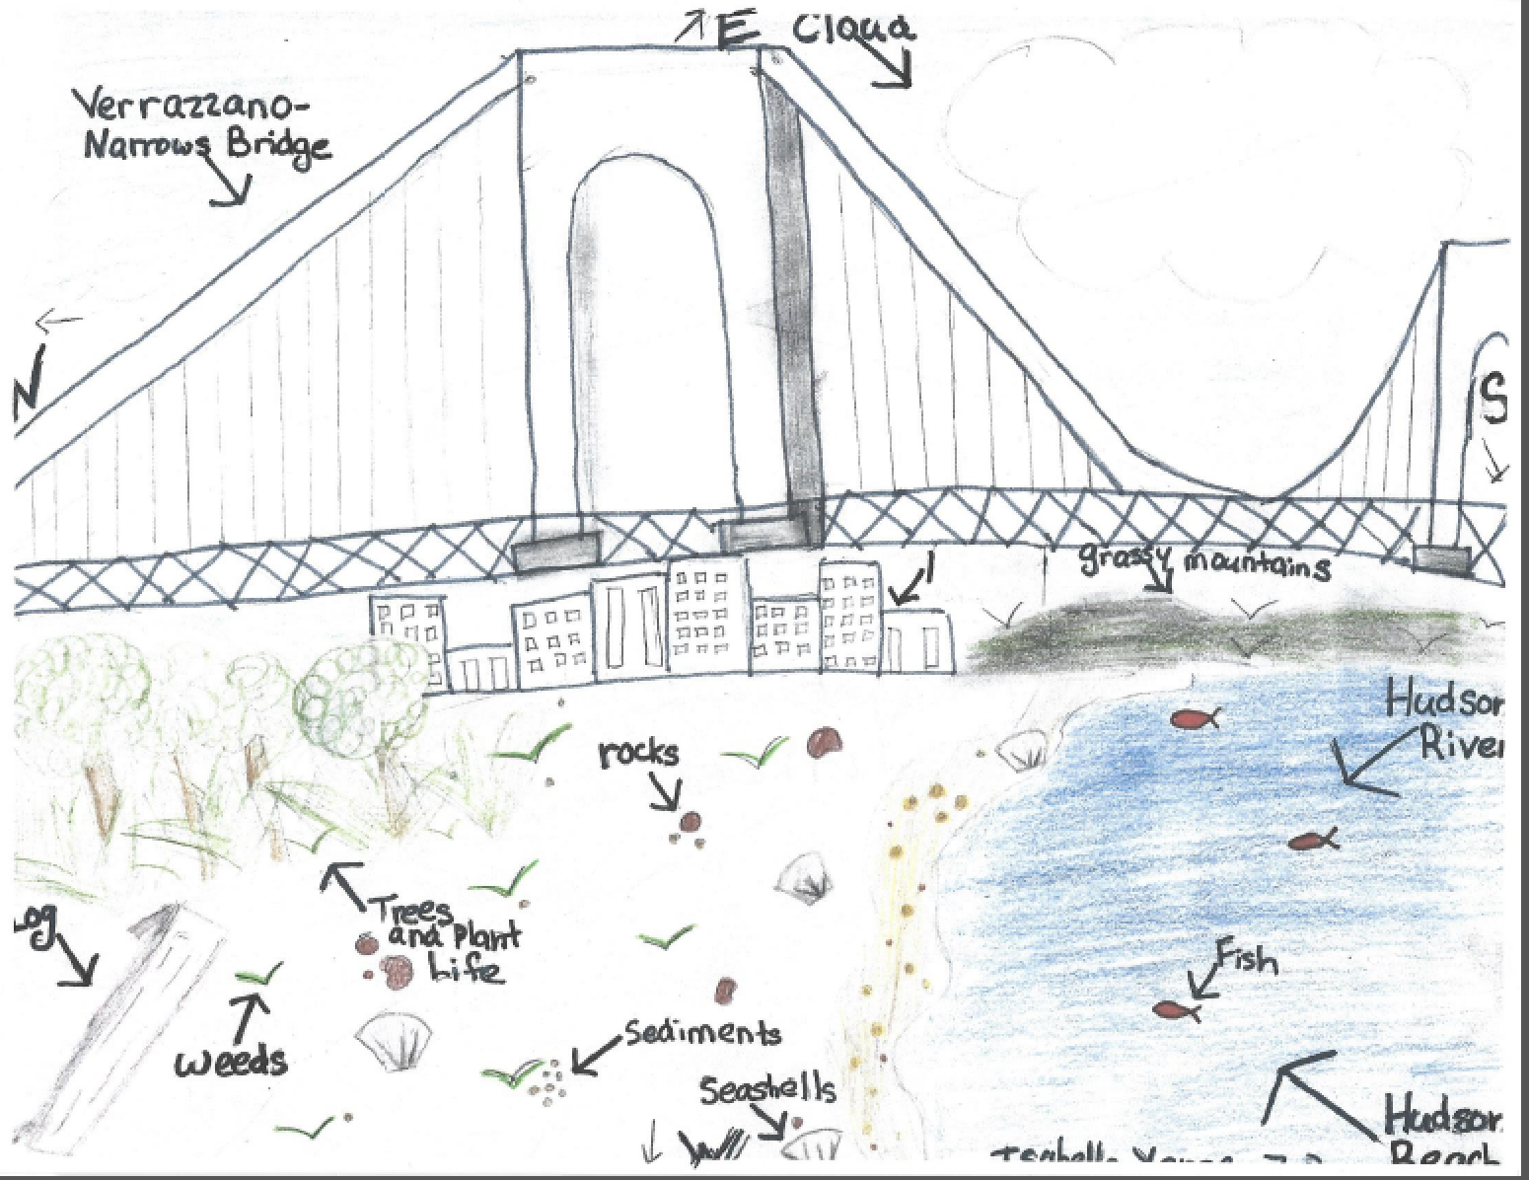

Location: Seabee Fishing Beach, Fort Wadsworth, just south of Verrazano Bridge, Staten Island, NY
Area: Beach with riprap; concrete broken in areas, pier nearby, behind beach covered with vegetation & lots of rocks
Surrounding Land Use: National Park Site
Sampling Site: Beach area with riprap to bridge side of where we were sampling
Shoreline: 80% Beach; 15% Forested, 5% other – parking lot, picnic area, fort
Plants in area: No plants in water area
Water: 12 inches deep, calm
River Bottom: Sandy
ITEM |  | Time | Reading |  |  |  | Comments
Physical
Air Temperature: |  | 10:50 AM  11:55 PM | 15 º C  15 º C |  |  | 59 º F  59 º F
Wind Speed: |  | anemometer | 7 kts or 9 mph |  |  | Beaufort 3 | Varied
Weather Today: |  | Rained later in the day and evening |  |  |  |  | Water Choppy
Weather Previous: |  | Some rain
Water Temperature |  | 10:23 AM  10:45  11:10  11:35  12:05 PM | 15 º C |  |  | 59 º F | Temp. constant all day – 1 reading per session
Turbidity -  Long sight tube |  | 10:44 AM  11:55 AM | 22, 27, 23.4  22, 27, 23.4 |  |  | AVERAGES | 24.13 cm  22 cm
Chemical
Salinity- hydrometer |  | All day same | 23 ppt Hydrometer  30 ppt Refractometer |  |  |  | *calibrate refractometer?
DO – ampules Chemets (constant) |  | Time | Temp |  |  | ppm DO | % saturation
 |  | 11:35 AM | 15 º C |  |  | 9 | 90
pH - indicator solution |  | All day long | 7.9
Nitrates- API test kit |  | All Day | 0
Nitrites |  | All Day | 0.25 ppm
Ammonia |  | All Day | 0 ppm
Phosphates |  | During Day | Raged 0.5 to 0.25 all day |  |  |  | Average 0.35 ppm
Fish – seine 10ft X 15 ft - 11:25 AM  5 seine pulls – 1 fish |  | Number | Name |  |  | Length of longest | * Also found a dead dogfish shark(60 cm) & a dead seahorse 7.5 cm
 |  | 1 | Lookdown Fish (selene vomer) |  |  | 3 cm
 |  | TOTAL: 1 | Diversity: 1
Macroinvertebrates- Seine |  | Number | Name |  |  | Length of longest
 |  | 27  1  1  1  1  1 | Moon Jellies  Asian Shore Crab  Mole Crab  Grass Shrimp  Blue Mussel  Marine Amphipod
 |  | TOTAL: 32 | Diversity: 6
Tides- |  | Time | Rising, Falling, Still | Height (cm) |  | Rate of Tidal Change (cm/min)
 |  | 10:52 AM  10:59 AM  11:10 AM  11:20 AM  11:31 AM  11:42 AM  11:51 AM  12:02 PM | Rising  Rising  Rising  Rising  Rising  Rising  Rising  Rising  *rising the whole time | 35 cm  37.5 cm  30 cm  20 cm  20 cm  10 cm  8 cm  2.5 cm |  | -  0.357  0.681  1.0  0.0  0.91  0.22  0.5  *underwater after we left
Currents Flow - Time |  | Cm/30 sec | Cm/second | Knots |  | North/South | Ebb/Flood/Still
10:35 AM  10:41 AM  10:56 AM  11:17 AM  11:23 AM  11:52 AM |  | 82  370  235  478  336  228 | 2.73  12.3  7.83  16  11.2  8.26 | 0.0053  0.239  0.15  0.31  0.22  0.16 |  | South  North  South  South  South  North | Should have been flooding throughout but was hard to tell as water very choppy
Sediment Core |  | W370ater depth235 | Length | Oxid Top |  | Grain Size | Other
Not done
Boats | Time | Type |  | Color |  | North/South | Loaded/Light
Com  Com  Com  Rec.  Com  Com  Com  Com  Com  Com  Com  Com Com  Com | 10:21 AM  10:22 AM  10:21 AM  10:29 AM  10:30 AM  10:43 AM  10:45 AM  10:46 AM  10:48 AM  11:03 AM  11:38 AM  11:40 AM  11:42 AM  11:46 AM | Barge  Small Coast Guard  Ferry  Sailboat  Pilot  Pilot 2  Ferry  Bulk Carrier Cargo  Fishing Boat  Container – Ocean Promise  Pilot  Tugboat Pushing Barge  Ferry  Pilot |  |  | Gray  White  White  White  Dark Green  White/Black  Black  White  Blue & Red  Black  Black  Blue  Black | Stationary  North  North  South  North  South  North  North  Stationary  North  South  North  South  South | Loaded  Light  Loaded  Light  Loaded  Light  Light  Loaded  Light  Light  Light  Loaded  Loaded  Light
Other Observations |  | NR

