Day in the Life of the Hudson River 10/22/19
GERRITSEN CREEK, BROOKLYN
RIVER MILE: -8
Salt Front: ~ RM 53
PS130K- Sydra Mallery
128 students 4th grade
Salt Marsh Nature Center + Park Department
Latitude 40.60399 N & Longitude – 73.9306 W
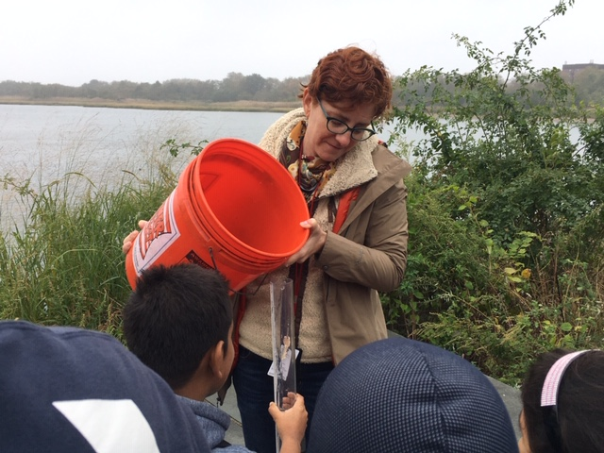
Location: Gerritsen Creek, Brooklyn , New York
ITEM | Time | Reading |  | Comments
Physical
Air Temperature | 10:34 AM  10:35 AM  10:39 AM 11:09 AM  11:10 AM  11:11 AM  11:38 AM  11:39 AM  12:07 PM  12:08 PM  12:11 PM | 20 º C  20 º C; 16 º C  14 º C  16 º C; 20 º C  18 º C  15 º C  15 º C  16 º C  16 º C  15 º C  15 º C
Wind Speed: | NA
Weather today | NA
Weather the past 3 days: | NA
Tides- Tide stick | Time | Rising, Falling, Unchanged | Height (cm) | Tidal Change (cm)
 | 10:36 AM  11:46 AM  12:07 PM | Rising  Rising  Rising | NA  29.5 cm  78.74 cm | 4 cm  5.5 cm  0.462 cm/min
Current- | cm/second | Knots | North/South | Ebb/Flood/Still
 | NA
Water Temperature | 10:34 AM  10:35 AM  10:39 AM  11:09 AM  11:10 AM  11:11 AM  11:38 AM  11:39 AM  12:07 PM  12:08 PM  12:11 PM | 15 º C  13 º C; 14 º C  16 º C  15 º C; 15 º C  16 º C  13 º C  16 º C; 16 º C  15 º C; 15 º C  14 º C  17 º C; 15 º C  14 º C
Turbidity - long sight tube | 10:34 AM  10:35 AM  10:39 AM  11:09 AM  11:10 AM  11:11 AM  11:38 AM  11:39 AM  12:07 PM  12:08 PM  12:11 PM | 120 cm  120 cm; 120 cm  120 cm  82 cm ; 82 cm  82 cm  82 cm  NA  NA  76 cm  76 cm; 76 cm  76 cm
Chemical
Salinity- Hydrometer | Time  10:34 AM  10:35 AM  10:39 AM  11:09 AM  11:10 AM  11:11 AM  11:38 AM  11:39 AM  12:07 PM  12:08 PM  12:11 PM | Chloride ppm Cl⁻ | Total Sal. ppm  26000 ppm  28000; 26000 ppm  28000 ppm  26000; 26000 ppm  26000 ppm  26000 ppm  26000; 27000 ppm  29000; 25500 ppm  26000 ppm  26000; 26000 ppm  32000 ppm
DO – | Time | Temp | ppm DO | % saturation
 | 10:34 AM  10:35 AM  10:39 AM  11:09 AM  11:10 AM  11:11 AM  11:38 AM  11:39 AM  12:07 PM  12:08 PM  12:11 PM | 15 º C  13 º C; 14 º C  16 º C  15 º C; 15 º C  16 º C  13 º C  16 º C; 16 º C  15 º C; 15 º C  14 º C  17 º C; 15 º C  14 º C | 8 ppm  8ppm; 8 ppm  8 ppm  8 ppm  8 ppm  8ppm  8 ppm  8ppm  8 ppm  8 ppm  6ppm | 76%  76%  80%  70%
pH – | 10:34 AM  10:35 AM  10:39 AM  11:09 AM  11:10 AM  11:11 AM  11:38 AM  11:39 AM  12:07 PM  12:08 PM  12:11 PM | 7  7  7  7  7  7  7  7  7  7  7
Fish | Number | Name | Length of longest
10:36 AM  11:00 AM  11:46 AM  12:07 PM | 36  2  3  18  55 | Atlantic Silverside  Mummichog  Atlantic Silverside  Atlantic Silverside  Atlantic Silverside
Fish Totals | TOTAL: 114 | Diversity: 2
Macroinvertebrates | Number | Name | Length of longest
10:36 AM  11:00 AM  11:46 AM  12:07 PM | 8  1  1  1  1  1 | Periwinkle Snails  Moon Jelly  Moon Jelly  Mud Snails  Hermit Crab  Moon Jelly
Macroinvertebrate Totals | TOAL: 13 | Diversity: 4
Observations | Blue crab molt.

