Day in the Life of the Hudson River 10/22/19
Steeplechase Pier, Coney Island, Brooklyn NY
RIVER MILE -9.1
Salt Front ~RM 53
IS 240 Magnet School of STEM- Deborah Sarria
50 students 6th grade, 5 adults
Latitude 40º 34’ 12”N & Longitude – 73º 59’ 1”W
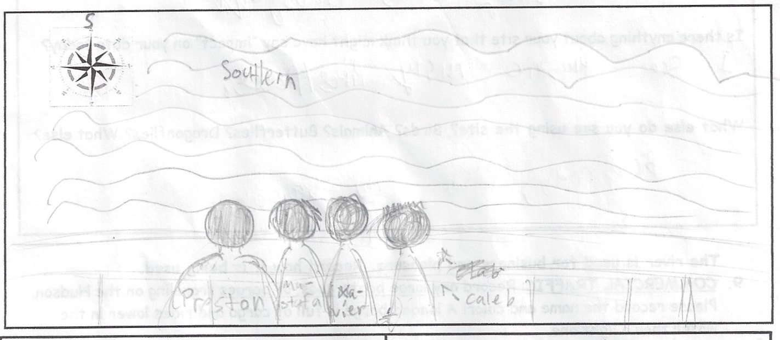

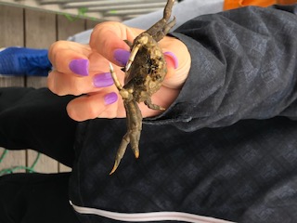
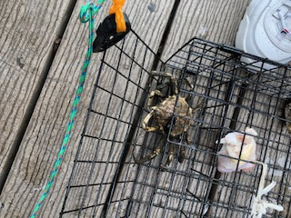
Location: Steeplechase Pier, Coney Island, Brooklyn, NY
Area: 15% Urban/Residential, 70% Beach, 15% Industrial/Commercial
Surrounding Land Use: 12.5% Urban/residential; 12.5% Industrial/Commercial; 75% Beach
Sampling Site: Beach areas with pier and riprap shoreline.
Plants in area: no plants in water area
Water: choppy
River Bottom: Sandy

ITEM | Time | Reading |  | Comments
Physical
Air Temperature: | 11:02 AM  11:46 AM | 15.5 º C  15.5 º C | º F  º F
Wind Speed: | 11:02 AM  11:46 AM | Anemometer | 9.2 mph  11.4 mph | East
Weather Today: | Rain, light drizzle, overcast
Weather Previous: | 10/19 clear, 10/20 rain, 10/21 clear
Current- *measured in a cove | cm/second | Rising, Falling, Unchanged | Height (cm) | Rate of Change (cm/min)
Water Temperature | 11:15 AM | 15.8 º C  15.9 º C | º F
Turbidity -  Long sight tube | 11:05 AM | 1220cm  121 cm
Chemical
Salinity- hydrometer | 11:25AM | 24 ppt  23 ppt | Average 23.5 ppt
DO – meter | Time | Temp | ppm DO | % saturation
DO – meter | 11:15 AM | 15.8 º C | 9.49 | 90%
pH - meter | 11:25 AM | 7.52  7.73 | Average 7.625
Fish – | Number | Name | Length of longest
Fish – | N/R
Fish – | TOTAL: | Diversity:
Macroinvertebrates- trap | Number | Name | Length of longest
Macroinvertebrates- trap | 7  1 | Spider Crab  mussel
Macroinvertebrates- trap | TOTAL: 8 | Diversity: 2
Tides- | Time | Rising, Falling, Still | Height (cm) | Rate of Tidal Change (cm/min)
 | 11:12 AM  11:30 AM | -  Rising | 510 cm  400 cm | -  6.1 cm/min
Commercial Boats | 10:45 AM | Rockaway Ferry | East | Light
 | 11:30 AM | Rockaway Ferry | West | Light

