Day in the Life of the Hudson River 10/22/19
FALLING WATERS PRESERVE RIVER MILE: 100.5
Salt Front: ~RM 53
Brian Robinson- Saugerties HS
20 students 11th-12th grade
Latitude 42.049215 N & Longitude – 73.938933
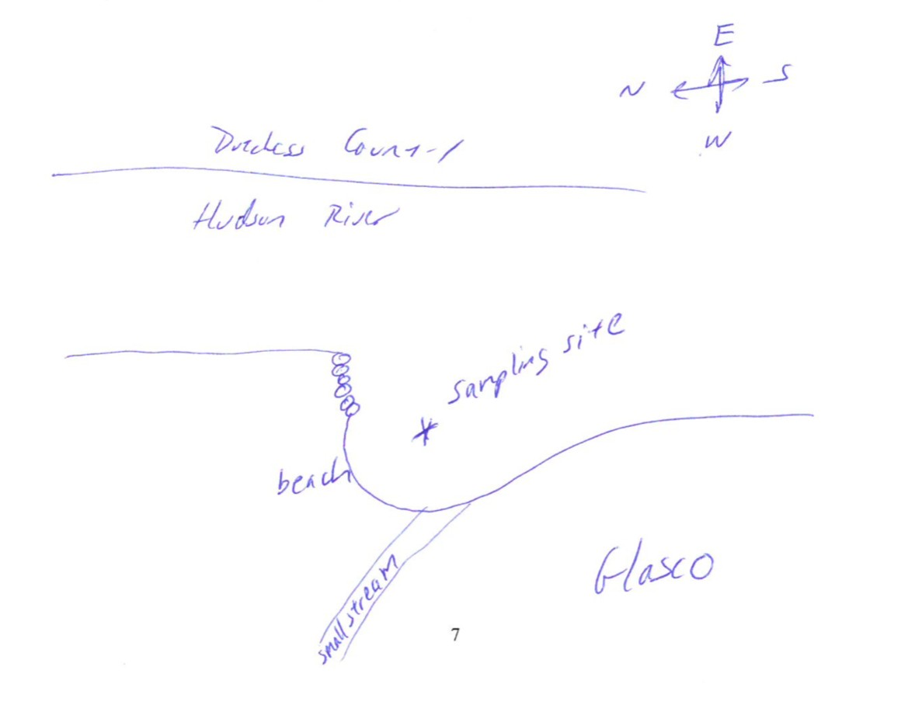
Location: Falling Waters Preserve (protected area), Saugerties, Ulster County, NY
Area: Forested, cove with a shallow beach
Surrounding Land Use: 50% Forested; 50% Beach- mostly forested with a viewing area overlooking the beach/cove
Sampling Site: Parkland, beach, wood bulkhead, lots of rocks, not much plant growth
Shoreline: Sandy Water: calm Plants in area: 0
River Bottom: Solid bottom containing a mix of sand and small rocks

ITEM | Time | Reading |  |  | Comments
Physical
Air Temperature: | 8:00 AM | 12 ℃ |  | 53.6 oF
Wind Speed: |  | Beaufort:
Weather Today: | Overcast (100%), no rain
Weather Previous:
Tides- | Time | Rising, Falling, Still | Height  (cm) | Rate of Tidal Change  (cm/min)
Tides- | 8:20 AM | Still
Currents Flow | Time | Cm/second | Knots | North/South | Ebb/Flood/Still
Water Temperature | 8:20 AM | 11.7 ℃ |  | 53.06 oF
Water Temperature |  | ℃ |  | oF

Turbidity - |  | N/R
Chemical
Salinity- |  | NR forgot Quantabs | ppm Cl- |  | dppm TS
Dissolved Oxygen – |  | Time | Temp |  | ppm DO |  | % saturation
 |  | 8:20 AM | 12 ℃ |  | 11 ppm |  | 100%
pH - inicator solution |  | 8:20 AM | 6
Nitrates |  | 8:20 AM | 4 mg/L
Phosphates |  | 8:20 AM | 0.2mg/L
Biological
Fish – Seine  30' TOTAL: 3 pulls |  | Number | Name |  |  | Length of longest | 10:01 AM
 |  | 3 | Spottail Shiner |  |  | 6 cm | 10:01 AM
 |  | TOTAL: 3 | DIVERSITY: 1 |  |  |  | 10:01 AM
Macroinvertebrates- Seine |  | Number | Name |  |  | Length of longest
 |  | TOTAL: 0 | DIVERSITY: 0
Sediment Core |  | Water depth | Length | Oxid Top |  | Grain Size | Other
NR
Boats | Time | Name | Color |  |  | North/South | Loaded/Light
NR
Other Observations

