Day in the Life of the Hudson River 10/22/19
LASHER PARK, GERMANTOWN
RIVER MILE: 108.5
Salt Front: ~ RM 53
Hudson High School – Jim McDarby
Columbia Land Conservancy- Heidi Bock
40 students 10-12th grade, 9 adults
Latitude 42.1589 N & Longitude – 73.9959 W
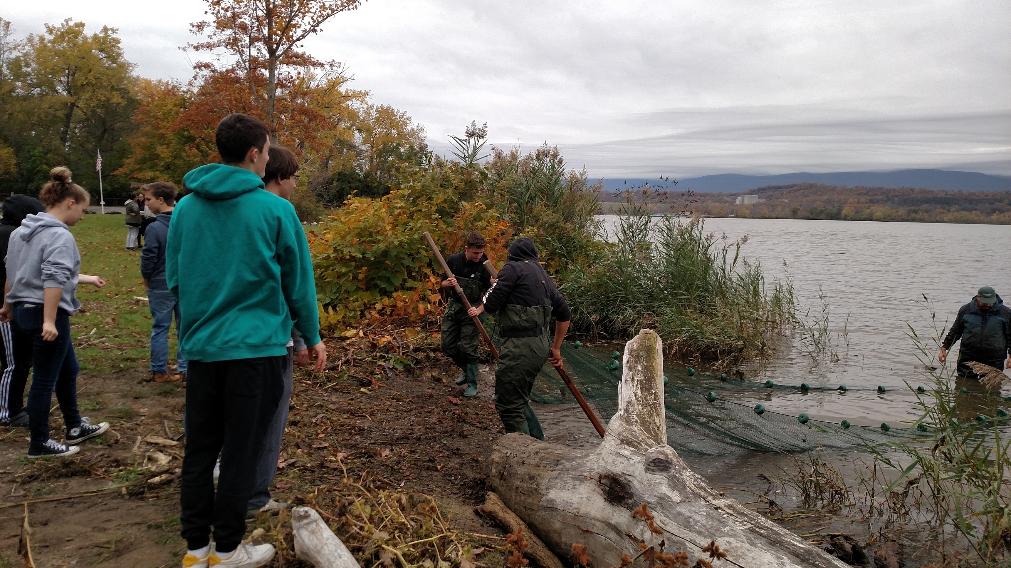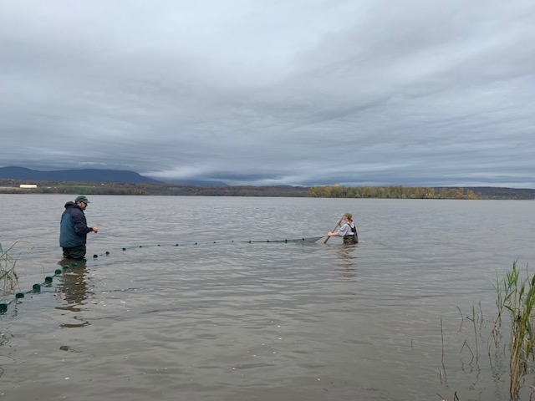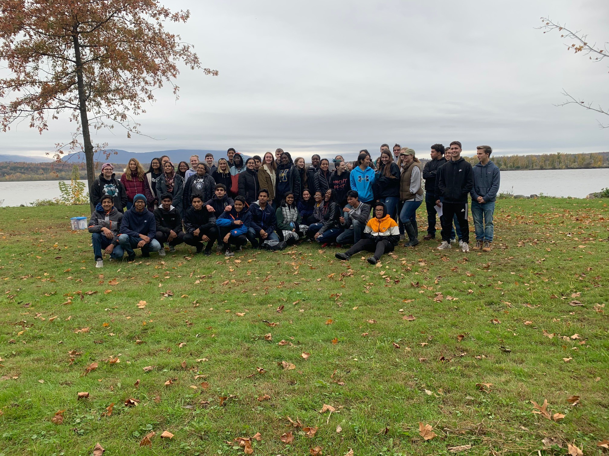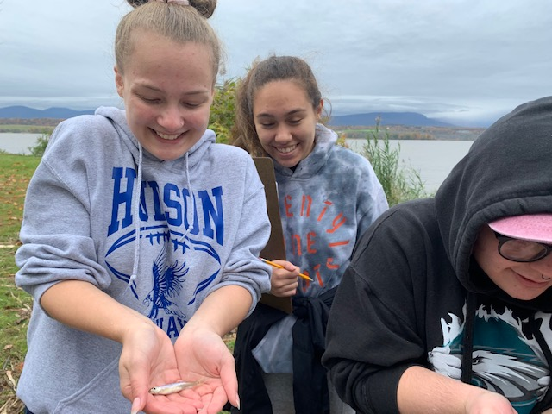
Location: Lasher Memorial Park, Boat Launch, Northern Germantown Landing, Columbia County, NY
Area: Grassy area, boat launch, pier, parking lot- used for picnics and boating
Surrounding Land Use: 5% Forested; 80% Urban/Residential; 5% Beach; 10% Industrial/Commercial
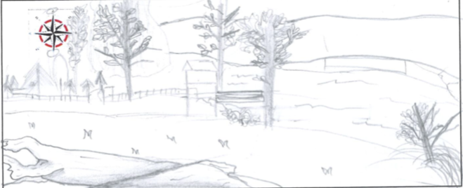
Sampling Site: Park with mowed lawn, beach, riprap in area
Shoreline: 75% Sandy; 20% muddy; 5% rocky
Water: 60 cm
River Bottom: Muddy, weedy, sandy
Plants in water: 60-80% water chestnuts, 10% sweetflag, 10% bulrush (cattail), 5-10% spatterdock, 5-10% duckweed, common reed, golden club, water celery

ITEM | Time | Reading |  | Comments
Physical
Air Temperature | 9:25 A M  9:35 AM  10:15 AM  10:55 AM  11:45 AM  11:55 AM  12:05 PM  12:40 PM  1:05 PM | 56 º F  57.2 º F  59 º F  59 º F  60 º F  59 º F  62 º F  59 º F  59 º F | 13.3 º C  14 º C  15 º C  15 º C  16 º C  15 º C  17 º C  15 º C  15 º C
Wind Speed: | 9:25 A M  10:15 AM 11:45 AM  12:40 PM | Beaufort 1  Beaufort 1  Beaufort 1  Beaufort 2 | SW  S  S  S
Weather today | Overcast (>75%)
Weather the past 3 days: | Rained on Sunday. Monday was chilly but seasonal
Tides- | Time | Rising, Falling, Unchanged | Height (in) | Rate of Tidal Change (cm/min)
 | 9:15 AM  10:00 AM  10:50 AM  11:35 AM  12:15 PM  12:25 PM  1:05 PM | Still  Ebb  Ebb  Ebb  Ebb  Ebb | At top of the stick  85 cm  75 cm  65 cm  55 cm  45 cm  40 cm | NA  NA  0.2  0.22  0.25  0.14  .0125
Current- | cm/second | Knots | North/South | Ebb/Flood/Still
9:15 AM  9:35 A M  10:15 AM  10:20 AM  10:40 AM  11:40 AM  11:50 AM  12:40 PM  12:45 PM | 0  0  0  5.6  4.1  13  7  17.5  7 | 0  0  0  0.114  0.079  0.252  0.136  0.34  0.14 | South  South  South  South  South | Still  Still  Still  Still  Ebb  Ebb  Ebb  Ebb  Ebb
Water Temperature | 9:15 AM  10:05 AM 11:36AM  12:35 PM | 11 º C, 12 º C  12 º C, 12 º C  12 º C, 13 º C  12 º C, 13 º C | 51.2 º F, 51.2 º F  54 º F, 55 º F
Turbidity- long sight tube | 9:40 AM  10:35 AM  12:00 PM  12:55 PM | 16.75, 15.25 cm, 22.5 cm, Avg: 18.16 cm  24.2 cm, 23 cm, 24.2 cm, Avg: 23.8 cm  16.8 cm, 20.5 cm, 19.5 cm, Avg: 18.9 cm  16.25 cm, 19 cm, 15 cm. Avg: 16.75 cm
Chemical
Salinity- LR Quantabs | Time | Chloride ppm Cl⁻ | Total Sal. Ppm
 | 9:40 AM  10:25 AM  11:35 AM  12:40 PM | < 28 ppm  < 28 ppm  < 28 ppm  < 28 ppm | Below Detection  Below Detection  Below Detection  Below Detection
DO – Drop count kit | Time | Temp | ppm DO | % saturation
*DO readings seem high, perhaps there was an air bubble or didn’t swirl after each titration drop | 9:50 AM  10:45 AM  10:55 AM  12:06 PM  12:20 PM  1:00 PM | 12  12  12  12.5  12.5  12.5 | 10  18  12  18  19  14 | 90%  >140%  130%  >140%  >140%  130%
pH – Color Match Kit | 9:25 AM  10:15 AM  11:45 AM  12:40 PM | 7, 7  6.8, 8.3, Avg: 7.5  7.75, 7.25, Avg: 7.5  7.5
Fish | Number | Name | Length of longest
Seine: 25’  # Pulls: 4 | 2  8  1  1  3  1  6  2  1  5  1  1 | Striped Bass  Spottail Shiner  Banded Killifish  Gizzard Shad  Spottail Shiner  Goldfish  Spottail Shiner  Spottail Shiner  Striped Bass  Spottail shiner  White Perch  Herring spp. | 9 cm  8 cm  7 cm  8 cm  9.5 cm  7.5 cm  9 cm  8 cm  9 cm  9 cm  15 cm  11.5 cm | 9-10 am  10-11 am  11:30-12:30 pm  12:30-1:15 pm
Fish Totals | TOTAL: 32 | Diversity: 7
Macroinvertebrates | Number | Name | Length of longest
 | 1  1  2 | Blue Crab (M)  Amphipod  Blue Crab (M) |  | 10-11 am  11:30-12:30 pm
Macroinvertebrate Totals | TOTAL:4 | Diversity: 2
Boats | Time | Name/Color | North/South | Loaded/Light
Commercial  Recreational  Commercial  Commercial | 9:30 AM  9:40 AM  11:55 AM  11:55 AM | Unknown  Small Cruise  Oil Barge  Rock/sand barge | North  South  South  No moving | Light  Loaded  Loaded  Loaded

