Day in the Life of the Hudson River 10/22/19
HENRY HUDSON RIVERFRONT PARK, HUDSON
RIVER MILE: 117
Salt Front: ~ RM 53
Montgomery C. Smith Elementary School- Tani Quinion
19 students 3rd grade, 7 adults
Chatham Elementary School - Sam Moses
SCA, Green County Soil and Water Conservation District: Nathan Horstman
Cary Institute of Ecosystem Studies – Shelley Forester
Everett Nack Environmental Center- Nick Zachos
Latitude 42.25369 N & Longitude – 73.79935 W
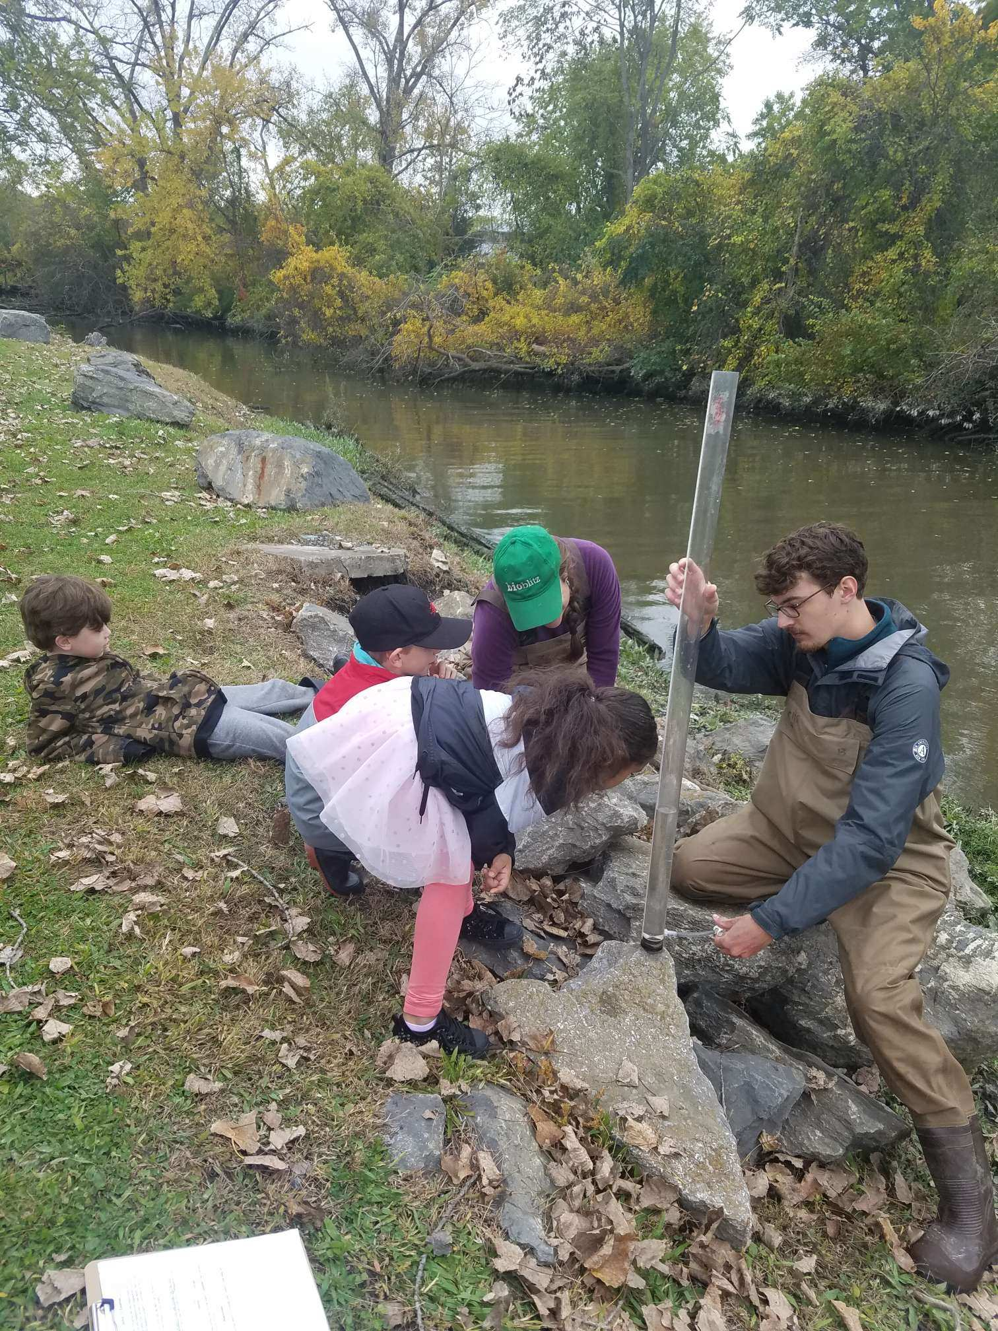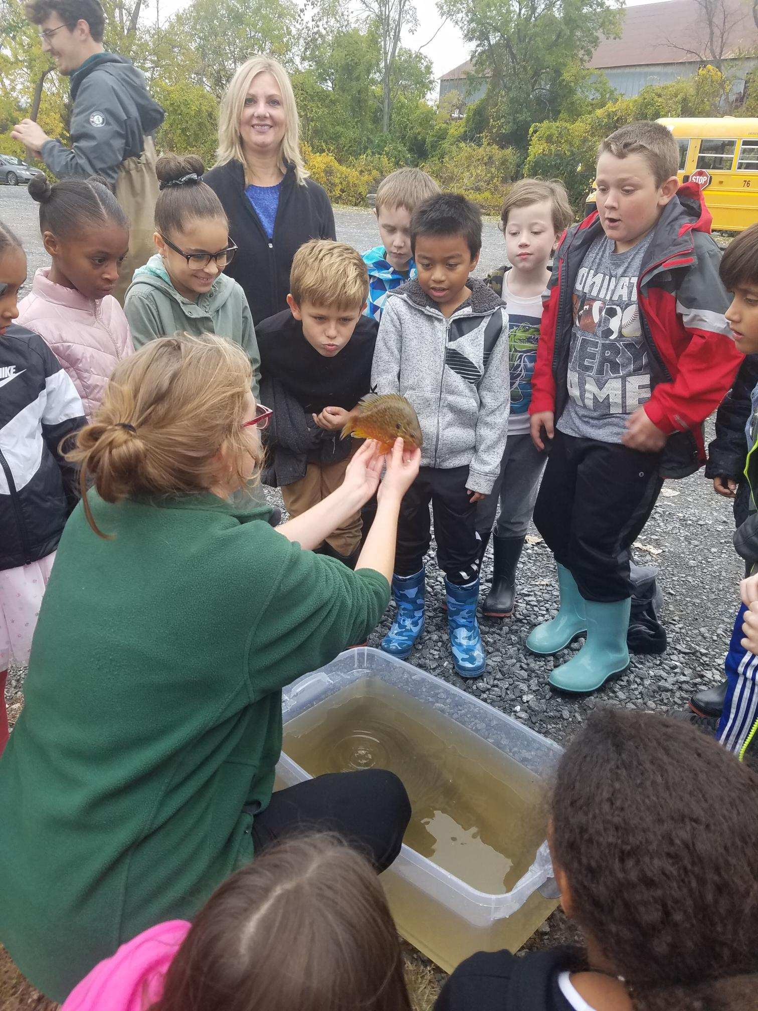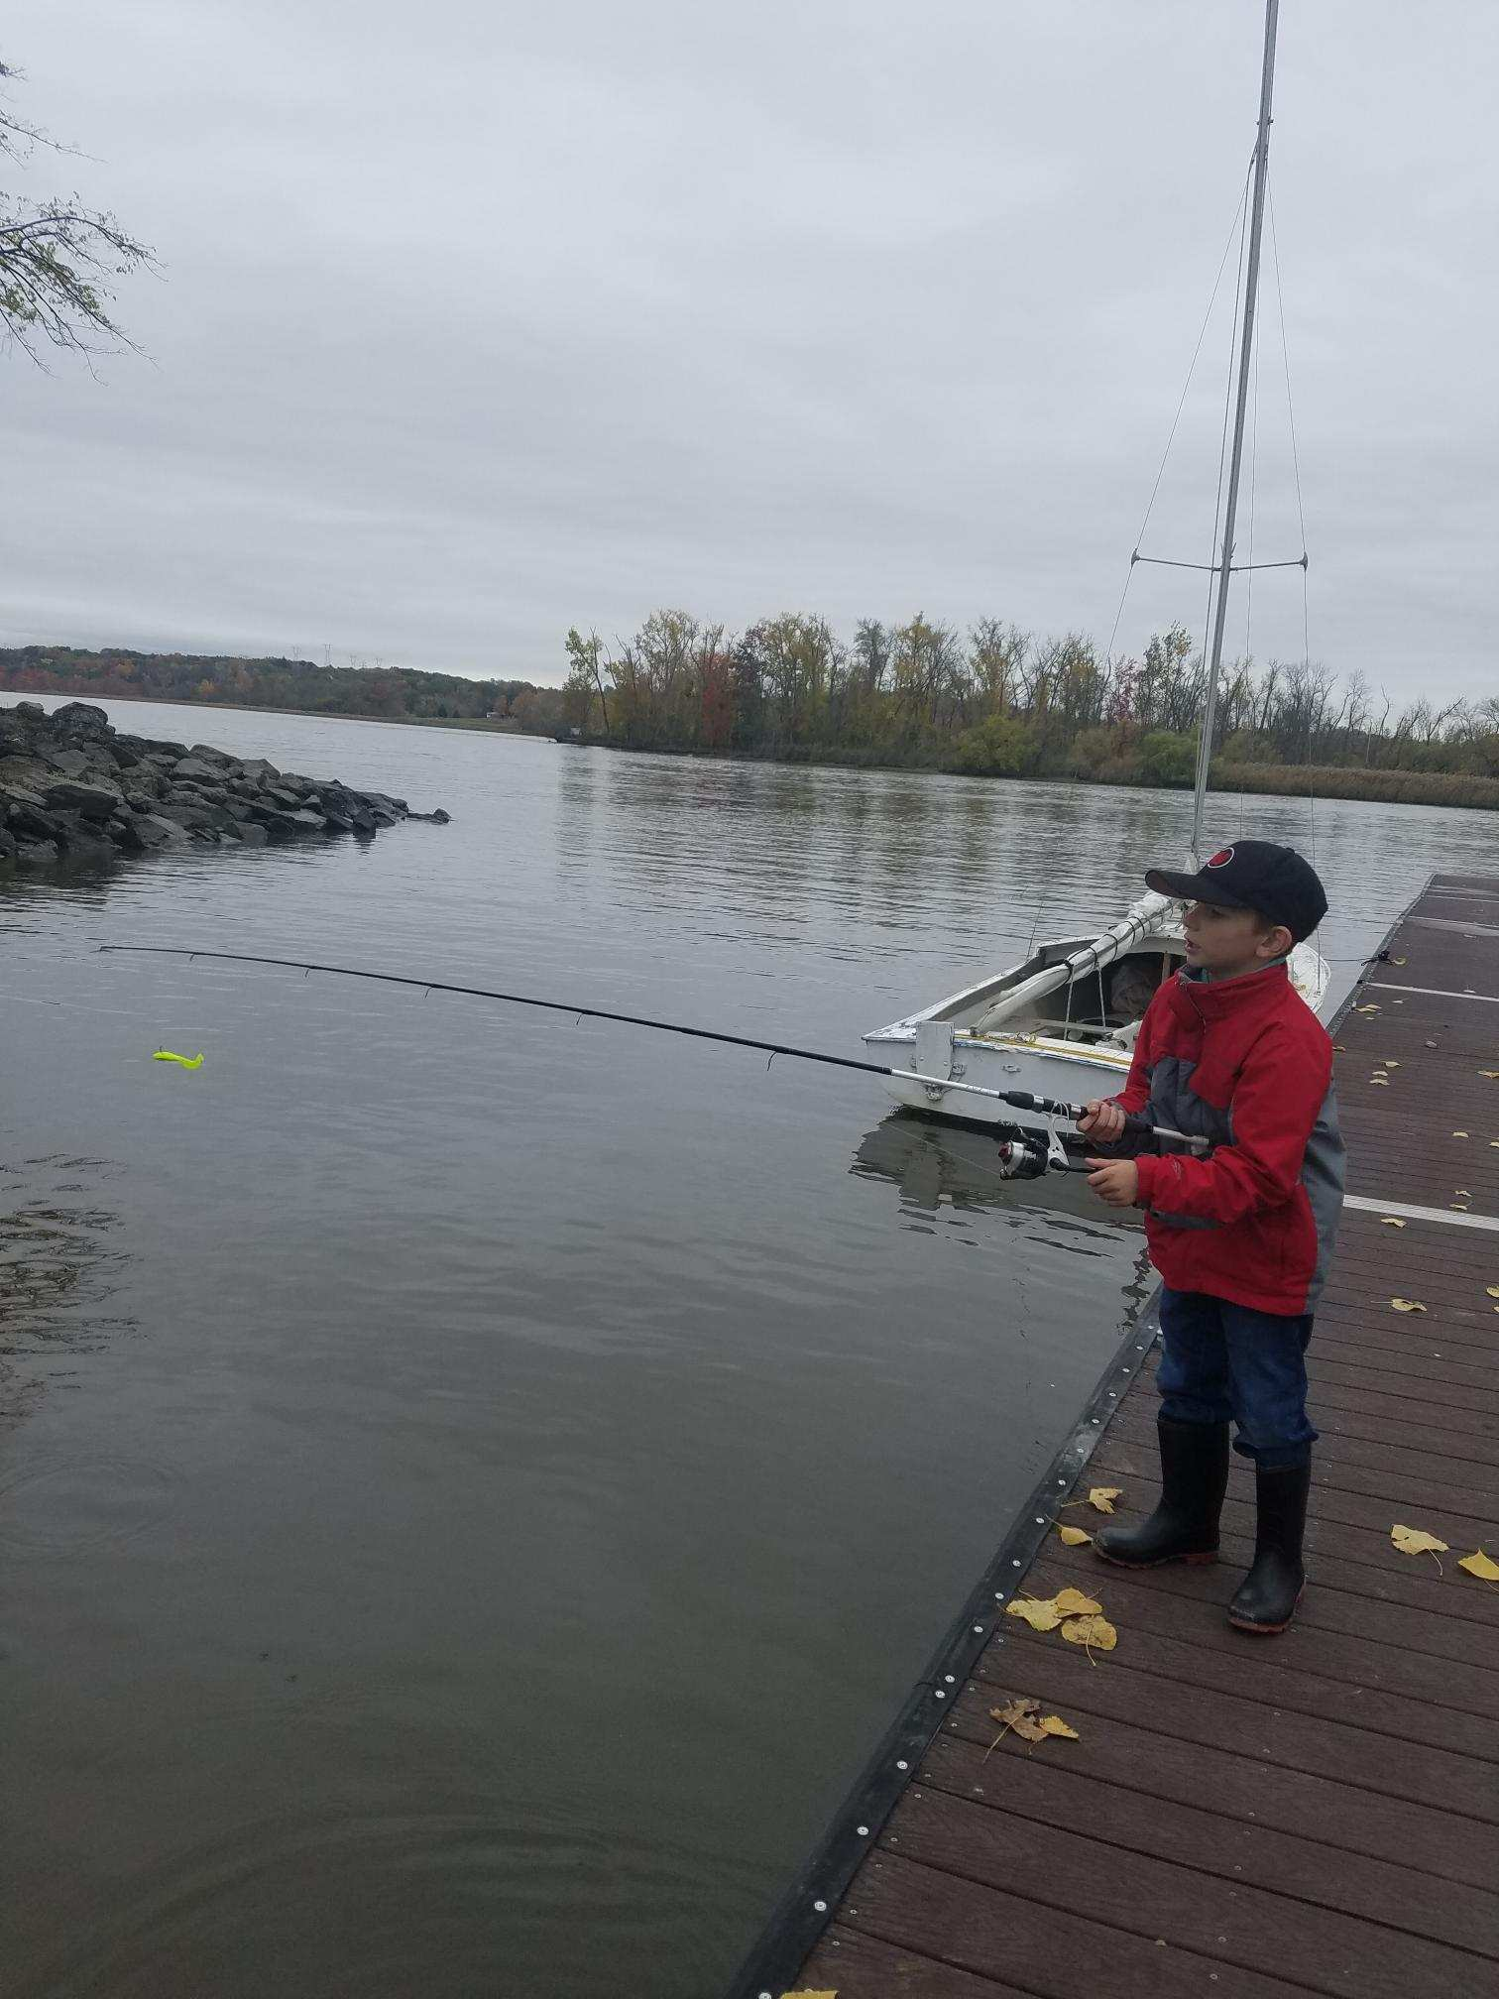
Location: Henry Hudson Riverfront Park, City of Hudson, Columbia County, NY
Area: 1st dock I the waterfront property used for fishing, marina, picnics, large grassy area with parking lot, just north of the old quarry site
Surrounding Land Use: 50% Industrial/Commercial; 50% Urban/Industrial
Sampling Site: Waterfront with banks 100% altered to include wooden and concrete bulkheads and large riprap on shoreline; pier, grassy, parking lot
Shoreline: 30% Muddy; 70% Rocky; riprap
River bottom: Muddy, rocky
Plants in area: < 1% Water chestnuts; 10% water celery
Water: AM calm, PM slightly choppy; 6-9 feet

ITEM | Time | Reading |  | Comments
Physical
Air Temperature | NA
Wind Speed: | NA
Weather today | NA
Weather the past 3 days: | NA
Tides- | Time | Rising, Falling, Unchanged | Height (cm) | Rate of Tidal Change (cm/min)
NA
Current- | cm/second | Knots | North/South | Ebb/Flood/Still
NA
Water Temperature
Turbidity - | 1:15 PM -2:15PM | 36 cm
Chemical
Salinity- NA | Time | Chloride ppm Cl⁻ | Total Sal. ppm
DO – | Time | Temp | ppm DO | % saturation
NA
pH – | NA
Fish | Number | Name | Length of longest
Seine | 12 | Red Breasted Sunfish
Fish Totals | TOTAL: 12 | Diversity: 1
Macroinvertebrates | Number | Name | Length of longest
Macroinvertebrate Totals | TOAL: | Diversity:
Sediment Core | Time | Oxid Top | Grain Size | Other Items
NA
Observations

