Day in the Life of the Hudson River 10/22/19 Data
COXSACKIE RIVERFRONT PARK
Coxsackie, NY
RIVER MILE: 123
Salt Front: ~RM 53
Coxsackie Elementary School-
22 students 4th grade, 15 adults
Jen Rausch, Coxsackie E.S.
Latitude N 42º 22.2’ & Longitude W 73º 47.756”
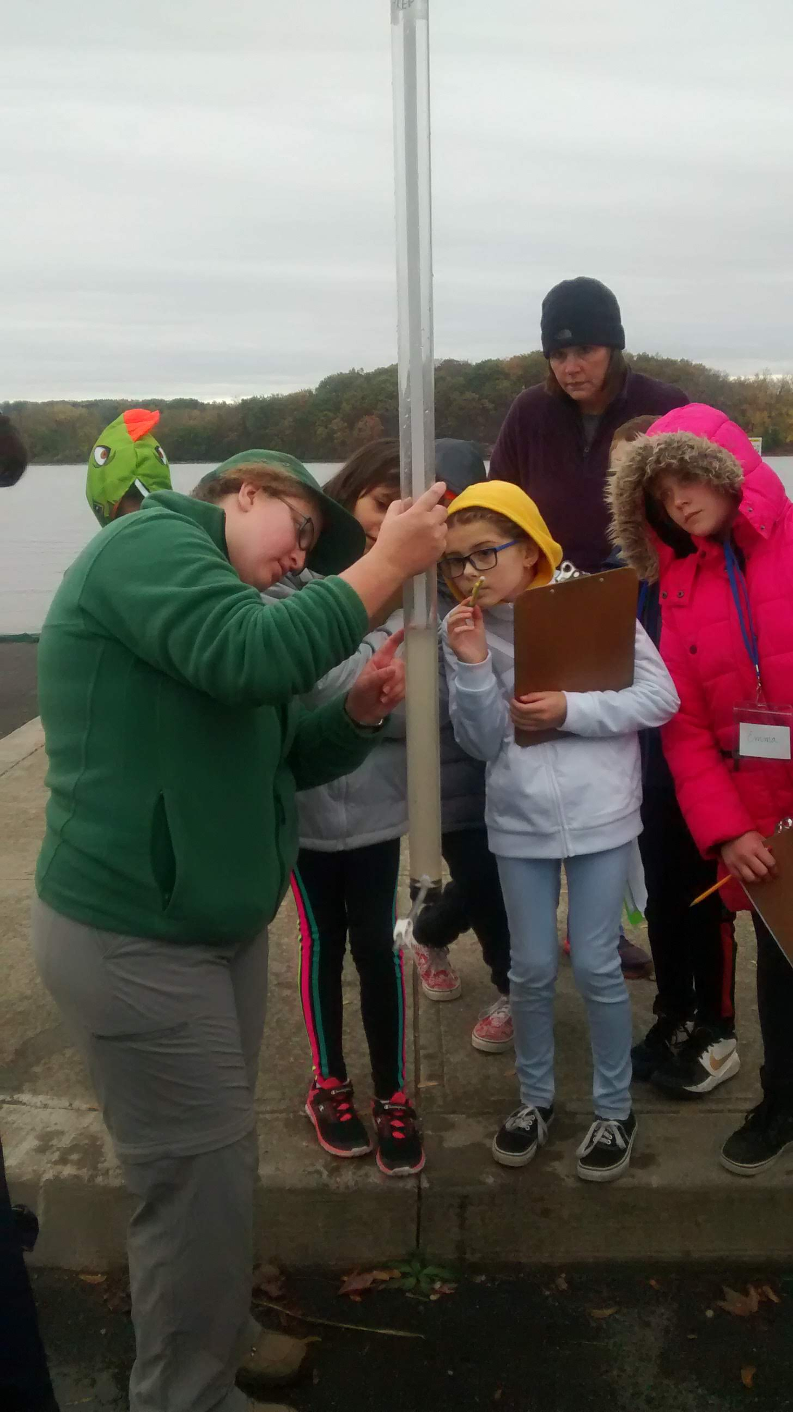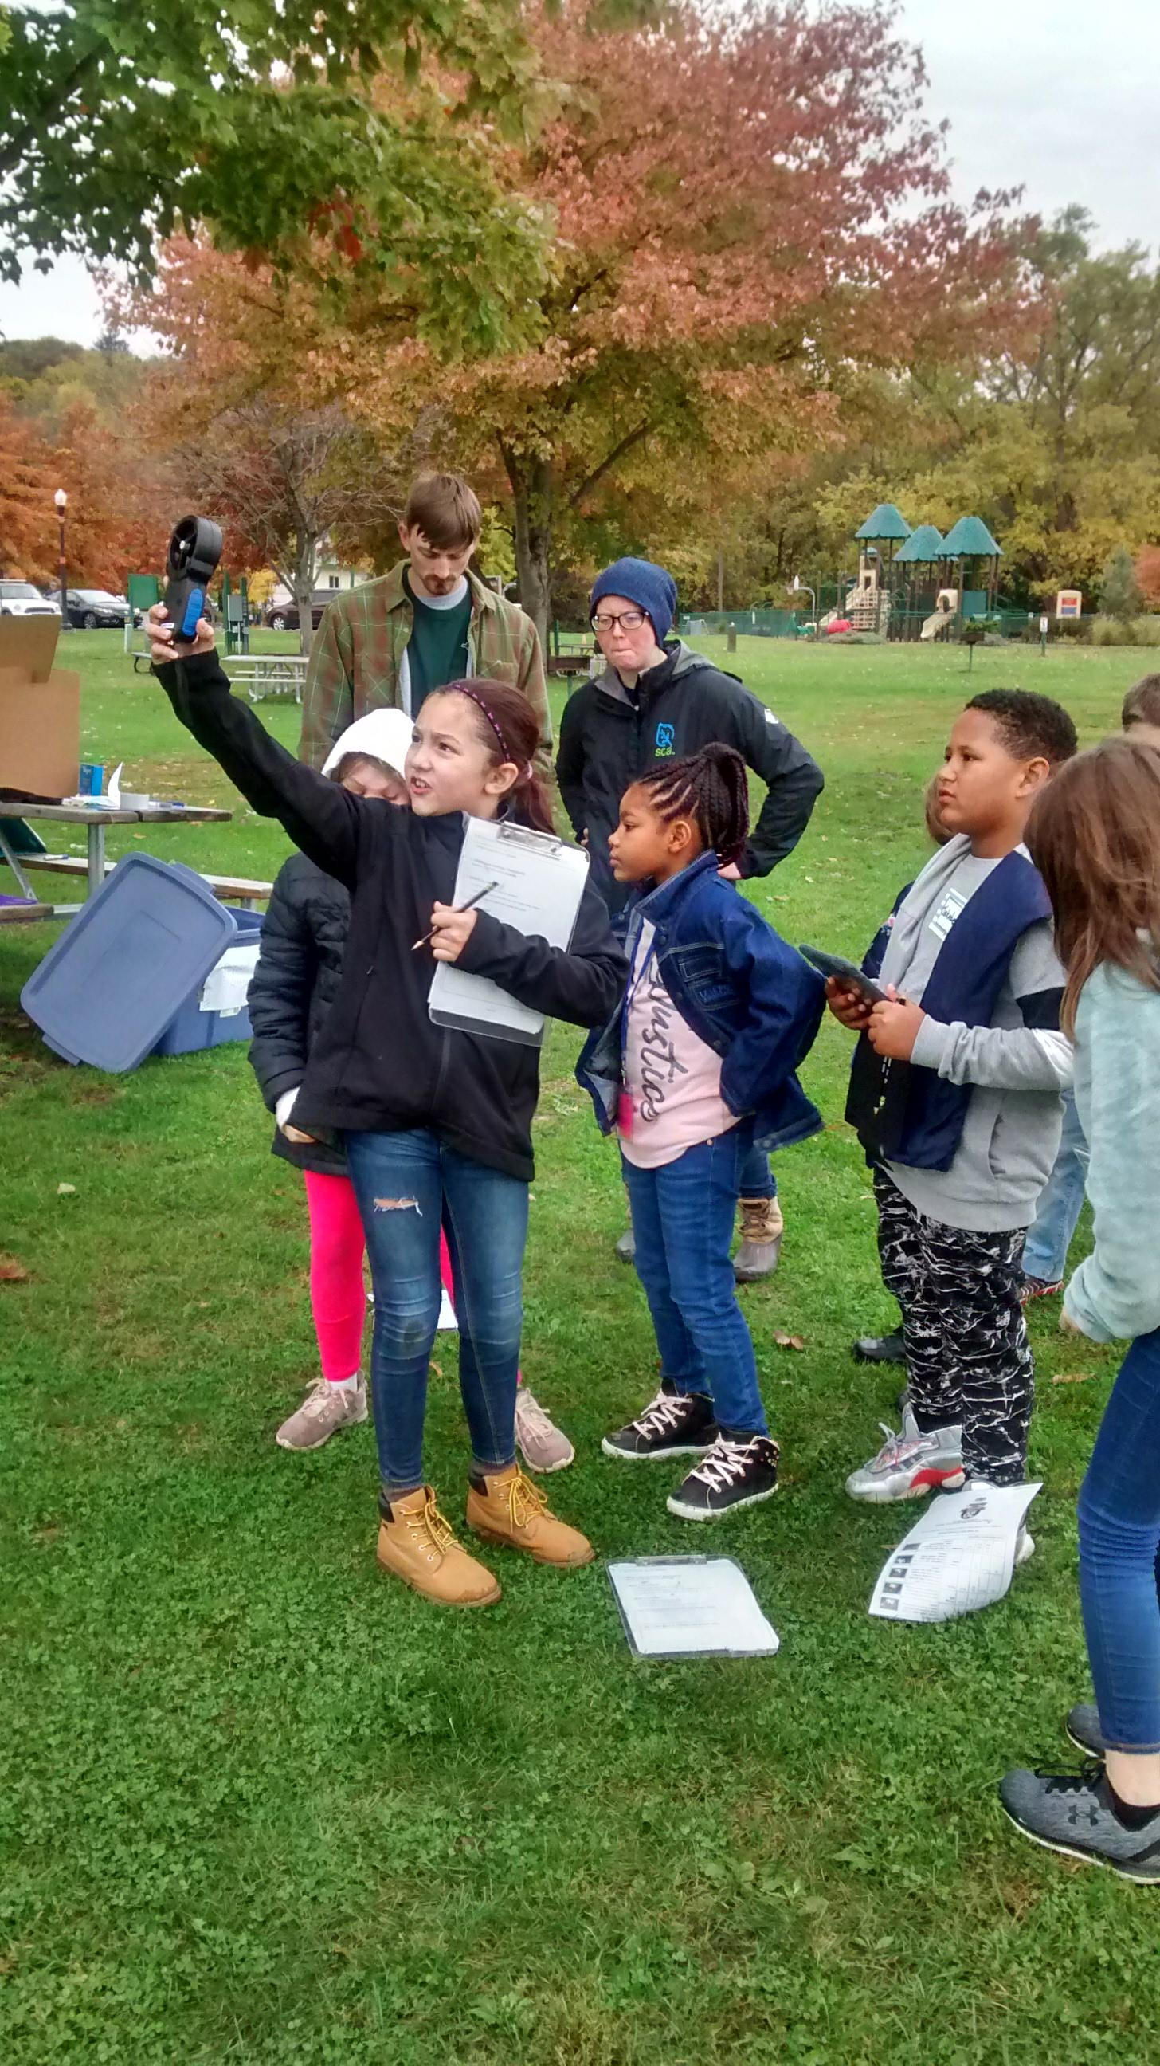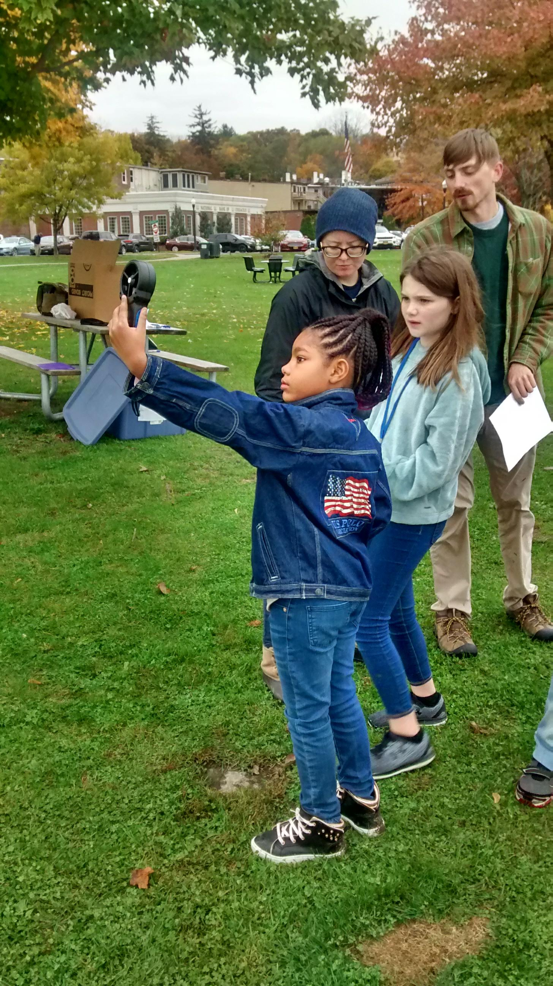

Location: River front park
Area: Parking area, cement boat launch, fishing and grassy picnic area
Surrounding Land Use: 15% forested, 65% boat launch, parking lot, park, covered with vegetation
Sampling Site: Off the concrete boat launch
Shoreline: RipRap (large rocks), metal bulkheads
Plants in area: No visible plants in water
River Bottom description: muddy, rocky
Water: calm, 2 feet depth
Other: Few seagulls

ITEM | Time | Reading |  | Comments
Physical
Air Temperature | 10:10 AM  10:40 AM  11:10 AM | 13.6ºC  13.2 ºC  13.5 ºC | 56 ºF  54.8 ºF  56.4 ºF
Wind Speed: Wind Meter | 11:15 AM | 1-2 Beaufort | 0.22 mph | North
Weather today | No Rain, partly cloudy (26-50%)
Weather recently | Partly cloudy, cool days with some sun
Water Temperature | 10:05 AM  10:39 AM  11:10 AM | 10 ºC  10 ºC  11 ºC | ºF  ºF
Turbidity - long sight tube | 10:05 AM  10:39 AM  11:10 AM | 27.2, 20.8, 39.2 cm  13, 16.8, 18 cm  39.2, 25, 27.8 cm |  | Average: 29 cm  16. cm  31 cm
Chemical
Salinity- Low Range quantabs | 10:05 AM | 0,0,0 | 0 mg/L | *Seems as if there is an issue
DO – drop count | Time | Temp | ppm DO | % saturation
 | 10:05 AM | 10 ºC | 14 mg/L | 145%  145%
pH – color match test kit | N/R
Fish | Number | Name | Length of longest
Seine 5mX1m  10:00-11:00 AM | 9  4  1  1 | **Spottail Shiner  *Banded Killi  White Perch  Sunfish |  | **1 reported as common shiner but photo was spottail  *2 reported as striped killi
Fish Totals | TOAL: 15 | Diversity: 4
Tides | Rising, Falling, Unchanged | Height (cm) | Rate of Tidal Change (cm/min)
9:55 AM  10:15 AM | Rising  Rising | 6.5 cm  13.5 cm | 7 cm/20 mins | A barge knocked the stick out
Currents | Cm/second | Knot | North/South | Ebb/Flood/Still
11:15 AM  11:17 AM | .667  .567 | .013  .011 | South  South | Ebb  Ebb
Core | Description | Rare | Common | Abundant
NR
Boat Traffic | Name | Color | North or South | Loaded or Light
10:15 AM  10:15 AM | Barge  Barge |  | South  North | Light  Loaded

