Day in the Life of the Hudson River 10/22/19
HENRY HUDSON PARK, BETHLEHEM
RIVER MILE: 138
Salt Front: ~ RM 53
The Albany Academies- Sarah Loya and Bob Neudel
31 students 5th grade, 5 adults
College of St. Rose- Mary Cosgrove
Latitude 42.543455 N & Longitude – 73.759119 W
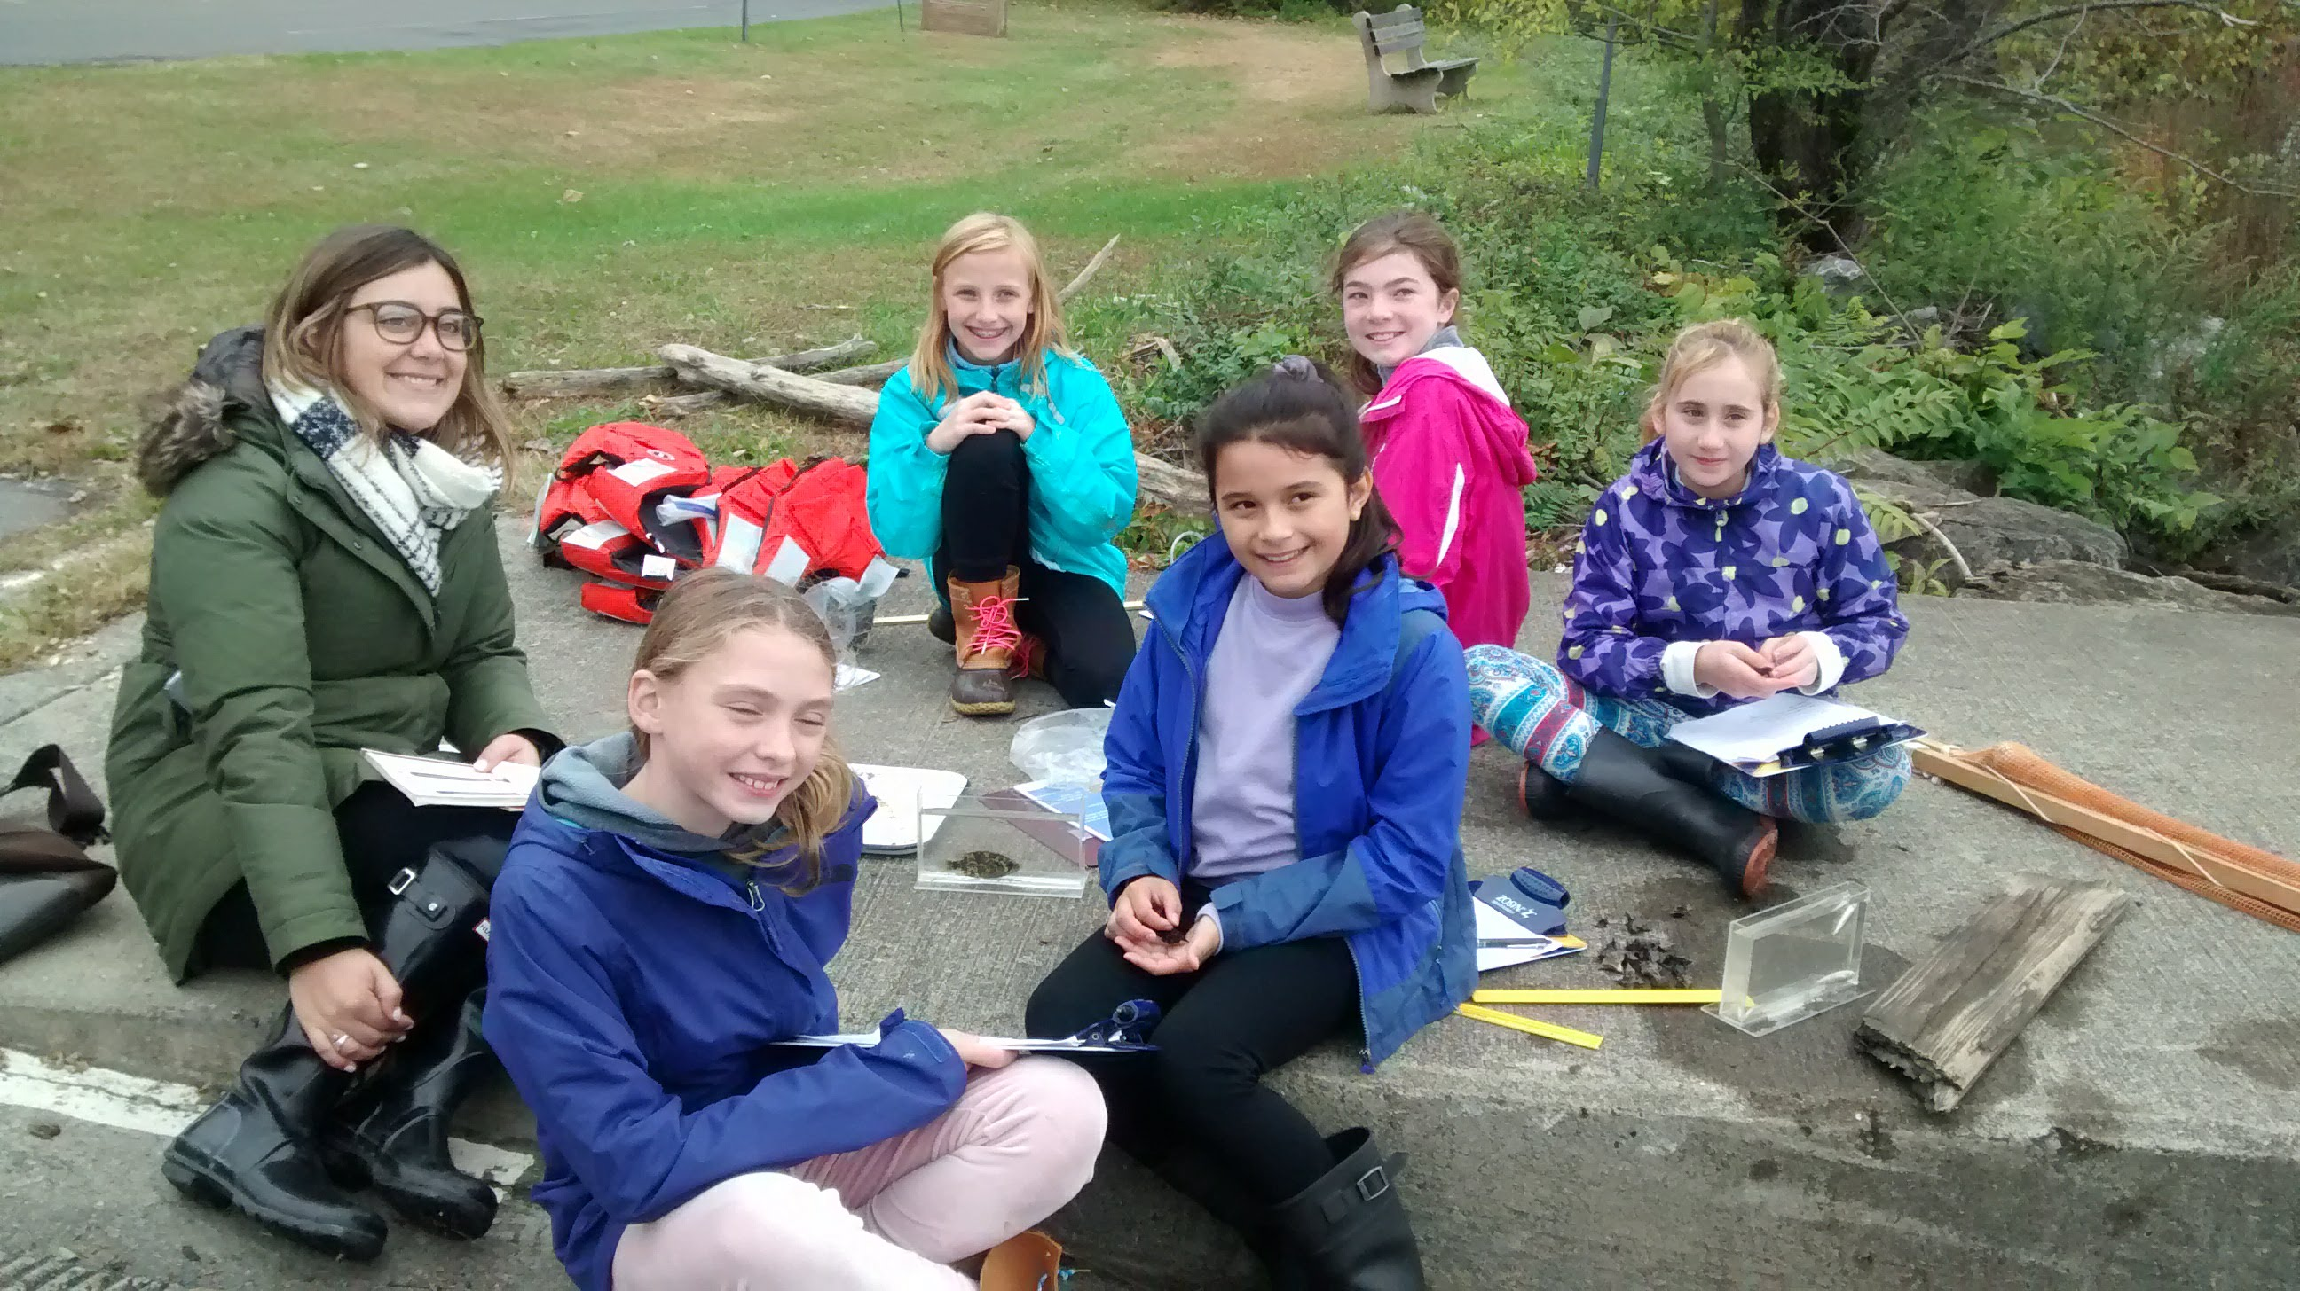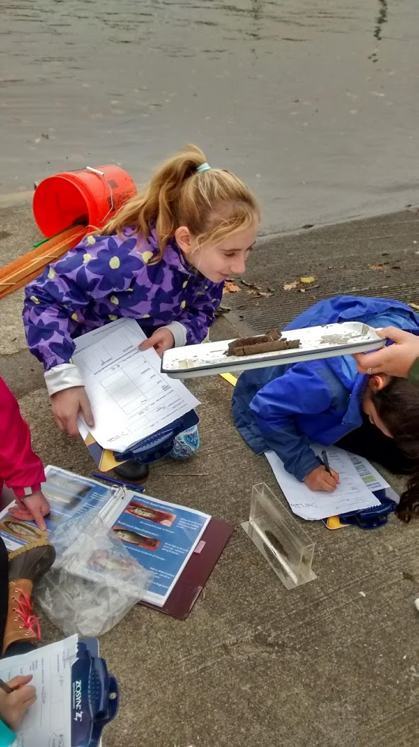
Location: Henry Hudson Park Waterfront, Bethlehem, Albany County, New York
Area: Park/boat launch, used for picnics, just north of Vloman Kill
Surrounding Land Use: 100% parkland with 75% vegetated coverage
Sampling Site: Grassy, parking lot, banks altered, riprap, bulkhead rocky
Plants in area: Water chestnuts

ITEM | Time | Reading |  | Comments
Physical
Air Temperature | 9:36 AM  10:23 AM  10:45 AM  11:20 AM  11:43 AM  11:55 AM | 14 º C  12 ºC  12 ºC  14 ºC, 13 ºC  16 ºC  16 ºC | 53.6 º F  53.6 º F  57.2 º F, 55.4 º F
Wind Speed: Anemometer | 9:36 AM  10:23 AM  10:45 AM  11:20 AM  11:43 AM  11:55 AM | 0 mph  1.8 mph, 6.1 mph  4.8 mph, 2.4 mph  4.7 mph, 1.9 mph  6.7 mph, 10.8 mph  3.2 mph, 5.1 mph | Beaufort 0  Beaufort 1-2  Beaufort 1-2  Beaufort 1-2  Beaufort 2  Beaufort 1-2 | North  North  North  North  North  North
Weather today | NA
Weather the past 3 days: | NA
Tides- | Time | Rising, Falling, Unchanged | Height (cm) | Rate of Tidal Change (cm/min)
 | 9:36 AM  10:23 AM  10:45 AM  11:20 AM  11:43 AM  11:55 AM | Rising  Rising  Rising  Rising  Rising  Rising | +3.5 cm  +1.5 cm  +1 cm  + 0.5 cm  +1 cm  + 4 cm | NA  0.032  0.045  0.014  0.043  0.333
Current- | cm/second | Knots | North/South | Ebb/Flood/Still
 | 9:36 AM  10:23 AM  10:45 AM  11:20 AM  11:43 AM  11:55 AM | 0.33 cm/s  1 cm/s, 1.33 cm/s  1.83 cm/s, 2.33 cm/s  2.67 cm/s, 3 cm/s  3.7 cm/s  3.3 cm/s, 2.3 cm/s | South  South  South  South  South  South | Ebb  Ebb  Ebb  Ebb  Ebb  Ebb
Water Temperature | 9:36 AM  10:23 AM  10:45 AM  11:20 AM  11:43 AM  11:55 AM | 12 º C  11 º C  11.5 º C  12 º C  12 º C  11 º C, 12 º C | 51.8 º F  52.7 º F  53.6 º F
Turbidity - long sight tube | 9:35 AM  10:10 AM  10:46 AM  11:08 AM  11:31 AM  12:00 PM | 31.2 cm  32 cm  42 cm, 32 cm - average 37 cm  32 cm, 32 cm – average 32 cm  25 cm, 31 cm – average 28 cm  32 cm
Chemical
Salinity- quantabs LR | Time  9:35 AM  10:10 AM  10:40 AM  11:10 AM  11:40 AM  12:00 PM | Chloride ppm Cl⁻  32 ppm  27 ppm  17 ppm  22 ppm  22 ppm  22 ppm | Total Sal. Ppm  58 ppm  49 ppm  31 ppm  40 ppm  40 ppm  40 ppm
DO – | Time | Temp | ppm DO | % saturation
 | 9:35 AM  10:10 AM  10:40 AM  11:10 AM  11:34 AM  12:02 PM | 12 º C  11 º C  11.5 º C  12 º C  12 º C  11 º C, 12 º C | 9 ppm *air bubble  9 ppm  7 ppm  9 ppm  10ppm *air bubble  12 ppm *air bubble
pH – | 9:35 AM  10:10 AM  10:40 AM  11:10 AM  11:40 AM  12:00 PM | 7  7  7  7  7  7.4
Chlorophyll | 9:35 AM  10:10 AM  10:40 AM  11:10 AM  11:40 AM  12:00 PM | 1 ppm  1.5 ppm  0.7 ppm  1.5 ppm  1.5 ppm  0.7 ppm
Fish | Number | Name | Length of longest
Seine | 10 | Goldfish | *all in a cove | 9:30-10:30 AM
Fish Totals | TOTAL: 10 | Diversity: 1
Macroinvertebrates | Number | Name | Length of longest
NA
Macroinvertebrate Totals | TOAL: | Diversity:
Sediment Core | Color | Smell | Texture | Composition
 | Dark brown, olive green, some black | Smells like dirt/mud/grass/woody-smell | Moist, clay-like, mostly smooth (feels like play-doh), squishy, a little grainy, slightly prickly, sandy | Mostly mud, some grass, roots, 4 tiny worms, small rock
Boats  Recreational  Recreational  Recreational  Commercial  Recreational | Time  10:10 AM  10:31 AM  10:50 AM  11:52 AM  12:13 PM  12:25 PM  12:27 PM | Name/Color  Two Boats passed  Boat passed  Sailboat passed  Small boat passed  Small boat passed  Shipping Boat passed  Small Boat passed | North/South  NA  NA  NA  NA  NA  NA  NA | Loaded/Unloaded
Observations | Water chestnuts

