Day in the Life of the Hudson River 10/22/19
ENGLEWOOD BOAT BASIN, ENGLEWOOD NJ
Bergen County, NJ
RIVER MILE: 14
Salt Front: RM 52 (West Point)
Paterson Academy for the Gifted and Talented-
50 students 6th grade, 5+ adults
Maureen Bruins, Paterson Academy
Kirk Weber, Meadowlands Environmental Center
Latitude 40.880581 N & Longitude – 73.944525 W

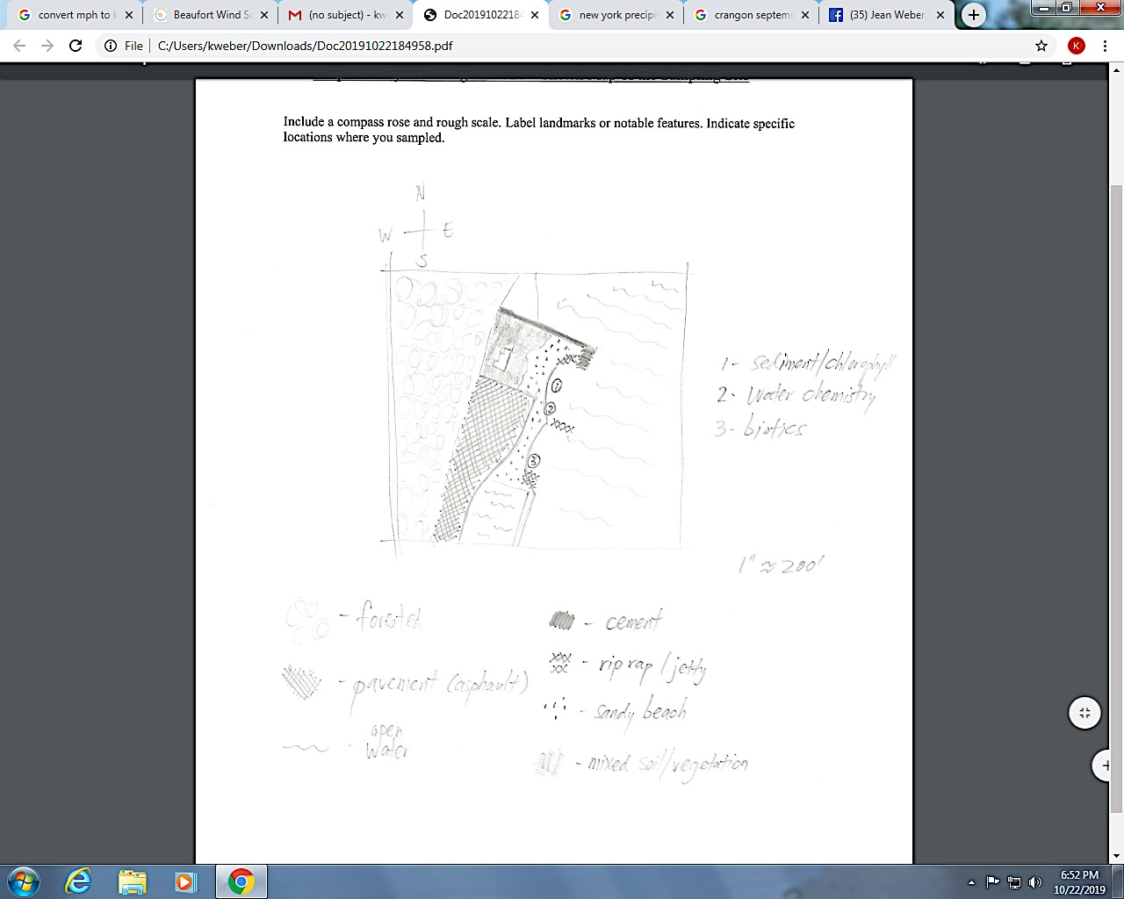
1: sediment core, salinity, turbidity
2: DO, pH, water temp.
3: Biotic sampling
Location: Bloomers Beach (North end), Englewood Boat Basin, NJ
Area: Sandy beach, banks altered, pier with riprap sections, wood bulkhead, debris in area. Piping ~30 ft located at sampling site. 2 concrete bulkheads and stone breakwaters on shoreline.
Surrounding Land Use: 40% Forested; 20% Beach; 20% Industrial/Commercial; 20% Urban/Residential
Shoreline: Loamy sand- sand and mud, a little weedy and rocky
Water: Choppy, 50 cm
River Bottom: Muddy
ITEM | Time | Reading |  | Comments
Physical
Air Temperature | 10:05 AM | 11 º C | 51 º F
Wind Speed: anemometer | 10:05 AM | 2-5.5 mph | 4.8 knots | Beaufort: 1-2  Direction: East
Weather today | Overcast, estimated <1 inch of rain/drizzle at 10:00 AM for 45 minutes.
Tides- | Time | Rising, Falling, Unchanged | Height (cm) | Rate of Tidal Change (cm/min)
 | 10:00 AM  11:30 AM | Falling  Rising | 50 cm  80 cm | .33 cm/min
Current- | cm/second | Knots | North/South | Ebb/Flood/Still
10:55 AM | 12.29 cm/sec | .24 knots | South | Ebb
Water Temperature | 10:15 AM  11:40 AM | 11 º C  16 º C  13 º C  Avg: 13.3 º C  13.4 º C  12.8 º C  13.9 º C  Avg: 13.4 º C | 51 º F  60 º F  55 º F  Avg: 55.3 º F  56 º F  55 º F  57 º F  Avg: 56 º F
Turbidity - long sight tube | 10:45 AM | 37 cm, 40 cm, 38 cm, Avg: 38.3 cm
Chemical
Salinity- Hydrometer | Time | Chloride | Total Salinity
 | 10:30 AM | -  -  -  - | 5 ppt  6 ppt  6 ppt  Avg: 5.7 ppt
DO – ampules | Time | Temp | ppm DO | % saturation
 | 10:30 AM | 15.6 º C | 6 ppm | 60%
pH – Indicator solution | 10:30 AM | 8, 8, 7, Avg: 7.7
Fish | Number | Name | Length of longest | Comments
Seine #2 10:15 AM  Seine #5  Seine #7 11:30 AM  Seine #10 | 2  2  3  2 | Atlantic Silverside Atlantic Silverside Atlantic Silverside Atlantic Silverside | 7.5 cm  7 cm  8 cm  6 cm | Seine Net:  252” x 43 “  mesh size: ¼”
Fish Totals | TOTAL: 9 | Diversity: 1
Macroinvertebrates | Number | Name | Length of longest
 | 18  2  1 | Blue Crab  Sand Shrimp  Moon Jelly |  | Seine and Dip net
Macroinvertebrate Totals | TOAL: 21 | Diversity: 3
Boats: Time | Name | Color | North/South | Loaded/Light
10:00 AM Recreational  10:00 AM | Circle Line  Tugboat |  | South  South | Light
Observations | Also observed some small private recreational vessels, both sail and motor driven.

