Day in the Life of the Hudson River 10/22/19
RENSSELAER BOAT LAUNCH
RIVER MILE: 146
Salt Front: ~ RM 53
Tech Valley High- Ashley Phillips
39 students 9th grade, 6 adults
CMOST- Dawn Baldwin
Latitude 42.6587 N & Longitude – 73.73452 W
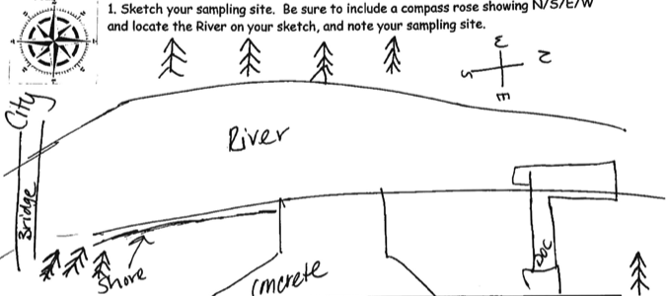
Location: Rensselaer Boat Launch, Rensselaer County, NY
Area: Boat launch with small beach area, wooded, landscaped, adjacent to urban, residential, and industrial areas.
Surrounding Land Use: 30% Urban/Residential, 30% Industrial/Commercial, 15% Park, 15% Beach, 10% Forested
Sampling Site: Concrete boat launch with beach, removable dock
Shoreline: Beach with sandy, small rocks, concrete boat launch
Water: 2-4 ft, ripples
River Bottom: muddy
Plants in water: no plants in water area

ITEM | Time | Reading |  | Comments
Physical
Air Temperature | 9:06 AM  10:02 AM | 52 º F  53 º F | 11.11 º C  11.67 º C
Wind Speed: |  | Beaufort 1 | Southwest
Weather today | Overcast, no rain
Weather past 3 days: | Fairly consistent on the 19th-21^{st.} Mid 50’s with some sun. Breezy on 10/21
Tides- tide stick | Time | Rising, Falling, Unchanged | Water Height (cm) | Rate of Tidal Change (cm/min)
 | 8:05 AM  9:06 AM  9:25 AM  9:56 AM | NA  Rising  Rising  Rising | 45  53  60  70 | NA  0.157  0.368  0.323
Current- | Time | cm/second, Knots | North/South | Ebb/Flood/Still
In the earlier tests, there was a lot of push to the north, but eventually travelled south | 9:06 AM  9:38 Am  10:02 AM  10:10 AM | 6.10 cm/s, .12 knots  5.04 cm/s, .10 knots  11.18 cm/s, .22 knots  32.5 cm/s, .63 knots | South  South  South  South | Ebb  Ebb  Ebb  Ebb
Water Temperature- | 9:40 AM  9:08 AM  10:09 AM | 52.8º F, 48.2º F, 53.42º F  Avg: 51.5 º F  52.88º F, 50º F, 52.34 º F  Avg: 51.74 º F  50º F, 51.62º F, 52.16º F  Avg: 51.26 º F | 11.6º C, 9º C, 11.9 º C  Avg: 10.83 º C  11.6 º C,10 º C, 11.3 º C  Avg: 10.967 º C  10 º C, 10.9 º C, 11.2 º C  Avg: 10.7 º C
Turbidity- | NR
Chemical
Salinity- Refractometer | 10:00 AM | Below Detection for this instrument
DO – drop count | Time | Temp | ppm DO | % saturation
 | 9:25 AM | 11.6 º C | 10 | 90%
pH – pH strip | 9:51 AM | 6.5, 6.4, 6.6, Avg: 6.5
Nitrates- | 10:09 AM | 0ppm, 0.1ppm, 0.4ppm, Avg: .17 ppm
Phosphates | 9:10 AM | 0ppm, 0ppm, 0ppm
Alkalinity | 9:30 AM | 50 ppm, 50 ppm, 52 ppm, Avg: 50.67 ppm
Biological
Fish | Number | Name | Length of longest
Seine  10 pulls |  | No fish
Fish Totals | TOTAL: 0 | Diversity: 0
Macroinvertebrates | Number | Name | Length of longest
Macroinvertebrate Totals | TOTAL: 0 | Diversity: 0
Sediment Core | Time | Oxid Top | Grain Size | Other Features
NR
Boats | Time | Name/Color | North/South | Loaded/Light
Recreational | 9:11 AM |  | South
Observations | 9:30 AM “On a cloudy morning at the Rensselaer boat launch, students from Tech Valley high School were discussing why DITL was important. A 9th grader summed it up by saying we can look at climate change markers and help scientists prove that it is real.”

