Day in the Life of the Hudson River 10/22/19 Data
HUDSON SHORES PARK, WATERVLEIT
Albany County, NY
RIVER MILE: 152
Salt Front: ~ RM 53
North Colonie CSD Learning Enrichment Program-
50 students 5th grade, 4 adults
Amy Parks & Stacey Shepard, North Colonie CSD
Latitude 41.471 N & Longitude - 74.016 W
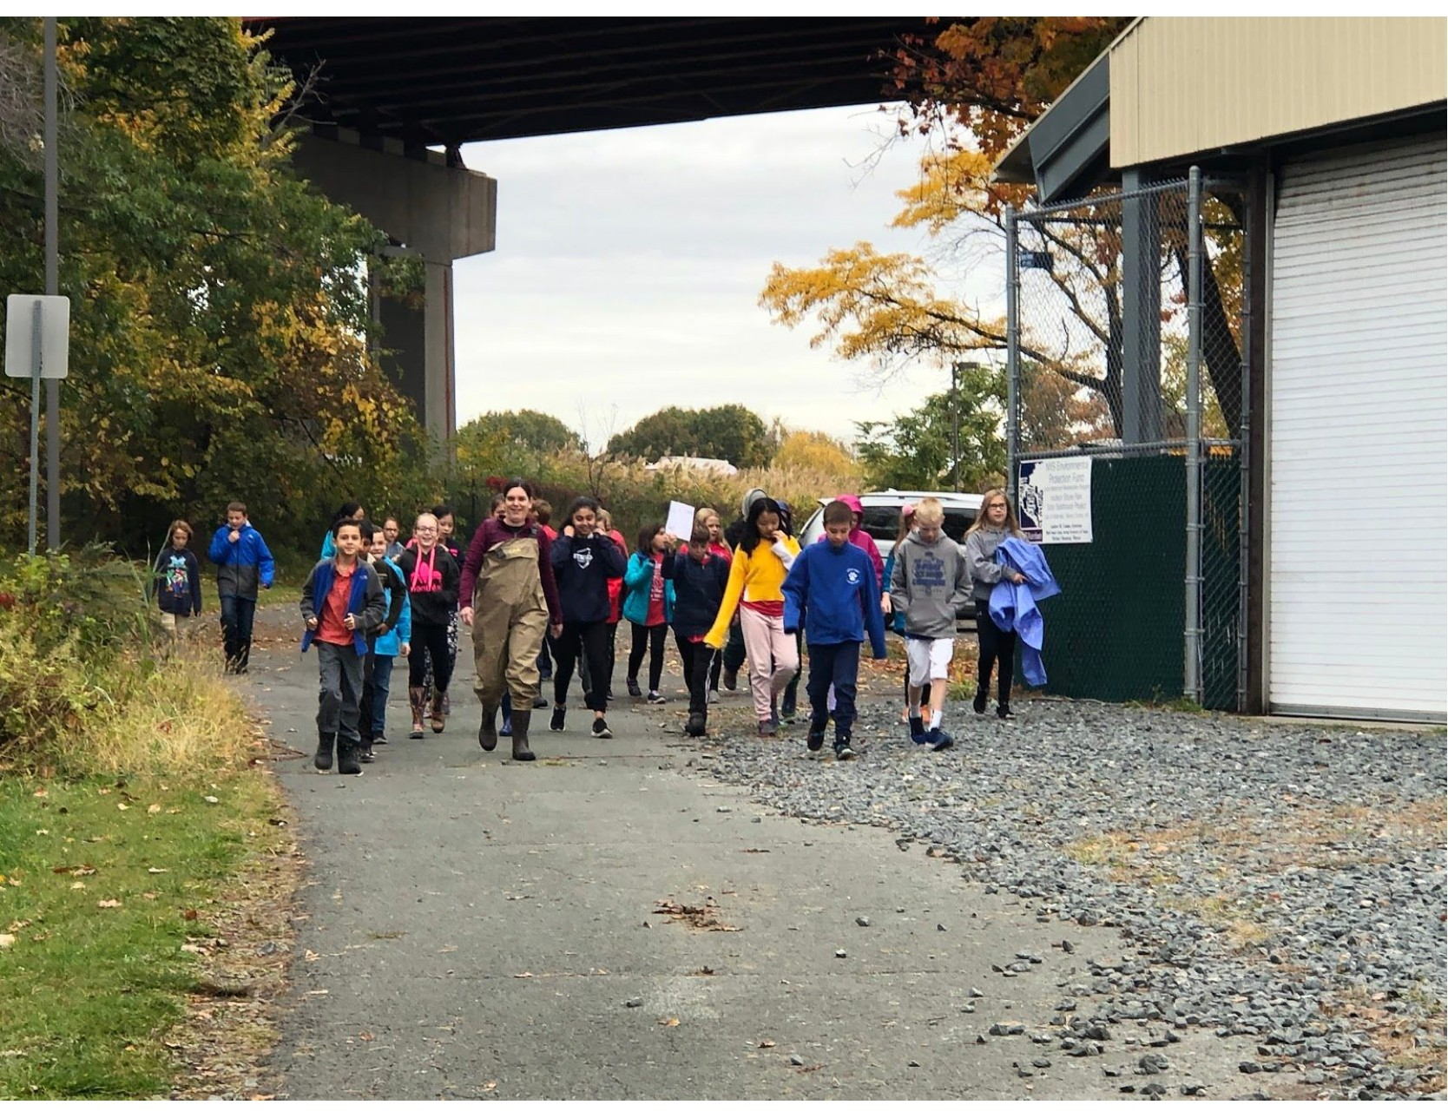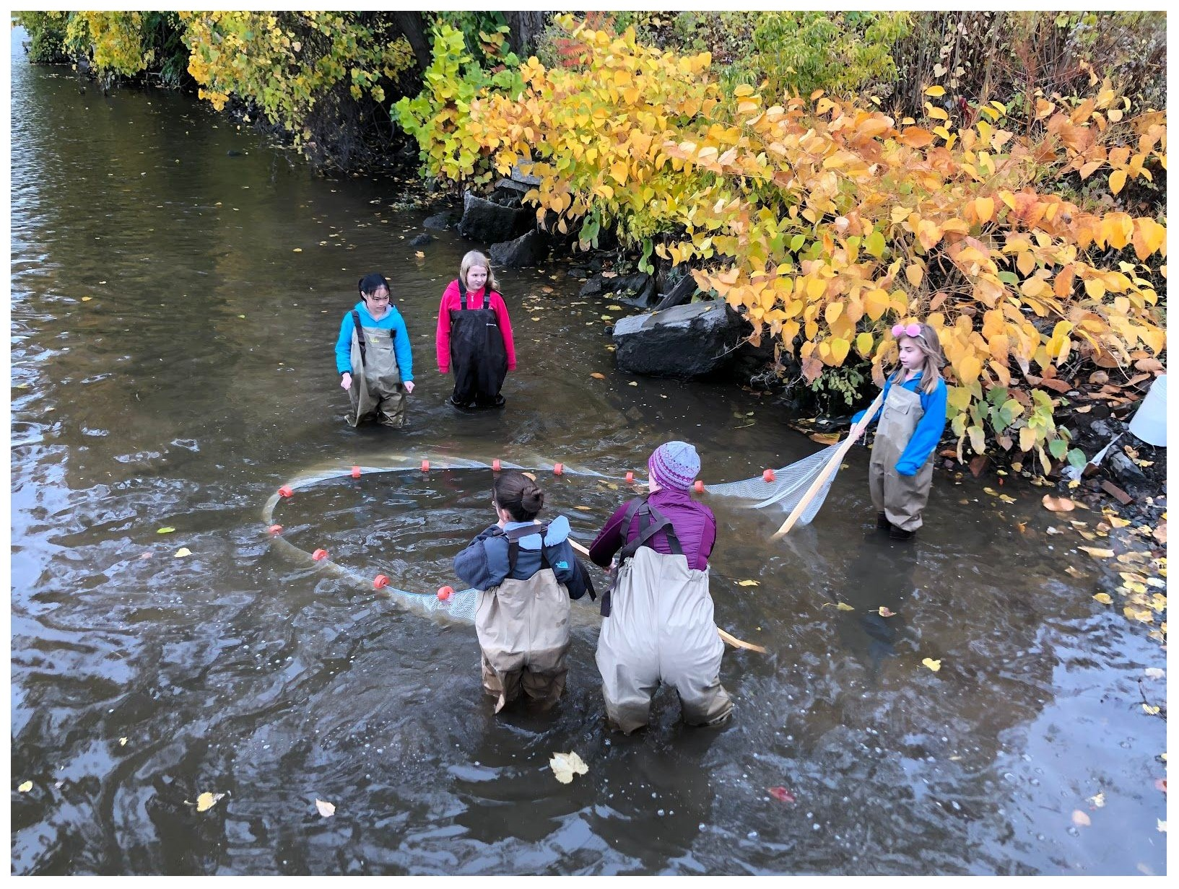

Location: Hudson Shores Park, Watervleit, Albany County, NY
Area: Rowing dock at park right on the river’s edge
Surrounding Land Use: Fishing launch, dock, parking lot, rocky, trees, bushes
Sampling Site: 10% Beach at low tide; 70% Park/Parking area; 20% Planted/forested; (across the river) 100% Industrial/Commercial. Noisy from the highway.
Shoreline: Rocky and muddy, vegetation, riprap
Water Depth: 8+ feet, calm
Plants in area: No plants in water area
River Bottom description: sand/mud, rocky
Other: Geese, turkey vultures

ITEM | Time | Reading |  | Comments
Physical
Air Temperature | TIME | DEGREES F | DEGREES C
 | 9:28 AM | 50 | 11
 | 9:48 AM | 51 | 12
 | 10:13 AM | 56 | 13
 | 11:00 AM | 57 | 14
 | 12:04 PM | 60 | 15
 | 12:36 PM | 60 | 15
 | 1:05 PM | 60 | 15
Wind Speed: Beaufort # | TIME | BEAUFORT # | WIND METER/ | UNIT KNOTS
 | 9:30 AM | 1 | 1.5
 | 9:51 AM | 1 | 2.5
 | 10:17 AM | 1 | 2.7
 | 10:51 AM | 2 | 3.4
 | 12:10 PM | 2 | 5.8
 | 12:27 PM | 2 | 8.1
 | 12:43 PM | 3 | 12.2
Weather today | Mostly cloudy all day (56-75%)
Weather recently | Rain 2 days ago – Lots of fog - windy
Water Temperature | See DO below
Turbidity - long sight tube | TIME | READING AVERAGE IN CMs
 | 9:23 AM  9:45 AM  10:14 AM  10:44 AM  11:54 AM  12:20 PM  12:44 PM | 32  32  35  32.3  32.3  34.3  33.7
Chemical
Salinity- Low Range Quantabs | 9:35 AM |  | Chloride  32 ppm Cl⁻ | Total Salinity  57.9 ppm
DO – drop count kit | Time | Temp | ppm DO | % saturation
 | 9:27 AM  9:43 AM  10:10 AM  10:39 AM  11:47 AM  12:16 PM  12:39 PM | 11 ºC  10 ºC  12 ºC  10 ºC  11 ºC  10 ºC  11 ºC | 12  12  13  12  11  9  12 | 105 %  106 %  121 %  106 %  100 %  80 %  109 %
pH – color match test kit | 9:33 AM  10:05 AM  10:29 AM  10:59 AM  12:07 AM  12:35 PM  12:58 PM | 7.5  7.5  7.5  7.5  7.5  7.3  7.5
Fish | Number | Name | Length of longest (cm) | Teams seining
Seine- 12 ‘ | 1  4 | Spottail Shiner  Pumpkinseed Sunfish | 5 cm  8 cm | 1 of 4 teams  1 of 3 teams
Fish Totals | TOTAL: 5 | Diversity: 2 | NYSDEC Fisheries Brought | Catfish  Sucker  Striped Bass
 | Digital Microscopes | Copepods  Mayfly  Fly Larvae | 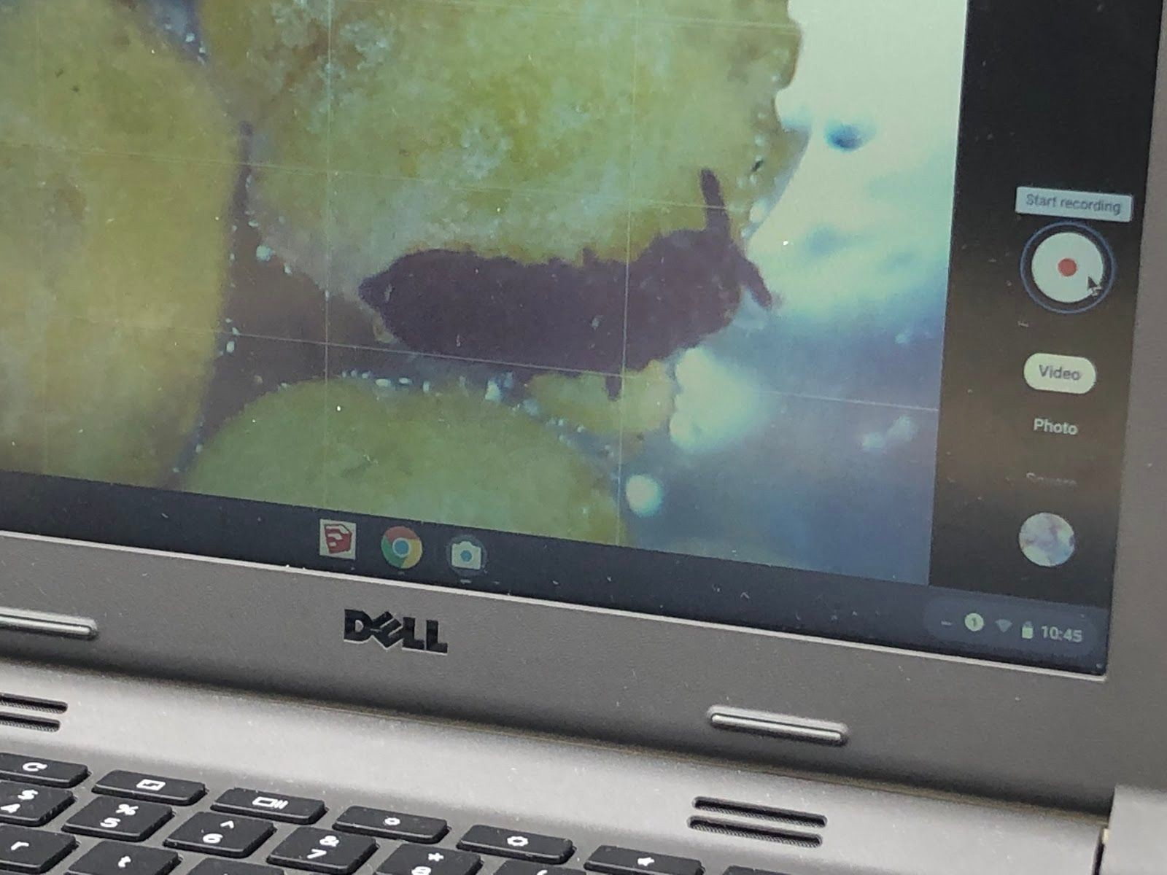
Tides- | Time | Rising, Falling, Unchanged | Change (cm) | Rate of Tidal Change
 | N/R
Current- | cm/10 second | Cm/Sec | North/South | Ebb/Flood/Still
9:15 AM  9:44 AM  10:00 AM  10:58 AM  12:05 AM  12:33 PM  1:00 PM | 353  379  326  328  255  263  278 | 35.3  37.9  32.6  32.8  25.5  26.3  27.8 | N/R | N/R
N

