Day in the Life of the Hudson River 10/21/19
HUDSON SHORE PARK WATERVLEIT
RIVER MILE: 152
Salt Front: ~ RM 53
Girl Scouts of North Eastern NY- Stacey Shepherd
10 students 4th-5th grade, 4 adults
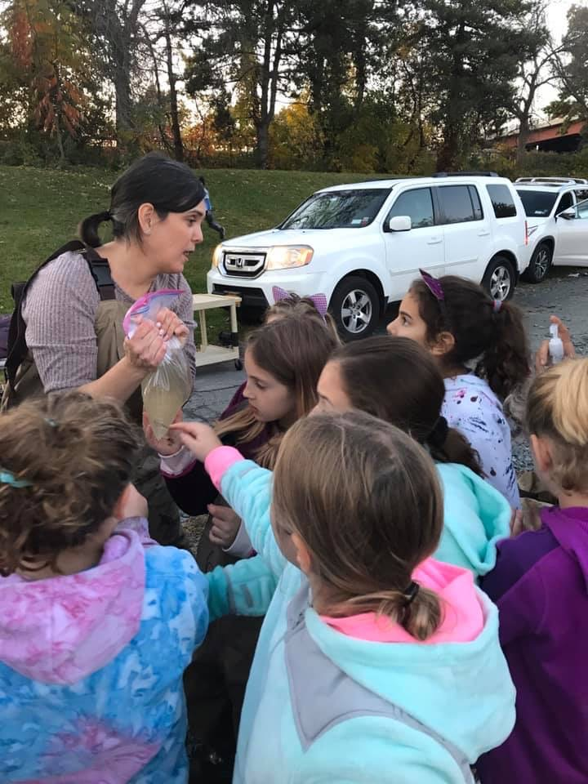
Latitude 42.73074 N& Longitude – 73.69759 W
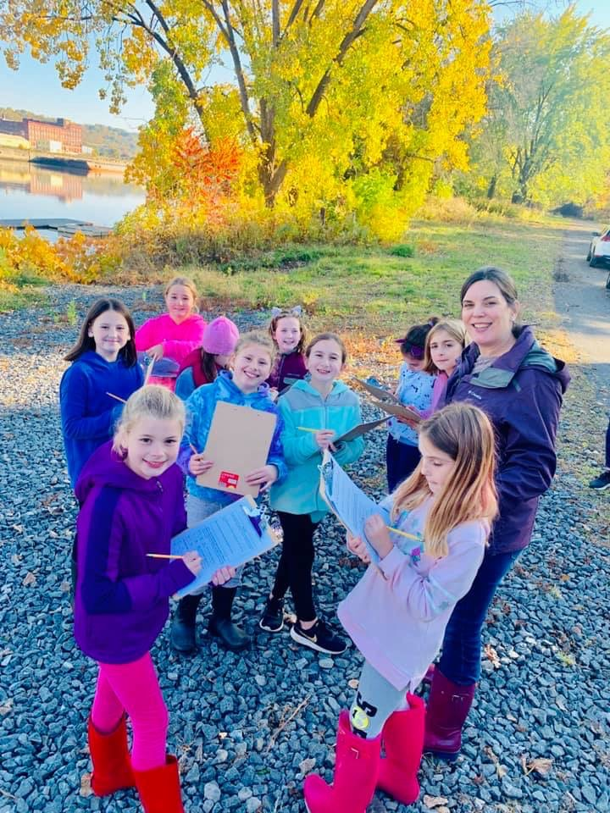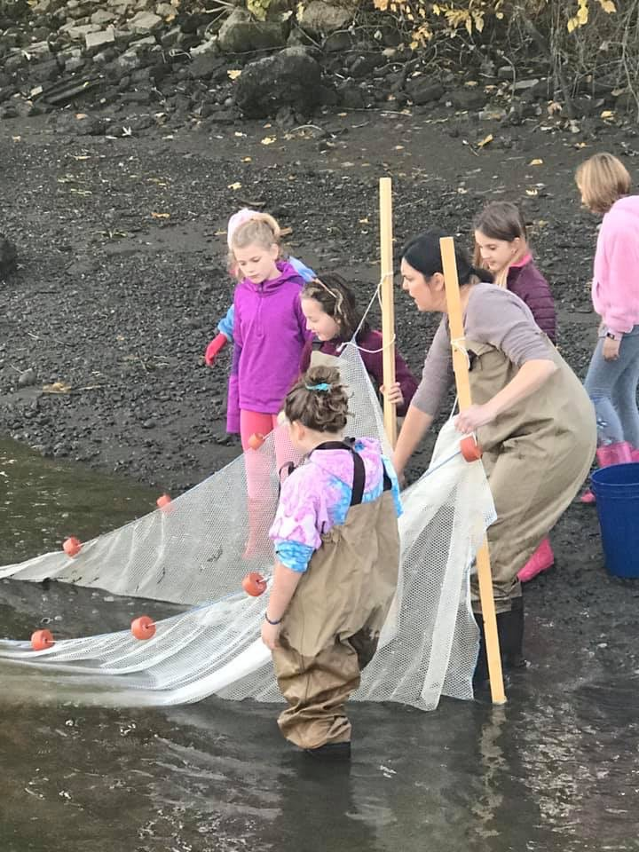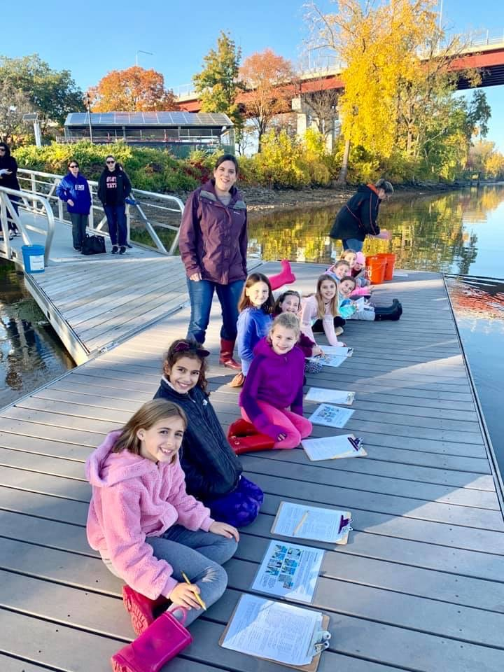
Location: Hudson Shores Park, Watervleit, Albany County, NY
Area: Rowing dock at park on the river’s edge
Surrounding Land Use: 10% Beach at low tide; 70% Park/Parking area; 20% Planted/Forested (across from the river); 100% Industrial/Commercial.
Sampling Site: Fishing launch, dock, parking lot, rocky, trees, bushes. Noisy from the highway
Shoreline: Rocky and muddy, vegetation, riprap
River Bottom: Sand, mud, rocky
Water depth: 8+ feet
Plants in area: No plants in water area

ITEM | Time | Reading |  | Comments
Physical
Air Temperature | 4:42 PM | 15 ºC | 57 ºF
Wind Speed: Anemometer | 4:47 PM | Beaufort 3 | 13.1 knots
Weather today | NR
Weather the past 3 days: | NR
Tides- | Time | Rising, Falling, Unchanged | Height (cm) | Rate of Tidal Change (cm/min)
NR
Current- | cm/second | Knots | North/South | Ebb/Flood/Still
4:20 PM | 32
Water Temperature | 5:28 PM | 9.5 ºC
Turbidity - long sight tube | 5:09 PM | 15 cm
Chemical
Salinity- | Time | Chloride ppm Cl⁻ | Total Sal. Ppm
DO – drop count kit | Time | Temp | ppm DO | % saturation
 | 5:28 PM | 9.5 ºC | 13 ppm | 115%
pH – color match test | 5:38 PM | 7.5
Fish | Number | Name | Length of longest
Seine | 2 | Banded Killifish | 6 cm
Fish Totals | TOTAL: 2 | Diversity: 1
Observations | The girls loved this experience. And were engaged the whole time. The best moment of our evening was when we caught 2 fish in the seine net. My co-leader who is not an outdoors girl, screamed, “I need hand sanitizer!” She ran for the car and returned with her purell!

