Day in the Life of the Hudson River 10/22/19 Data
SCHUYLERVILLE- LOCK 5, RIVER MILE: 200
Hudson Estuary Salt Front: ~RM 53
Trish Benton & Wendt DeLaCruz & Hudson Crossing Park
Schuylerville Elementary School-
60 students 2nd & 4th grade, 10 adults
Doug Reed, Hudson Basin River Watch
Latitude 43.11196 N & Longitude -73.57793 W
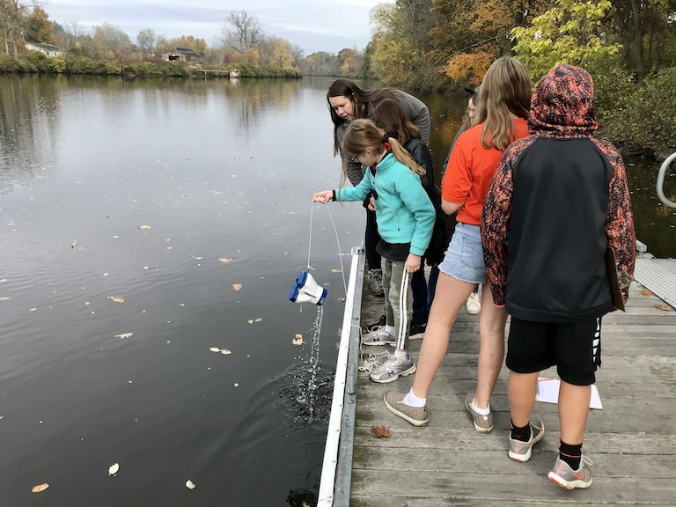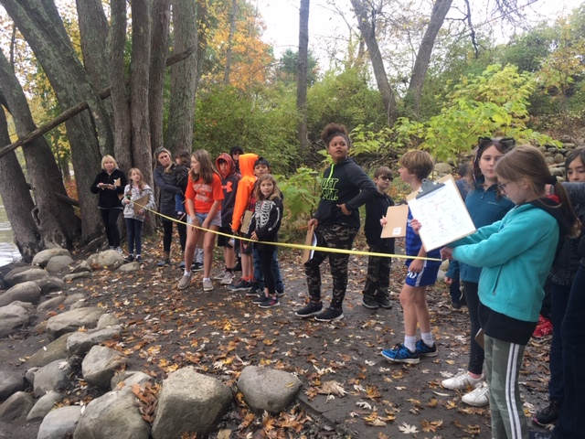
Location: Kayak launch, Hudson Crossing Park, Lock 5 in Schuylerville, Saratoga County, NY
Area: Old industrial site, now used for recreation- waterfalls, boating, fishing
Surrounding Land Use: 85% Forested; 1% Beach; Urban/Residential (several houses on site); Industrial/Commercial (dredging downriver, lots of barge activity)
Sampling Site: Small beach area, pier and lock, construction gravel in the area and covered in vegetation
Shoreline: Muddy and rocky
Plants in water: N/R
Water: 3-5 feet, calm
River Bottom: muddy, rocky
Sampling time: 1:00 PM
Upper Hudson Site above the head of tide
ITEM |  | Time | Reading |  | Comments
Physical
Air Temperature: |  | 1:00 PM | 52 º F | 12 º C
Wind Speed: |  | 1:00 PM | <1 mph
Weather Today: |  | No rain, overcast
Weather Previous: |  | NA
Current- *measured in a cove |  | cm/second | Rising, Falling, Unchanged | Height (cm) | Rate of Change (cm/min)
Water Temperature |  | 1:00 PM | 11 º C | 53º F
Turbidity - secchi disk |  | 1:00 PM | 3 feet, 11 inches | 119 cms
Chemical
Salinity- quantabs - LR |  | 1:00 PM | 32 ppm chloride | 58 ppm Total Salinity
DO – Not Recorded |  | Time | Temp | ppm DO | % saturation
 |  | NR
pH – strip |  | 1:00 PM | 6.8
Flow – above head of tide |  | Cm/second
 |  | 30.48 cm/sec
Sediment Core |  | Time | Description | Common | Abundant
Core collected and sent with Doug Reed
Boats | Time | Name | Color | North or South | Loaded or Light
 | 1:16 PM  1:16 PM | Passenger  Passenger |  | Southbound  Northbound | People  People

