Day in the Life of the Hudson River 10/22/19 Data
PIERMONT PIER
Piermont, NY
RIVER MILE: 25.4
Salt Front: ~ RM 53
Jen Mazza, Clarkstown South High School- 8
Jessica Flanagan, Clarkstown North High School- 7
Shawn Kapusinsky, Spring Valley High School- 12
Brian Newburger, Pat Kilkelly, Tappan Zee High School- 10
Tom Mullane, Cathleen Bonanno, Eileen McCaffrey, Pearl River High School – 33
Margie Turrin, Laurel Zaima and 11 Lamont Scientists, Lamont Doherty Earth Observatory
Brent Turrin, Rutgers University
Latitude N 41º 02’592 Longitude W 73º 53’789

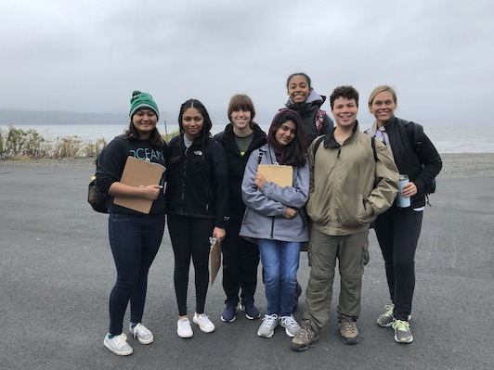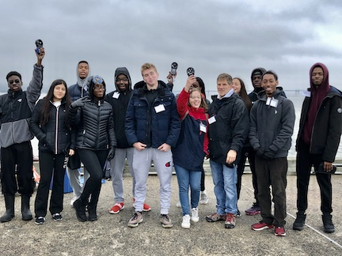
Clarkstown South High School
Spring Valley High School

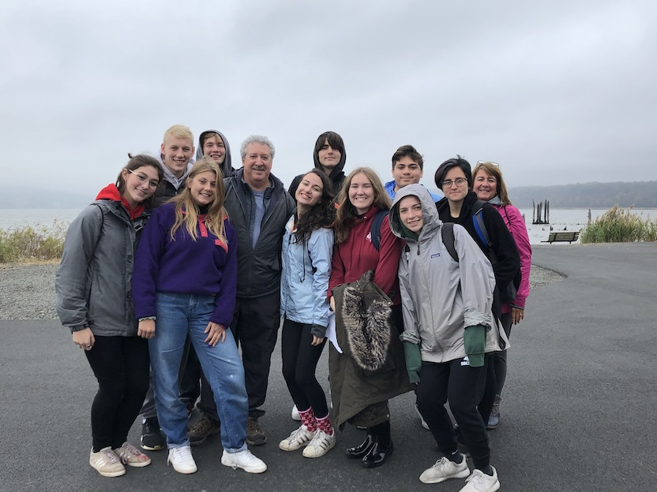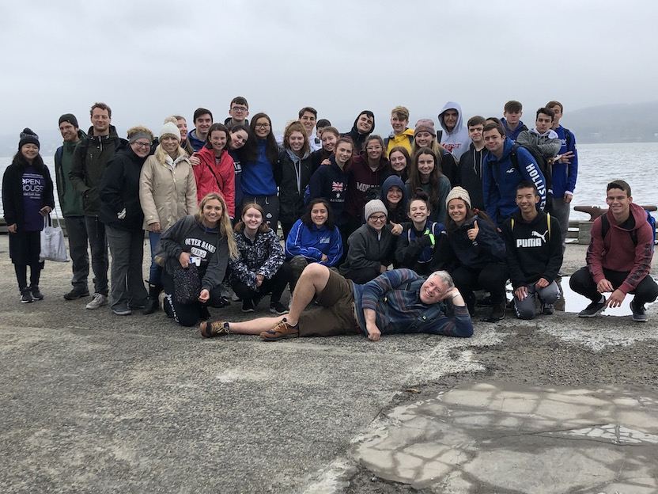
Tappan Zee High School
Pearl River High School

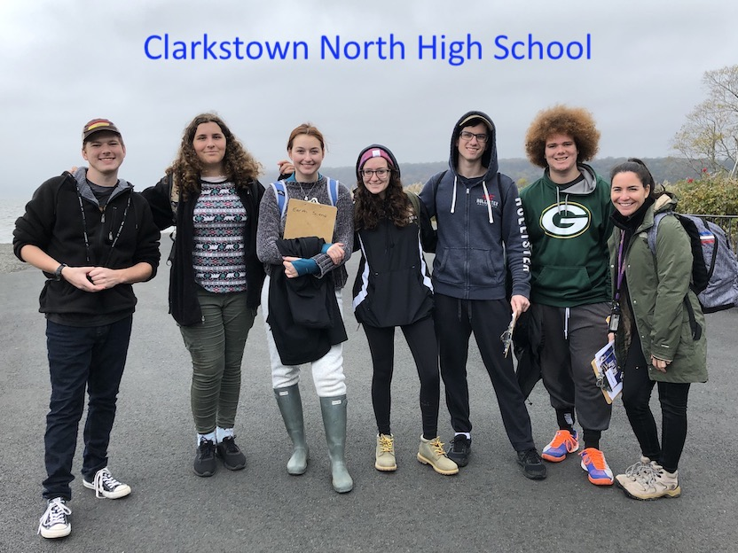
Location: Piermont Pier, Piermont NY
Area: Man made fishing/shipping pier at the east end, long pier with paved roadway and vegetated strip along both sides.
Surrounding Land Use: 80% Urban/Residential, 20% Forested
Sampling Site: Pier, roadway in center of whole pier, parking area at the end, plants and trees along side. Shoreline riprap, collected wood in area and piping entering river on the south of sampling site.
Water Depth: Varied by location on the pier and by the tide
Plants in area: 15% sumac and other plants; 85% phragmites; No submerged aquatic plants in the water
River Bottom description: sandy, rocky bottom with phragmites growing in our near the water

ITEM | Time | Reading |  | Comments
Physical
Air Temperature  Group A  Group B | 8:56 AM  9:53 AM  10:39 AM  12:15 PM  1:01 PM  8:56 AM  9:41 AM  10:42 AM  12:15 PM  Not recorded | 15.8 º C  15.3 º C  14.1 º C  14.1 º C  15 º C  15.6 º C  14.2 º C  14 º C  14.1 º C  Not recorded | 60.4 º F  59.5 º F  57.4 º F  57.4 º F  59 º F  60.1 º F  57.6 º F  57.2 º F  57.4 º F  Not recorded
Wind Speed:  Group A  Group B | 8:56 AM  9:53 AM  10:39 AM  12:15 PM  1:01 PM  8:56 AM  9:41 AM  10:42 AM  12:15 PM  Not recorded | Anemometer  3.4 knots  3.1 knots  6 knots  3.8 knots  10 knots  5 knots  3.5 knots  2.7 knots  6.4 knots  6.5 knots | Beaufort  2  2  2  2  2  2  2  2  2  2
Weather today | Fog, drizzling, misty, wavy, full cloud cover (100%)
Weather recently
Tides-  LT: 11:22 am | Time | Rising, Falling, Unchanged | Height (cm) | Rate of Tidal Change (cm/min)
Group A | 8:56 AM  9:53 AM  10:39 AM  12:15 PM  1:01 PM | Set Group  Not recorded  Not recorded  Flood  Flood | 348  320  319  334  375 | -  -0.49  -0.02  0.42  0.89

Group B | 8:56 AM  9:41 AM  10:42 AM  12:15 PM  Not recorded | Set Group  Not recorded  Not recorded  Not recorded  Not recorded |  | 385  360  355  363  378 | -  -0.56  -0.08  0.09  -
Currents | Time | Cm/second |  | North/South | Flood/Ebb/Still
Group A | 8:56 AM  9:53 AM  10:39 AM  12:15 PM  1:01 PM | 6.8  13.9  4.1  22.9  26.36 |  | South  South  South  North  North | Ebb  Ebb  Ebb  Flood  Flood
Group B | 8:56 AM  9:41 AM  10:42 AM  12:15 PM  Not recorded | 8.9  9.7  5  30.4  31.5 |  | South  South  South  -  North | Ebb  Ebb  Ebb  -  Flood
Water Temperature  Group A  Group B | 9:00 AM  9:45 AM  10:30 AM  12:12 PM  12:50 PM  9:00 AM  9:50 AM  10:33 AM  12:06 PM  1:01 PM | 16 º C  15 º C  15 º C  15 º C  15 º C  16 º C  15 º C  15 º C  15 º C  15 º C |  | 60.8 º F  59 º F  59 º F  59 º F  59 º F  60.8 º F  59 º F  59 º F  59 º F  59 º F
Turbidity-  Secchi disk (cm)  Group A-  Group B-  Long sight tube (cm)  Group A-  Group B- | Time:  9:05 AM  9:45 AM  10:26 AM  12:09 PM  12:42 PM  -  10:00 AM  10:45 AM  12:36 PM  1:13 PM  9:05 AM  9:45 AM  10:26 AM  12:09 PM  12:42 PM  -  10:00 AM  10:45 AM  12:36 PM  1:13 PM | Readings:  85, 52, 142  102, 96, 101  92, 70, 81  77, 87, 82  68, 66, 84  -  82, 73, 80  84, 89, 91  69, 68, 66  40, 64, 84  51.2, 54.6, 50.5  63.2, 64.5, 64.7  63.5, 67, 63.5  65.5, 51, 43.2  54, 52.4, 42.4  -  55, 56.9, 54.1  59, 58.5, 62.7  56.8, 58, 57.4  55, 39.5, 36.5 |  | Average (cm):  93  99.6  81  82  73  -  78.3  88  68  63  50.4  62.5  63  58.13  47.9  -  53.6  58.4  55.73  42
CHEMICAL
Salinity-  Group A:  Group B: | Time  9:00 AM  9:45 AM  10:30 AM  12:12 PM  12:50 PM  9:00 AM  9:50 AM  10:33 AM  12:06 PM  1:01 PM | Refractometer Total Salinity (ppt)  5  5  4  -  5  4  5  5  5  5 |  | Hydrometer Total Salinity (ppm)  5  4  4  6  *0  4  7  *12  6  5 | *anomalous; low  *anomalous; high
DO – Titration Kit | Time | Temp |  | ppm DO | % saturation
Group A:  Group B: | 9:00 AM  9:45 AM  10:30 AM  12:12 PM  12:50 PM  9:00 AM  9:50 AM  10:33 AM  12:06 PM  1:01 PM | 16 º C  15 º C  15 º C  15 º C  15 º C  16 º C  15 º C  15 º C  15 º C  15 º C |  | 5  11  -  12 *high  9  9, 10  10, 10  10  7, 10  9 | 50  109  -  120  89  90, 100  99, 99  99  70, 99  90
Group A:  Group B: | Time  9:00 AM  9:50 AM  10:33 AM  12:06 PM  1:01 PM  9:00 AM  9:45 AM  10:30 AM  12:12 PM  12:50 PM | pH- color match kit  8  7.5  8  7.75  7.75  7  7  7.5  7  7.5 |  | Alkalinity (ppm)  20  60  162  158  -  100  94  100  100  - | *anomalous; low
Group A:  Group B: | Time  9:00 AM  9:50 AM  10:33 AM  12:06 PM  1:01 PM  9:00 AM  9:45 AM  10:30 AM  12:12 PM  12:50 PM | Nitrates (ppm)  <0.88  1.32  <0.88  -  <0.88  0  0  .0044  <0.88  - |  | Phosphates (ppm)  0.16  0.18  0.19  0.22  0.34  0.5  0.16  0.1  0.22  0.3
Fish- Seine | Number | Name |  | Length of longest (cm)
Atlantic Silverside Group  Brook Silverside Group  White Catfish Group  Chanel Catfish Group  Mummichog Group  Striped Killifish Group  Menhaden Group  Blueback Herring Group  Yellow Perch Group  White Perch Group | 7  1  19  1  62  2  60  1  1  5  2  16  1  1  8  3  41 | Atlantic Silverside  Striped Bass  Atlantic Silverside  Atlantic Silverside  Atlantic Silverside  Striped Bass  Atlantic Silverside  Mummichog  Striped Bass  Atlantic Silverside  Atlantic Silverside  Atlantic Silverside American Eel  Striped Bass  Atlantic Silverside  Striped Bass  Atlantic Silverside |  | 11  9  10.1  9 cm  10.5  9.5  10.0  9.0  7.0  9.2  9.5  11.5  14  9  10.5  11  11 | Total Striped Bass - 8  Total Eel – 1  Total Mummichog – 1  Total Atlantic Silverside -221
Fish Totals | TOTAL: 231 | Diversity: 4
Macroinvertebrates | Number | Name |  | Length of longest (cm)
-Atlantic Silverside Grp  -Brook Silverside Group  White Catfish Group  Chanel Catfish Group  Mummichog Group  -Striped Killifish Group  -Menhaden Group  -Blueback Herring Group  -Yellow Perch Group  -White Perch Group | 0  4  6  1  4  2  0  3  4  1  2  0 | Blue Crab  Sand Shrimp  Blue Crab  Blue Crab  Blue Crab  Comb Jelly  Blue Crab  Comb Jelly  Blue Crab |  | 9.1  5  2.9  6.5  3.0  3 | Total Blue Crab = 17  Total Sand Shrimp – 1  Total Comb Jelly = 4
Macroinvertebrate Totals | TOAL: 27 | Diversity: 3
Sediment Cores | Time | Length (cm) | Oxid Top | Grain Size | Other Items
White Perch Group  Northside | 9:15 AM | 15.5 | Yes | Abundant: Clay, Mud, Gravel, Pebbles  Common: Sand | Oil  Rare: Brick, Coal, Slag
Yellow Perch Group  Southside | 9:15 AM | 6.5 | No | Abundant: Clay, Mud  Common: Sand, Pebbles | H₂S smell  Rare: Brick, Slag, Living Veg
Atlantic Silverside Group  Southside | 10:00 AM | 10 | No | Abundant: Clay, Mud, Pebbles  Common: Sand, Gravel | Common: slag  Rare: Leaves, wood, oyster shells Brick  *Fruity smell?
Brook Silverside Group  Northside | 10:00 AM | 14 | Yes | Abundant: Pebbles  Common: Gravel  Rare: Clay, Mud, Sand | H₂S smell  Common: Brick  Rare: leaves, woods, oyster shells,macroinvert, coal slag
Chanel Catfish Group  Northside | 10:33 AM | 13 | Yes | Abundant: Clay  Common: Mud, Sand  Rare: Pebbles | H₂S smell  Common: Brick, Living vegetation  Rare: Wood
White Catfish Group | 10:40 AM | 10 | No | Abundant: Mud, Sand  Rare: Pebbles | Rare: Brick, Slag, living vegetation
Mummichogs Group  Northside | 12:11 PM | 12 | Yes | Abundant: sand, pebbles  Common: mud, gravel  Rare: clay | Common: Brick  Rare: Coal
Striped Killifish Group  Northside | 12:13 PM | 25.5 | No | Abundant: clay, mud  Common: sand  Rare: gravel, pebbles | H₂S smell  Abundant: leaves  Common: brick  Rare: shells oysters, macroinvertebrates
Menhaden Group  Northside | 1:00 PM | 10.5 | Yes | Common: Sand, gravel, pebbles  Rare: clay, mud | H₂S smell  Rare: Brick, slag
Blueback Herring Group  Northside | 1:00 PM | 9 | No | Common: Sand, Gravel, Pebbles  Rare: Clay, Mud | H₂S smell  Rare: Brick, coal, slag

