Day in the Life of the Hudson River 10/22/19
UPPER NYACK STATE PARK, LOWER BEACH
RIVER MILE: 30.4
Salt Front: ~ RM 53
Blue Rock School- Charlotte Jack
45 students 4-8th grade, 8 adults
Strawtown Studios- Laurie Seeman and Joanna Dickey
Latitude 41.119759 N & Longitude – 73.91243 W

Location: Nyack lower Beach, Upper Nyack, Rockland County, NY
Area: Park/Boat launch near Hook Mountain; sandy beach by the large sitting stairs
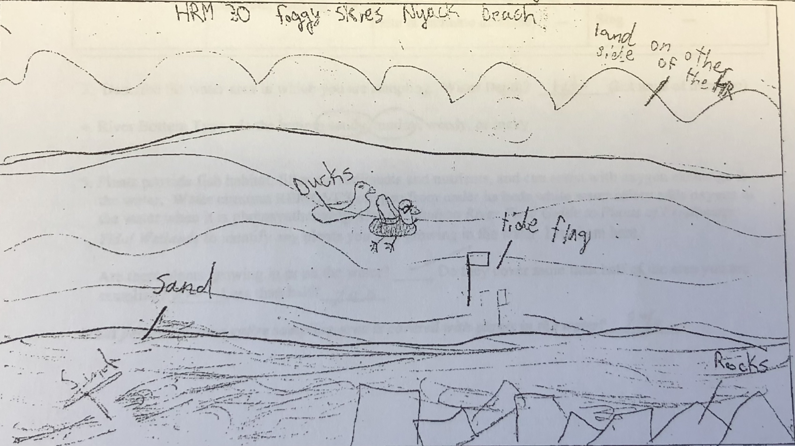
Surrounding Land Use: 40% Forested; 10% Industrial/Commercial; 40% Beach- used for recreation and picnics
Sampling Site: Beach, covered with vegetation beyond the beach, stonewall, riprap shore, pipe coming into the river south of the sampling site
Shoreline: Sandy and rocky, muddy offshore
River Bottom: sandy inshore (<3 ft depth), muddy off shore (>3 ft depth), scattered large rock (<2ft length inshore)
Plants in water: Water chestnuts and water celery
Water: calm, 1 ft depth

ITEM | Time | Reading |  | Comments
Physical
Air Temperature | 10:50 AM  1:30 PM | 55 º F  59 º F
Wind Speed: |  | Beaufort 3 | 8-12 mph | East
Weather today | Overcast (100%), no rain
Weather the past 3 days
Tides- | Time | Rising, Falling, Unchanged | Height (cm) | Rate of Tidal Change (cm/min)
 | 10:30 AM  11:00 AM  11:30 AM  12:00 PM  1:20 PM | NA  Rising  Rising  Rising  Falling | 0  23  40  100  80 | NA  0.767  0.567  2  0.25
Current- | Time | Speed | North/South | Ebb/Flood/Still
 | 10:45 AM | 4.13 cm/sec, 0.08 knots | North | Flood
Water Temperature | 10:30 AM  11:00 AM  11:30 AM  1:00 PM | 60 ºF  60 ºF  60 ºF | 16 ºC
Turbidity- short sight tube | 10:30 AM | 40, 40, 30, 40 JTUs
Chemical
Salinity- Quantabs | Time | Chloride ppm | Total Sal. ppm
 | 10:45 AM | 1505 ppm | 2719 ppm
DO – | Time | Temp | ppm DO | % saturation
 | 11:30 AM | 16 º C | 7.5 | 74%
pH – | 10:30 AM | 8.5, 8.5, 8.5
Biological
Fish | Number | Name | Length of longest
Seine | 15  1  1  0 | Atlantic Silverside  White Perch  American Eel  0 | 2.5 cm  3 cm  12.5 cm  0 | 1 Seine 10:30 AM  2 Seine 11:00 AM  3 Seine 11:50 AM  4 Seine 1:15 PM
Fish Totals | TOTAL: 17 | Diversity: 3
Macroinvertebrates | Number | Name | Length of longest
 |  | NR
Macroinvertebrate Totals | TOTAL: 8 | Diversity: 3
Sediment Core | Time | Oxid Top | Grain Size | Other Features
 | NR
Boats | Time | Name/Color | North/South | Loaded/Light
Recreational | 11:30 AM | 2 Rowing | South | NA
Observations

