Day in the Life of the Hudson River 10/22/19
HAVERSTRAW BAY COUNTY PARK
RIVER MILE: 38
Salt Front: ~RM 53
North Rockland High School- Jeanne Maguire 2 teachers, plus 2 Rockland County volunteers
68 students 10th-12th grade
Latitude 41.212559 N & Longitude – 73.963759 W
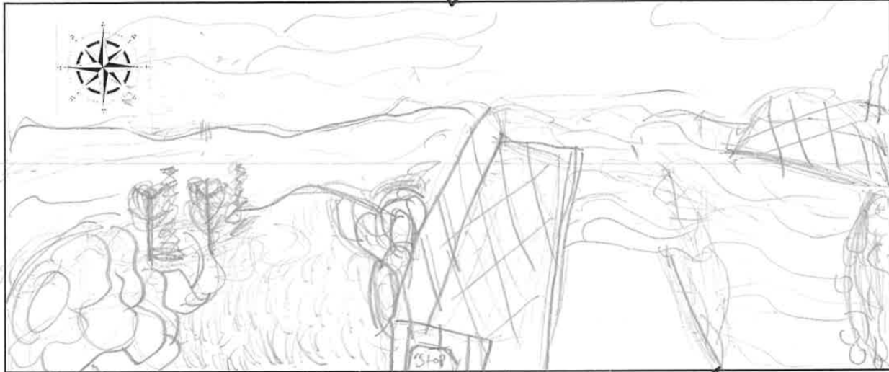
Location: Haverstraw Bay County Park, Village of Haverstraw, Rockland County, New York
Area: North Beach, dock/pier, grassy, forested, parking lot
Surrounding Land Use: 70% Forested; 20% Parkland; 10% Industrial/Commercial; 20% Urban/Residential
Sampling Site: small beach, banks altered, large riprap, concrete bulkhead, covered in vegetation.
Shoreline: 10% sandy; 90% rocky
River Bottom: muddy, sandy, rocky
Plants in area: Waterchestnuts; Nearby: bur-reed, wild rice, water celery
Water: 5-18 inches, choppy

ITEM | Time | Reading |  | Comments
Physical
Air Temperature | 9:25 AM  9:59 AM  10:30 AM  10:56 AM  11:27 AM | 13 º C  13 º C  13 º C  13 º C  13 º C | 54 º F  54 º F  54 º F  54 º F  54 º F
Wind Speed: | 9:25 AM  11:27 AM | 1.9 knots  2.7 knots | Northeast  Northeast
Weather today | Overcast (100%); 11:30 AM misting
Weather the past 3 days: | Rained on Sunday
Tides- | Time | Rising, Falling, Unchanged | Height (cm) | Rate of Tidal Change (cm/min)
Low Tide 12:10 PM per charts | 9:25 AM  9:37 AM  10:19 AM  10:36 AM  11:15 AM | NA  Falling  Falling  Rising –a wave?  Falling | 42  29  24  35  29 | NA  .32  .19  .14  .26
Current- | cm/second | Knots | North/South | Ebb/Flood/Still
9:31 AM  9:57 AM  10:22 AM  10:45 AM  11:20 AM | .003  6  3  1  1 |  | South  South  South  South  South | Ebb  Ebb  Ebb  Ebb  Ebb
Water Temperature | 9:31 AM  10:05 AM  10:30 AM  11:00 AM | 15 º C  20 º C  20 º C  12 º C* | 59 º F  68 º F  68 º F  53 º F | *seems low
Turbidity - long sight tube | 9:21 AM  9:49 AM  11:16 AM | 120 cm  46, 40 cm - Average 43 cm  15 cm, 18 cm, 13 cm – Average 15.33 cm |  | Brown, murky, cloudy water
Chemical
Salinity- Quantabs | Time  9:19 AM  10:32 AM | Quantab units  4.8 quantab units  4.6 quantab units | Chloride ppm Cl⁻  1872 ppm Cl-  1038 ppm Cl- | Total salinity ppm  3382 ppm TS  1875 ppm TS
DO – | Time | Temp | ppm DO | % saturation
 | 9:22 AM  9:47 AM  10:39 AM  10:57 AM  11:45 AM | 15 º C  20 º C  20 º C  12 º C | 9  9  9  8  9 | 85  85  80  60  90
pH – color match kit | 9:14 AM  9:48 AM  10:20 AM  10:44 AM  11:18 AM  11:40 AM | 7.4  7.4  7.4  7.4  7  7.4
Fish | Number | Name | Length of longest
Seine- 24’ | 2  21  2 | Striped Bass  Atlantic Silversides  Large Mouth bass | 9 cm  9.2 cm  7 cm | 9:30-12pm  *Seems unlikely
Fish Totals | TOTAL: 25 | Diversity: 3
Macroinvertebrates | Number | Name | Length of longest
 | 2 | Blue Crab | Female
Macroinvertebrate Totals | TOAL: 2 | Diversity: 1
Sediment Core | Time | Oxid Top | Grain Size | Other Items
Length: 7 cm | 9:00 AM | Yes | Abundant: mud, pebbles  Rare: gravel | Common: Brick
Boats  Commercial  Commercial  Recreational | Time  NA  9:30 AM  NA | Name/Color  Barge- Brown  Tug  Speed boat- white | North/South  South  North  South | Loaded/Unloaded  Light  NA  NA
Observations | Bald eagle, 3 seagulls, osprey, 2 cormorant, 2 Canadian geese, squirrels, deer, stink bugs

