Day in the Life of the Hudson River 10/22/19
STEAMBOAT DOCK, VERPLANCK
RIVER MILE: 41
Salt Front: ~ RM 53
Mahopac High School- Scott Rizzo and Trisha Johnson
18 students 9-12th grade, 2 adults
Latitude 41.24936 N & Longitude – 73.936474 W
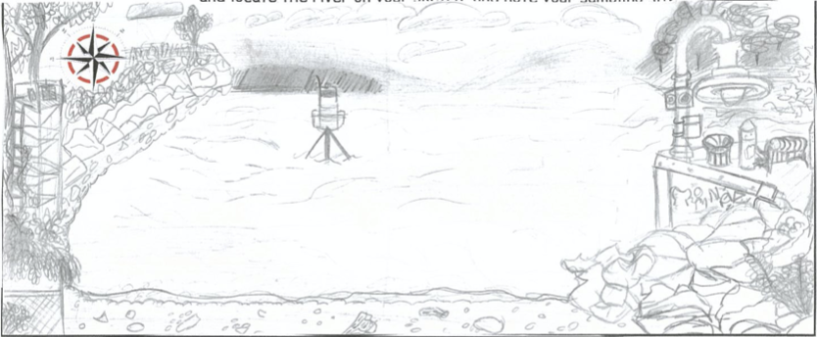
Location: Steamboat Dock Park Beach, City of Verplanck, Westchester County , NY
Area: Located in a small cove between a point and a bulkhead- pier, beach, grassy, parking lot, banks altered, riprap, pipe entering the water
Surrounding Land Use: 70% Beach; 25% Urban; 5% Forest
Sampling Site: Beach and parking lot
Shoreline: 33% Sandy, 33% Muddy, 33% Rocky
River Bottom: Muddy
Plants in water: no plants in water area
Water: 2 ft, calm
ITEM | Time | Reading |  | Comments
Physical
Air Temperature | 10:20 AM  11:11 AM | 55 º F  53 º F
Wind Speed: | 10:21 AM | Beaufort 1
Weather today | Mostly cloudy (75%) no rain
Weather past 3 days: | No rain
Tides- | Time | Rising, Falling, Unchanged | Water Height (cm) | Rate of Tidal Change (cm/min)
Lt 12:32 PM | 10:03 AM  10:19 AM  10:34 AM  10:49 AM  11:04 AM  11:19 AM  11:36 AM | Falling  Falling  Falling  Falling  Falling  Falling  Falling | 68  63.5  60.4  55.7  35 *anomalous  50  52.5
Current- orange toss | Time | cm/second | North/South | Ebb/Flood/Still
 | 10:27 AM  11:10 AM  11:43 AM | 1.967  1.933  2.167 | South  South  South | Ebb  Ebb  Ebb
Water Temperature- | 9:54 AM  10:57 AM  11:36 AM | 17.4 º C, 17.3 º C, 17.35ºC –Avg17.35 ºC  14.6 º C*  17.4 º C | 63.32 º F, 63.14 º F, 63.23ºF-Avg 63.23ºF  58.28 º F*  63.32 º F | *anomalous
Turbidity- long sight tube | 10:06 AM,  11:03 AM | 27.4cm, 25.5cm, 20.5cm, Avg: 24.46cm |  | Cloudy tan, silty
Chemical
Salinity- Meter | 9:54 AM  11:36 AM | 2403 ppm  1900 ppm
DO – Meter Probe | Time | Temp | ppm DO | % saturation
 | 9:54 AM  11:07 AM  11:54 AM | 17.4 º C  14.6 º C  17.1 º C | 7  11  12 | 70%  107%  121%
pH – Color Match Kit | 10:11 AM  11:13 AM  11:36 AM | 8  7.5  8
Alkalinity- kit | NR | 80, 80 ppm
Nitrate- kit | NR | 0.4, 0 ppm
Phosphate- kit | NR | 0.41, 0.58, 0.35 ppm
Biological
Fish | Number | Name | Length of longest | TOTALS
Seine- 25’ 10:12 AM  10:37 AM  1:10 PM  1:40 PM | 13  2  35  5  2  1  3 | Atlantic Silverside  Striped Bass  Atlantic Silverside  Striped Bass  Striped Bass  Atlantic Silverside  Atlantic Silverside | 5 cm  7 cm  6 cm  8 cm  8 cm  5 cm  4 cm | Atlantic Silverside: 49  Striped Bass: 9
Fish Totals | TOTAL: 58 | Diversity: 2
Macroinvertebrates | Number | Name | Length of longest | Totals
10:37 AM  11:10 AM  11:35 AM | 22  55  1 | Comb Jelly  Comb Jelly  Blue Crab (F) |  | 77 Comb Jelly  1 Blue Crab
Macroinvertebrate Totals | TOTAL: 78 | Diversity: 2
Sediment Core | Time | Oxid Top | Grain Size | Other Features
NR
Boats | Time | Name/Color | North/South | Loaded/Light
Commercial  Commercial  Commercial  Commercial | 9:56 AM  10:05 AM  10:48 AM  11:26 AM | Sea Toe, Yellow/white  Mercury 350, White  Barges RT106, red/black  Barge, black | South  North  North  South | Light  Loaded  Loaded  Loaded
Observations | Red Brick, mallard ducks, seagulls, Canadian geese, Coopers Hawk. Runoff could have impacted the data today
