Day in the Life of the Hudson River 10/22/19
RIVERFRONT GREEN, PEEKSKILL
RIVER MILE: 43.5
Salt Front: ~ RM 53
Walter Panas High School- Michael Billy
27 students 11-12th grade
Latitude 41.28561 N & Longitude – 73.93176 W
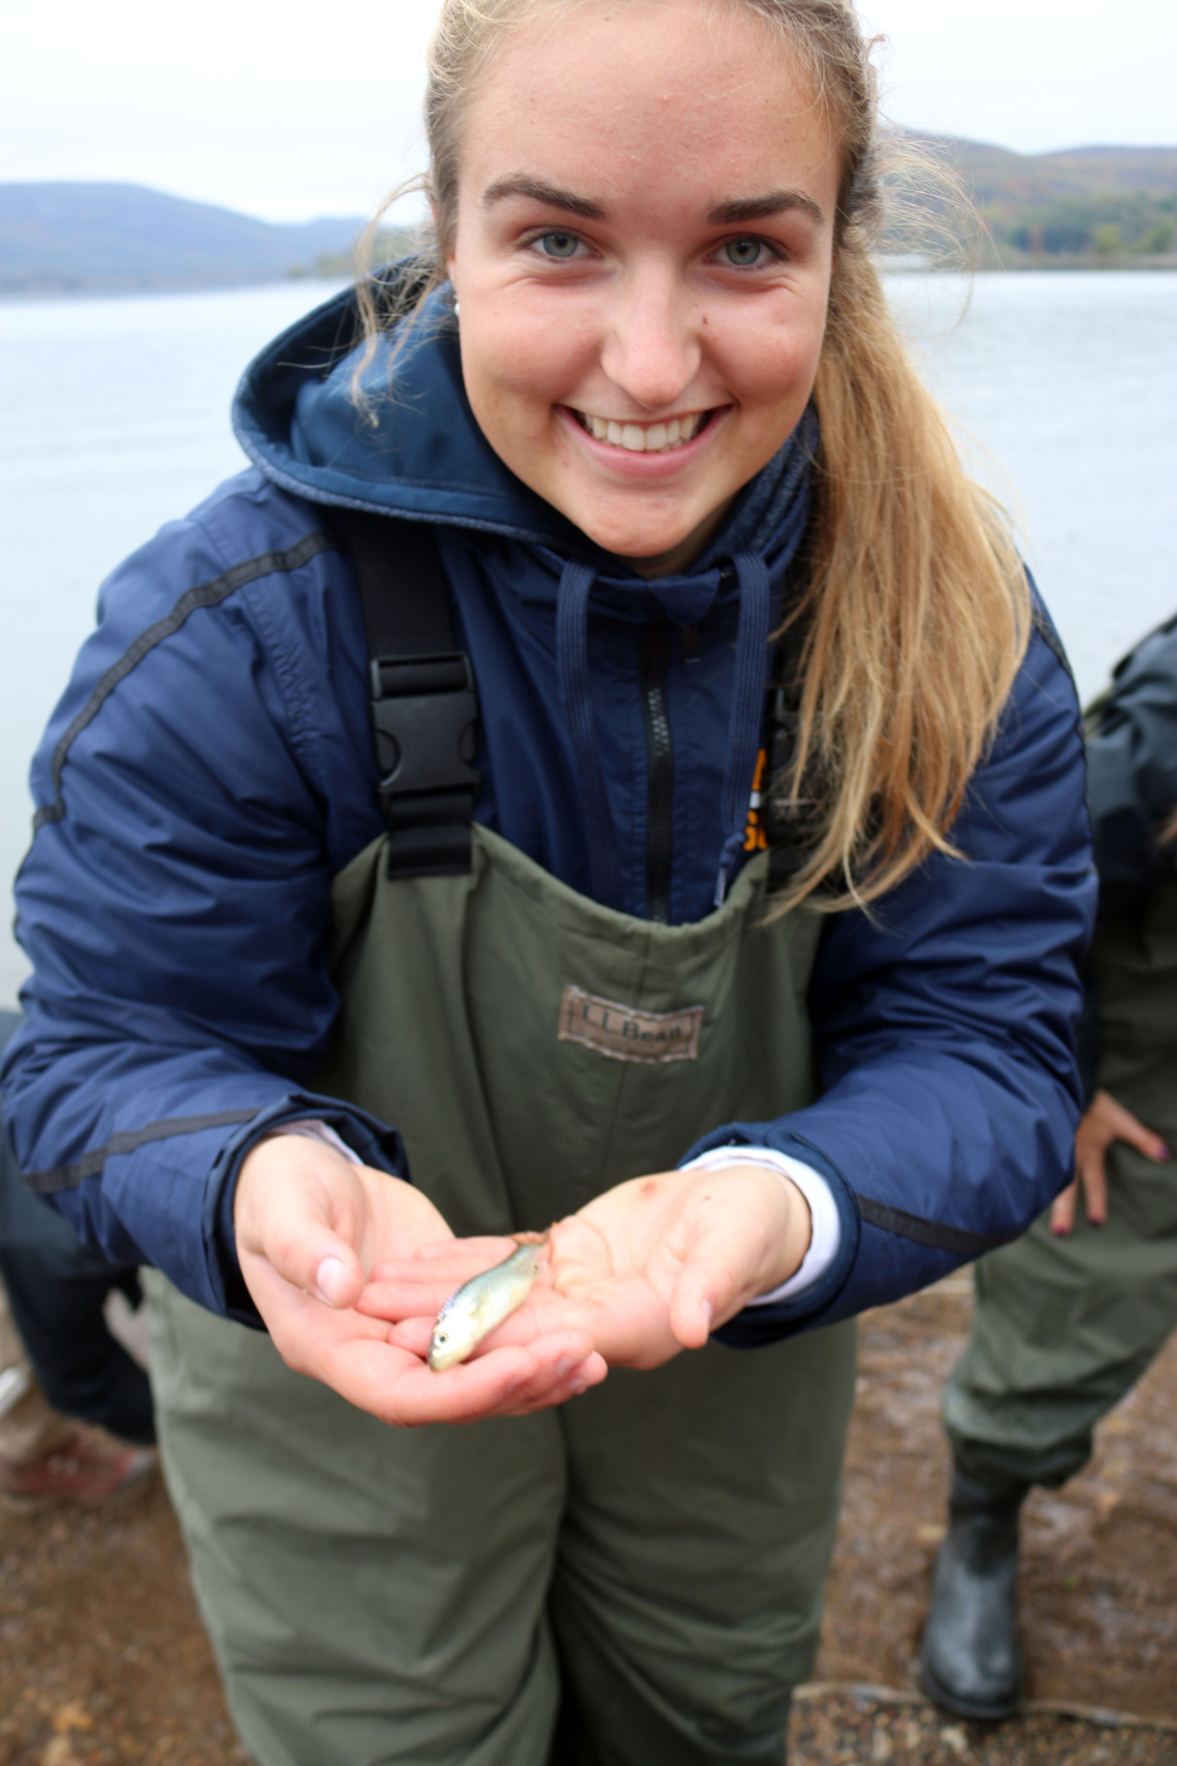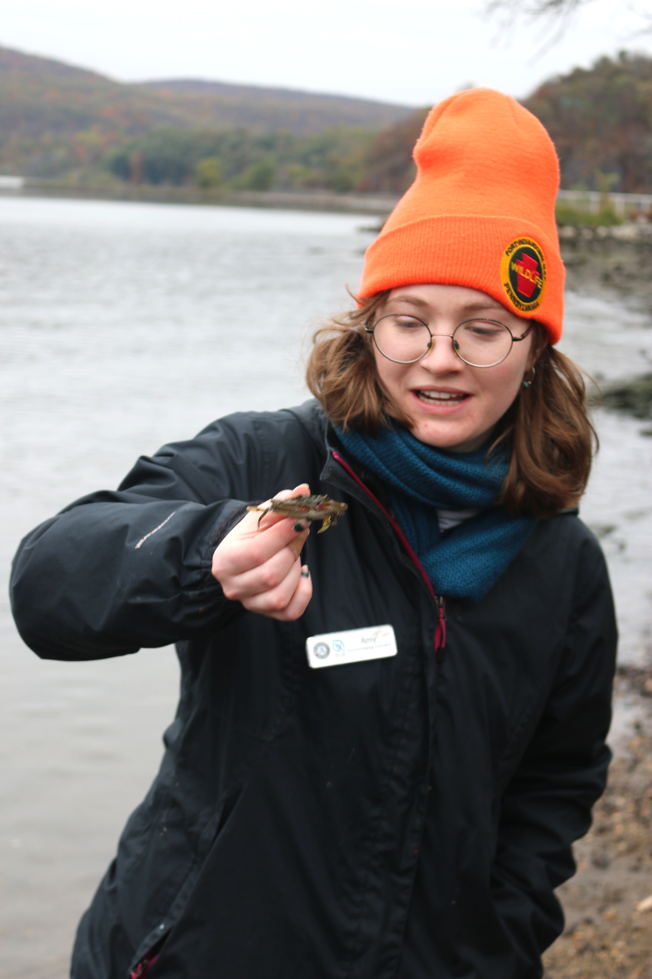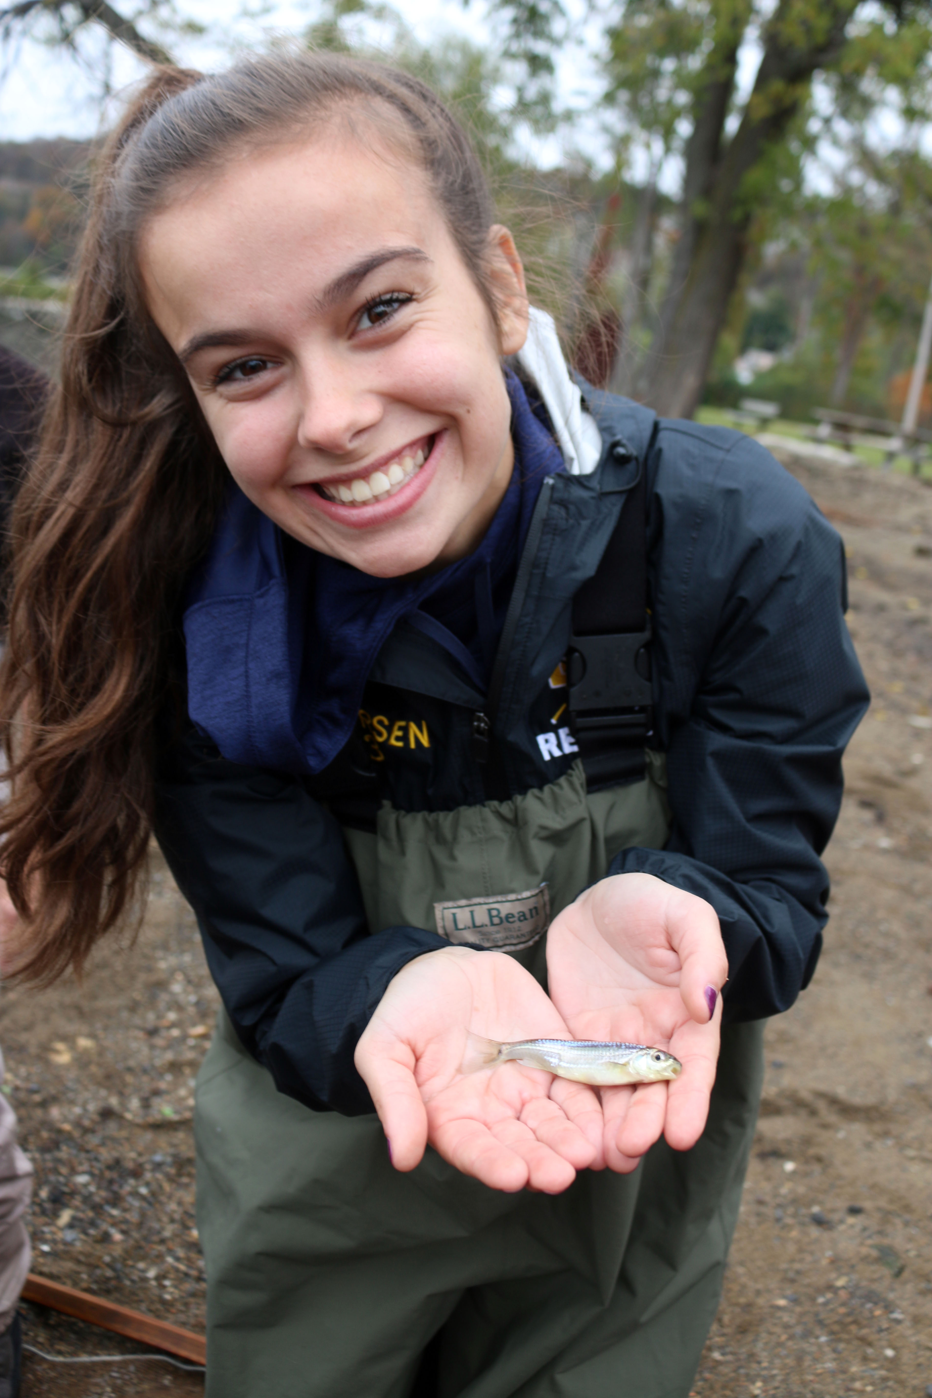
Location: Riverfront Green, Peekskill, Westchester County, NY
Area: Grassy, park area with sandy beachfront, pier, used for picnics, boating, and fishing
Surrounding Land Use: 50% grassy park; 40% industrial/commercial; 10% beach
Sampling Site: Beach with brick, charcoal, slag, and concrete bulkhead
Shoreline: Rocky, sandy, muddy with pebbles
Water: 2 ft
River Bottom: Rocky

ITEM | Time | Reading |  | Comments
Physical
Air Temperature | 8:45-9:15 AM | 10 º C
Wind Speed: | 8:45-9:15 AM | Beaufort 1
Weather today | Overcast (100%) no rain
Weather past 3 days: | NR
Tides- tide stick | Time | Rising, Falling, Unchanged | Water Height (cm) | Rate of Tidal Change (cm/min)
HT at 5:43 AM  LT 12:43 PM | 8:00 AM | Falling | Fell 25 cm in 2.5 hours
Current- | Time | cm/second, Knots | North/South | Ebb/Flood/Still
 | NR
Water Temperature- | 9:00 AM | 15 º C
Turbidity- long sight tube | 8:45 -9:15 AM | 46 cm
Chemical
Salinity- LR Quantabs | 8:45-9:15 AM | 285 ppm Cl- | 514.86 ppm total sal.
DO – drop count | Time | Temp | ppm DO | % saturation
 | 9:17 AM | 15 º C | 9.5 | 93%
pH – ColorpHast | 8:45-9:15 AM | 6
Biological
Fish | Number | Name | Length of longest | Notes
Seine: 20 ft  9 pulls total | 41  31  7 | Striped Bass  Atlantic Silversides  Spottail Shiner | 5.5 cm  7 cm  8.5 cm | 10AM first pull yielded 8 striped bass and 2 Atlantic Silverside
Fish Totals | TOTAL: 79 | Diversity: 3
Macroinvertebrates | Number | Name | Length of longest
 | 3 | Blue Crabs
Macroinvertebrate Totals | TOTAL: 3 | Diversity: 1
Sediment Core | Time | Oxid Top | Grain Size | Other Features
 | NR
Boats | Time | Name/Color | North/South | Loaded/Light
 | NR
Observations | NR

