Day in the Life of the Hudson River 10/22/19
PLUM POINT, KOWAWESE, NEW WINDSOR
RIVER MILE: 58.1
Salt Front: ~ RM 53
Vails Gate STEAM Academy – Krista Espinoza & Janet DeStafanso
Black Rock Consortium- Jack Caldwell
45 students 4th grade, 10 adults
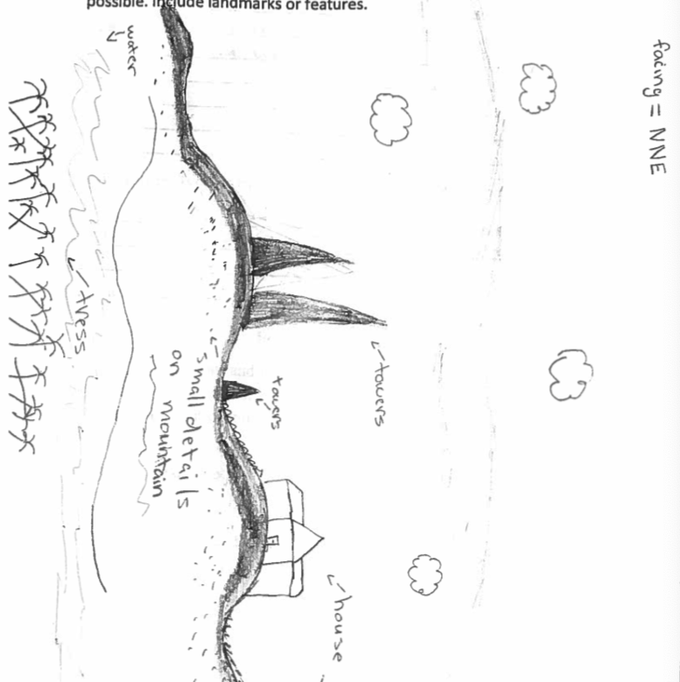
Latitude 41.463043 N & Longitude – 74.0119 W

Location: Plum Point Park Beach, New Windsor, Orange County, NY
Area: Northern sandy public beach bordered by forested area and parking lot. Area used for picnicking, fishing, and kayaking
Surrounding Land Use: 25% Forested; 75% Beach
Sampling Site: Sandy Beach (cove)
Shoreline: Beach area, riprap in area of sampling site, debris (broken concrete and docking) in area.
Water: 2 ft, choppy
River Bottom: rocky, sandy
Plants in water: 10% water chestnut

ITEM | Time | Reading |  | Comments
Physical
Air Temperature | 10:06 AM  11:30 AM | 57.3 ºF  57.2 ºF | 14 º C  14 ºC
Wind Speed: | 10:15 AM  10:41 AM  11:05 AM  11:27 AM | 2.4 mph  3.3 mph  3.3 mph  3.6 mph | Beaufort 2
Weather today | Overcast (100%)
Weather the past 3 days: | Rained 2 days before on 10/20/19
Tides- | Time | Rising, Falling, Unchanged | Height (in) | Rate of Tidal Change (cm/min)
 | 9:05 AM  10:55 AM  11:20 AM | Falling  Falling  Falling
Current- | cm/second | North/South | Knots | Ebb/Flood/Still
10:15 AM  10:41 AM  11:05 AM  11:27 AM | 3.1  11.7  .5  9 | 3.1  11.7  .5  9 | 0.06  0.23  0.01  0.18 | Ebb  Ebb  Ebb  Ebb
Water Temperature | 10:20 AM  10:48 AM  11:10 AM  11:33 AM | 62 ºF  62 ºF  61 ºF  62 ºF | 17 ºC  17 ºC  16 ºC  17 ºC
Turbidity- long sight tube | 10:57 AM | 54.4cm, 56.4 cm, 53.4 cm  Avg: 54.7 cm
Chemical
Salinity- Quantabs | Time | Chloride ppm Cl⁻ | Total Sal. Ppm
 | 11:00 AM | Below Detection  *maybe quantabs went bad |  | Standardized Sal: 81 ppm total sal
DO – | Time | Temp | ppm DO | % saturation
 | 10:30 AM | 14 ºC | 8 | 80%
pH – pH strips | 10:53 AM | 7.5, 7.5, 7.5
Fish | Number | Name | Length of longest
Seine: 12:20 PM  length 20’x pull 20’  Number of pulls: 8 | 2  1  7 | American Eel  White Perch  Striped Bass | 8 inches  7 inches  2 inches
Fish Totals | TOTAL: 27 | Diversity: 3
Macroinvertebrates | Number | Name | Length of longest
Macroinvertebrate Totals | TOTAL: | Diversity:
Sediment Core | Time | Oxid Top | Grain Size | Other Features
Length of core: 6 inches |  | No | Common: sand  Rare: clay, mud, gravel, pebbles | Rare: wood, oyster shells
Boats | Time | Name/Color | North/South | Loaded/Light
Commercial  Commercial  Recreational | 9:05 AM  12:55 PM  9-1:00 PM | Barge  Barge  Sailboat | South  North  North
Observations | Water celery, spatterdock, water chestnuts, duckweed on shore. Trains, seagulls, motorboat to fish.

