Day in the Life of the Hudson River 10/22/19 Data
PIER I, 59TH STREET, MANHATTAN
RIVER MILE: 6.8
Salt Front: ~ RM 53
Speyer Legacy School, Kimberly Schwab
58 students 38 first graders and 20 seventh graders, 10 adults
GLOBE- City College of New York
Latitude 40.778578 N & Longitude - 73.990636 W
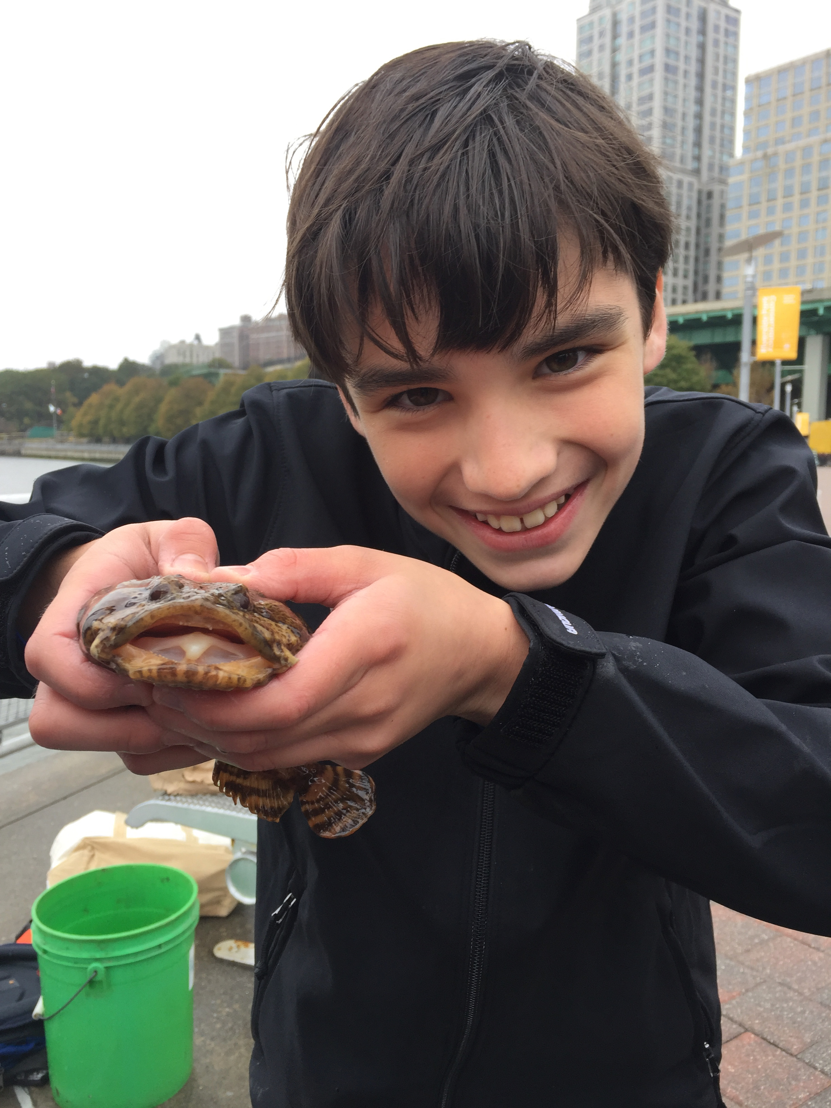

Location: Pier I, 59th Street, Manhattan, NY
Area: Restored former railroad pier and parking lot
Surrounding Land Use: 90% Urban/Residential, 10% Beach
Sampling Site: Sampling took place on Pier I
Shoreline: 10% muddy, 90% rocky. Tiny beach area, shore with concrete bulkhead, riprap, covered with vegetation, old railroad pilings, brick pieces
Water: ~ 160 cm
Plants in area: no plants just leaves
River Bottom: Rocky

ITEM | Time | Reading |  | Wind |  | Weather
Physical
Air Temperature | 10:00 AM | ºC | ºF | 5 mph |  |  | Overcast, misting
 | 10:30 AM | 15.3 | 59.6 | 0.6-3 mph |  |  | Overcast, mildly heavy rain
 | 11:00 AM | 12.8 | 55 | 2.0 |  |  | Overcast no rain
 | 11:30 AM | 14.4 | 58 | 2.0 |  |  | Overcast no rain
 | 12:00 PM | 14.4 | 58 | 0.6 |  |  | Overcast, misting
 | 12:30 PM | 14.4 | 58 | 0.6 |  |  | Overcast, misting
 | 1:00 PM & 1:30 PM | 15.6 | 60 | 2.5 |  |  | Overcast, no rain
 | 2:00 PM | 15.6 | 60 | 2.0 |  |  | Overcast, no rain
Water Temperature | Time | ºC | ºF | ºC | ºF |  | Note: Water depth noted at 160.02 cm
 | 10:00 AM | 15 |  | 15 |  |  | *Kimberly noted these readings were taken with a broken thermometer.  Appears depth is shallow enough not to impact temperature on this overcast day.
 | 10:30 AM | 20 |  | 35*
 | 11:00 AM | 37* |  | 15
 | 11:30 AM | 37* |  | 16
 | 12:00 PM | 40* |  | 16
 | 12:30 PM | 40* |  | 16
 | 1:00 PM | 17 |  | 17
 | 1:30 PM | 17 |  | 17
Turbidity - | Time | Top |  | Bottom |  |  | AVERAGES
* sheet noted short site tube as well as turbidimeter | 10:42 AM | 39 cm |  | 31 cm |  |  | Top = 40.3 cm
* sheet noted short site tube as well as turbidimeter | 11:12 AM | 41 cm |  | 38 cm |  |  | Bottom = 26.5 cm
 | 11:50 AM | 44 cm |  | 18 cm
 | 12:25 PM | 38 cm |  | 12 cm
 | 1:00 PM | 35 cm |  | 28 cm
 | 1:39 PM | 45 cm |  | 32 cm
Chemical
Salinity- glass hydrometer | Time | Top |  | Bottom
 | 10:00 AM | 10 ppt
 | 10:30 AM |  |  | 12 ppt
 | 11:00 AM | 8 ppm
 | 11:30 AM | 11 ppm
 | 12:00 PM |  |  | 17 ppt
 | 12:30 PM | 13 ppt
 | 1:00 PM | 17 ppt
 | 1:30 PM |  |  | 13 ppt
DO – Hach drop count kit | Time | Top/Bottom |  | ppm DO |  |  | Comments
 | 10:00 AM | Top |  | 10 ppm |  |  | % saturation not yet calculated since the temperature was faulty. Need to sort through for accurate results.
 | 10:30 AM | Bottom |  | 9 ppm
 | 11:00 AM | Top |  | 9 ppm
 | 11:30 PM | Bottom |  | 5 ppm
 | 12:00 PM | Top |  | 5 ppm
 | 12:30 PM | Bottom |  | 6 ppm
 | 1:00 PM | Top |  | 2 ppm
 | 1:30 PM | Bottom |  | 4 ppm
pH – | Time | Top |  | Bottom |  |  | Average
 | 10:16 AM | 7 |  | 7 |  |  | 7
 | 11:37 AM | 6.5 |  | 8 |  |  | 7.25
 | 12:12 PM | 8.5 |  | 8.5 |  |  | 8.5
 | 12:48 PM | 8 |  | 7.5 |  |  | 7.75
 | 1:16 PM | 8 |  | 7 |  |  | 7.5
 | 1:39 PM | 8 |  | 8 |  |  | 8
TIDES | Time | Rise/Fall/Slack |  | Height |  |  | Change per min
 | 9:54 | Set |  | 160.02
 | 10:24 | Rising |  | 167.64 |  |  | 0.254 cm
 | 10:54 | Rising |  | 175.26 |  |  | 0.254 cm
 | 11:24 | Rising |  | 193.04 |  |  | 0.593cm
 | 11:54 | Rising |  | 210.82 |  |  | 0.593 cm
 | 12:24 | Rising |  | 215.90 |  |  | 0.169 cm
 | 12:54 | Rising |  | 233.68 |  |  | 0.593 cm
 | 1:24 | Rising |  | 243.84 |  |  | 0.339 cm
 | 1:54 | Rising |  | 251.46 |  |  | 0.254 cm
Current | Time | Cm/sec |  | South or North |  |  | Ebb/Flood
 | 10:10 AM | 90 |  | South |  |  | Ebb
 | 10:40 AM | 50 |  | South |  |  | Ebb
 | 11:10 AM | 48 |  | South |  |  | Ebb
 | 11:43 AM | 42 |  | South |  |  | Ebb
 | 12:05 PM | 29 |  | South |  |  | Ebb
 | 12:40 PM | 1 |  | North |  |  | Flood
 | 1:10 PM | 24 |  | North |  |  | Flood
 | 1:38 PM | 32 |  | North |  |  | Flood
 | 2:01 PM | 42 |  | North |  |  | Flood
Fish & Macro Data | Time | Species |  | Sex |  |  | Trap | Place
 | 9:20 AM | Oyster |  | N/A |  |  | Hand | 7
 | 10:56 AM | Oyster Toadfish |  | Male |  |  | Rod | 6
 | 1:05 PM | Comb Jellyfish |  | N/A |  |  | Crab | 2
 | 1:35 PM | Blue Crab |  | Male |  |  | Crab | 2
 | Throughout Day | Periwinkles |  | N/A |  |  | Trap | 1
 | Throughout Day | Sea Squirt |  | N/A |  |  | Pole | 6
Boats | Time | Name |  | Color |  |  | N/S | Heavy/Light
 | 10:04 AM | NY Waterway |  | Blue |  |  | S | L
 | 10:12 AM |  |  | Red |  |  | N | L
 | 10:15 AM | Speedway |  | Blue |  |  | S | L
 | 10:16 AM |  |  | Blue |  |  | N | H
 | 10:21 AM |  |  | Dark Blue |  |  | N | H
 | 10:48 AM | Manhattan |  | Brown |  |  | S | L
 | 11:03 AM |  |  | White |  |  | N | H
 | 11:04 AM | ML |  | White Black |  |  | N | L
 | 11:06 AM | Coast |  | Black, Red, White |  |  | S | H
 | 11:07 AM | NVAA |  | White |  |  | S | L
 | 11:55 AM | NYC |  | White |  |  | N | L
 | 11:56 AM |  |  | White |  |  | N | H
 | 12:12 PM | Circle Line |  | Green |  |  | S | L
 | 12:22 PM |  |  | White, Black |  |  | S | H
 | 12:52 PM |  |  | Blue |  |  | N | L
 | 1:20 PM | NYPD |  | Gray, Blue |  |  | N | H
 | 1:27 PM | Fenn |  | White |  |  | N
 | 1:52 PM |  |  | Black |  |  | N
Other Observations | Site was trash free! Saw Pigeons and Seagulls.

