Day in the Life of the Hudson River 10/22/19 Data
LONG DOCK, BEACON, RIVER MILE: 61
Salt Front: ~RM 53
Excelsior Academy (Newburgh Free Academy)- Joyce D’lmperio
45 students 10th grade, 6 adults
Scenic Hudson- Kate Phipps and staff
Latitude 41.50312 N & Longitude – 73.98696 W

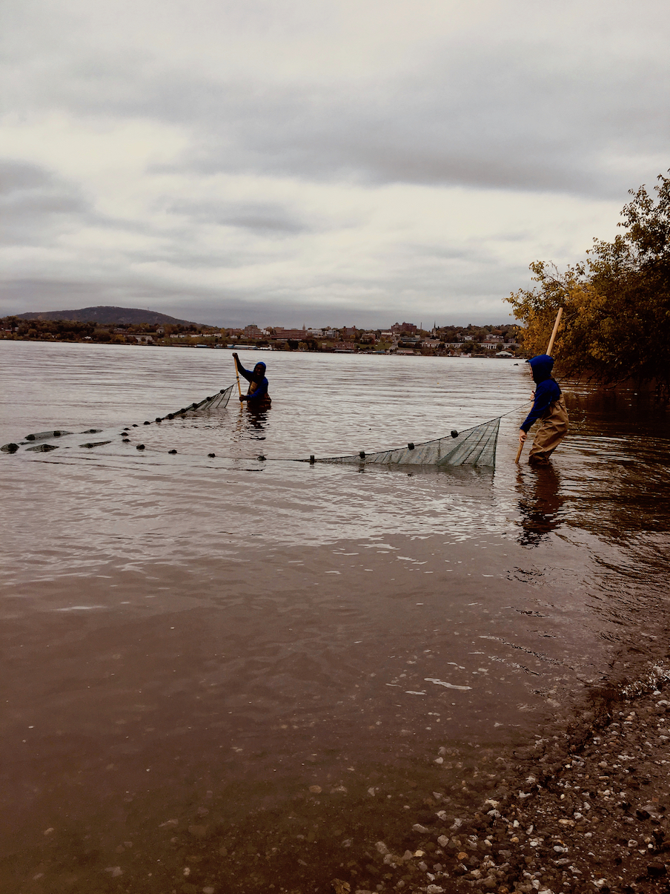
Location: Long Dock Park, Beacon, Dutchess County, NY
Area: Long Dock Park- a former brownfield now public park used for fishing, launching kayaks, picnics, fieldtrips, enjoying scenic view of the Hudson River, Hudson Highlands, and Hudson Valley. Most of the shoreline on the south side is lined with trees.
Surrounding Land Use: 25% Forested; 15% Beach; 60% Other
Sampling Site: Beach area rocky with lots of sand, water chestnut and grass
Plants in area: water chestnut
River Bottom: Muddy, Rocky

ITEM | Time | Reading |  | Comments
Physical
Air Temperature: | 9:38 AM  10:17 AM  11:54 AM  12:37 PM | 13 º C  15 º C  15 º C  15 º C | 55.4 º F  59 º F  59 º F  59º F
Wind Speed: | 9:38 AM  10:17 AM  11:54 AM  12:37 PM | 0 mph  0 mph  *20 mph  0 mph | *assume gust
Weather Today: | NR
Weather Previous: | NR
Water Temperature | 9:30 AM  10:30 AM  11:50 AM  12:46 PM | 14 º C  14 º C  15 º C  14 º C | 57.2 º F  57.2 º F  59 º F  57.2 º F
Turbidity - site tube | 9:38 AM  10:17 AM  11:54 AM  12:37 PM | 44 cm  42 cm  39 cm  39 cm
Chemical
Salinity- Low Range Quantabs | 9:30 AM  10:30 AM  11:50 AM  12:46 PM | 34 ppm Cl-  50 ppm  34 ppm  80 ppm | 61 ppm Total Sal  90 ppm  61 ppm  144.5 ppm
DO – | Time | Temp | ppm DO | % saturation
DO – | 9:30 AM  10:30 AM  11:50 AM  12:46 PM | 14 º C  14 º C  15 º C  14 º C | 8  9  11  9
pH - | 9:30 AM  10:30 AM  11:50 AM  12:46 PM | 7  7  7.4  7
Fish – seine – | Seine Number | Number | Name | OVERALL
Fish – seine –  Macroinvertebrates- Seine | 1st – 6 pulls  TOTAL – 12  DIV - 3 | 10  1  1 | Common Shiner  Spottail Shiner  Banded Killifish | Common 10  Spottail 18  Banded 2  Striped Bass 12  Yellow Perch 1  White Perch 1
Fish – seine –  Macroinvertebrates- Seine | 2nd - 5 pulls  TOTAL- 16  DIV - 5 | 8  1  5  1  1 | Spottail Shiner  Banded Killifish  Striped Bass  Yellow Perch  White Perch | Common 10  Spottail 18  Banded 2  Striped Bass 12  Yellow Perch 1  White Perch 1
Fish – seine –  Macroinvertebrates- Seine | 3^{rd -} 4 pulls  TOTAL - 2  DIV - 1 | 2 | Striped Bass
Fish – seine –  Macroinvertebrates- Seine | 4th – 5 pulls  TOTAL - 14  DIV - 2 | 9  5 | Spottial Shiner  Striped Bass
Fish – seine –  Macroinvertebrates- Seine |  | OVERALL TOTAL: 44 | Diversity: 6
Fish – seine –  Macroinvertebrates- Seine | Number | Name | Length of longest
Macroinvertebrates- Seine  Tides- dock to water | N/R |  |  | Rate of Tidal Change (cm/min)
Macroinvertebrates- Seine  Tides- dock to water | TOTAL: | Diversity: |  | Rate of Tidal Change (cm/min)
Macroinvertebrates- Seine  Tides- dock to water | Time | Rising, Falling, Still | Height (cm) | Rate of Tidal Change (cm/min)
 | 9:38 AM  10:07 AM  10:18 AM  10:38 AM  11:54 AM  12:37 PM | NR | 15.24  5.08  2.54  0  0
Currents Flow | Cm/second | Knots | North/South | Ebb/Flood/Still
9:38 AM  10:17 AM  11:54 AM  12:37 PM | 10.3  20.6  10.3  10.3 | 0.2  0.4  0.2  0.2

