Day in the Life of the Hudson River 10/22/19
CHELSEA BOAT LAUNCH
RIVER MILE: 65
Salt Front: ~ RM 53
Wappingers Jr High School- Rosellen Hardt
25 students 7th grade, 4 adults + 1 DEC
Latitude 41.553508 N & Longitude – 73.97024 W

Location: Chelsea Boat Launch, Wappinger Falls, Dutchess County, NY
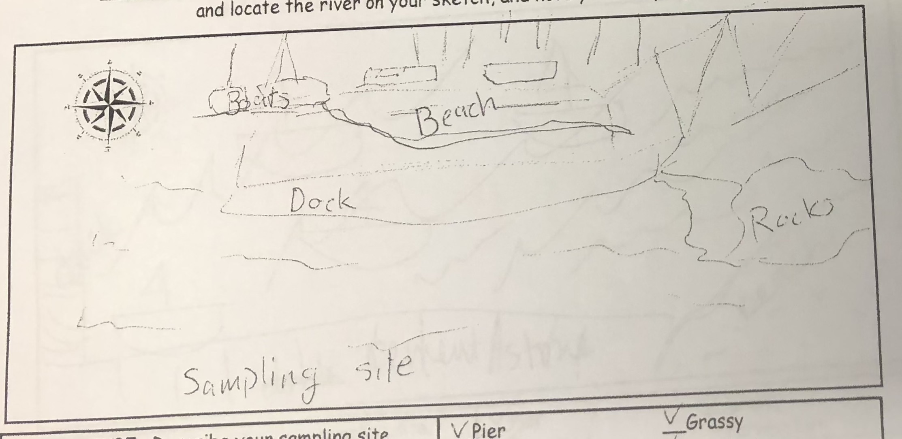
Area: Rocky, sandy beach for core samples and seining, dock for chemistry
Surrounding Land Use: 25% Urban/Residential, 35% Beach; 40% Industrial/Commercial
Sampling Site: beach area with pier, pipe entering the water, shoreline covered in vegetation, riprap shoreline, concrete docking in area
Shoreline: 30% sandy; 40% muddy; 30% rocky
River Bottom: muddy, rocky
Water: Calm

ITEM | Time | Reading |  | Comments
Physical
Air Temperature | 9:40 AM  10:00 AM  11:30 AM | 15 º C  15 º C  15.5 º C
Wind Speed: | 10:00 AM | Beaufort 2 | North
Weather today | Mostly cloudy (51-75%)
Weather the past 3 days: | No rain the past 3 days
Tides- | Time | Rising, Falling, Unchanged | Height (in) | Rate of Tidal Change (cm/min)
 | NR
Current- | Time | cm/second | North/South | Ebb/Flood/Still
 | 9:40 AM  10:00 AM | 7.47  8.86 | North  North | Flood  Flood
Water Temperature | 9:40 AM  10:40 AM  11:30 AM | 15 º C  15 º C  15.25 º C
Turbidity- long sight tube | 9:00 AM  10:00 AM  10:30 AM  11:01 AM  11:20 AM  12:45 PM  12:55 PM | 34.9, 42, 51, 57, 49, 60 - Avg: 55.3 cm  55.4, 53.3, 52.2 - Avg: 53.6 cm  49.2, 54.2, 57.1 - Avg: 53.5 cm  61, 65, 70.6 - Avg: 65.5 cm  38, 46.1, 53.4 - Avg: 45.83 cm  57, 62, 68.3 - Avg: 62.43 cm  66.2, 58.4, 76 - Avg: 66.86 cm |  | Cloudy, gray
Chemical
Salinity- Quantab | Time | Quantab reading | Total Sal. Ppm
 | 9:18 AM  10:17 AM  10:45 AM | 1.2  1.2  1.2 | Below Detection  Below Detection  Below Detection
DO – | Time | Temp | ppm DO | % saturation
 | 10:00 AM  10:40 AM  11:30 AM | 15 º C  15 ºC  15.25 ºC | 9  9  10 | 90%  90%  100%
pH – color match kit | 9:01 AM  9:56 AM  11:25 AM | 7.5  7.5  7.5
Biological
Fish | Number | Name | Length of longest | Totals
9:10 AM  9:30 AM  9:45 AM  10:30 AM  12:30 PM | 10  7  2  15  5  1  2  1  4 | Spottail Shiner  Spottail Shiner  Banded Killifish  Spottail Shiner  Spottail shiner  Banded Killifish  Striped Bass  Pumpkin Seed  White Perch | 5 cm  8 cm  13 cm  5 cm  5 cm  8 cm  8 cm  15 cm  5 cm | Spottail Shiner 37  Banded Killi 3  Striped Bass 2  Pumpkin Seed 1  White Perch 4
Fish Totals | TOTAL: 47 | DIVERSITY:  5
Macroinvertebrates | Number | Name | Length of longest
9:45 AM  10:30 AM | 1  1 | Blue Crab (M)  Blue Crab (M)
Macroinvertebrate Totals | TOTAL: | Diversity:
Observations | Pieces of shells, brick, water chestnut seeds, 1 bee, 1 blue heron, birds

