Day in the Life of the Hudson River 10/22/19
NORRIE POINT, STAATSBURG
RIVER MILE: 84.5
Salt Front: ~ RM 53
Poughkeepsie High School- Sharon Considine
24 students 11-12th grade AP. Environmental Science, 3 adults
NYS DEC Staff - Maija Niemisto, Jim Herrington, SCA
Latitude 41.83242 N & Longitude – 73.94129 W

Location: Norrie Point Environmental Center, Norrie Point, Dutchess County, NY
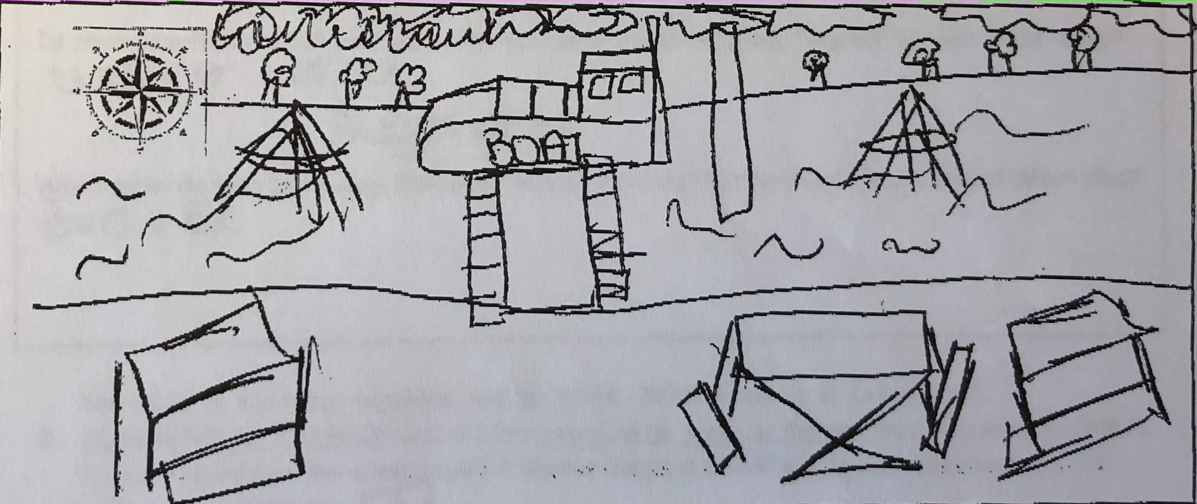
Area: East side of the Hudson, far from the main channel in a protected cove. Substantial paved areas nearby, large environmental center building adjacent to the water. Shallow cove facing south onto the Hudson River, bordered by riprap embankment, dock
Surrounding Land Use: 90% Forested; 10% Residential
Sampling Site: Front banks altered with riprap, cove is very muddy with some riprap and the west side is rocky
Shoreline: beach area, shore with bulkhead, shoreline riprap, banks altered for DEC building, riprap along the railroad tracks, piping entering river area
River Bottom: 50% muddy, 50% rocky
Plants in water: Water chestnuts and water celery remains
Water: calm

ITEM | Time | Reading |  | Comments
Physical
Air Temperature | 10:45 AM | 57 º F
Wind Speed | 12:05 PM | Beaufort 1 | 2 mph | West
Weather today | 10:45 AM overcast (100%), no rain
Weather the past 3 days | Rained yesterday, windy
Tides- tide stick | Time | Rising, Falling, Unchanged | Height (in) | Rate of Tidal Change (cm/min)
*HT 8:21 AM | 9:55 AM  10:45 AM | Falling  Falling | 56 inch  50 inch | NA  0.12
Current | Time | Speed | North/South | Ebb/Flood/Still
 | NR
Water Temperature | 9:55 AM  10:45 AM  10:57 AM | 52 º F  57 º F  52 º F | 11 º C
Turbidity- | NR
Chemical
Salinity- Hydrometer | Time | Chloride ppm | Total Sal. ppm
 | 10:45 AM |  | Below Detection for this instrument
DO – drop count | Time | Temp | ppm DO | % saturation
 | 9:55 AM  10:45 AM  11:12 AM | 11 º C  11 º C  11 º C | 7  *12  7 | * Seems high compared to others
pH – Test strips  color match kit | 10:45 AM  11:04 AM | 7.2  7.5
Biological
Fish | Number | Name | Length of longest
Seine 30’ | 18  34  5  47  6  1  2  3  11 | Banded Killifish  Spottail Shiner  Goldfish  Pumpkin Seed  Tessellated Darter  Red breasted sunfish  Striped Bass  American Eel  Bluegill Sunfish | 11.5 cm  13 cm  7.5 cm  5 cm  7.5 cm  2.5 cm  7.5 cm  28 cm  NR
Fish Totals | TOTAL: 127 | Diversity: 9
Macroinvertebrates | Number | Name | Length of longest
 | 3 | Blue Crab
Macroinvertebrate Totals | TOTAL: 3 | Diversity: 1
Sediment Core | Time | Oxid Top | Grain Size | Other Features
NR
Boats | Time | Name/Color | North/South | Loaded/Light
NR
Observations | Water chestnut seeds, birds, bees

