Day in the Life of the Hudson River 10/22/19
KINGSTON POINT PARK
RIVER MILE: 92
Salt Front: ~ RM 53
Robert Graves Elementary School- Nancy Koopman
Kingston Parks & Recreation- KC Keegan
60 students 3rd grade
Latitude 41.930213 N & Longitude – 73.96467 W
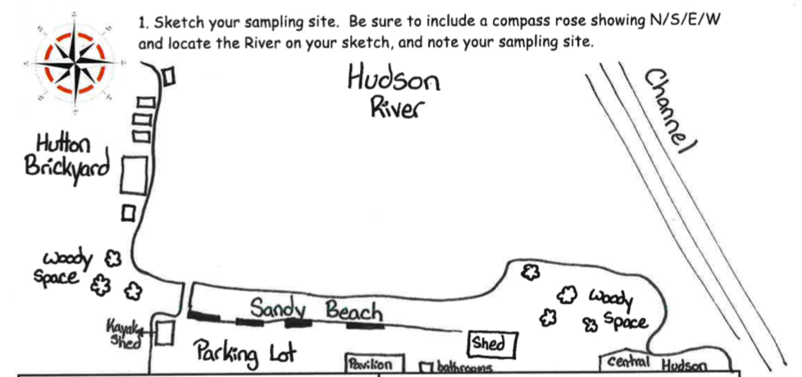
Location: Kingston Point Park, City of Kingston, Ulster County, NY
Area: Swimming beach, forested, parking lot; used for picnics, boating, fishing, swimming, jogging, kayaking
Surrounding Land Use: 5% Forested; 10% Industrial/Commercial; 85% Beach
Sampling Site: Beach Area
Shoreline: Sandy shoreline (75 ft from shoreline to parking lot and 200 ft wide); boat launch; banks are altered; riprap to north along brickyard shoreline; large amount of brick debris from prior industry
Water: 1 ft, calm
River Bottom: Sandy
Plants in water: Water celery, spatterdock, water chestnuts

ITEM | Time | Reading |  | Comments
Physical
Air Temperature | 10:55 AM  11:45 AM  1:00 PM | 50 º F  52 º F  51 º F
Wind Speed: |  | Beaufort 1 | 0.5 mph | South
Weather today | 10-1PM Overcast (100%)
Weather the past 3 days: | Rained on Saturday but no rain Sunday or Monday
Tides- | Time | Rising, Falling, Unchanged | Height (cm) | Rate of Tidal Change (cm/min)
 | NR
Current- | cm/second | North/South | Ebb/Flood/Still | Comments
 | NR
Water Temperature | 10:27 AM  11:15 AM  12:38 PM | 13 º C, 13.5ºC, 13.25ºC  13.5ºC, 13.0ºC, 13.25ºC  13.8ºC, 13.9ºC, 13.85ºC |  | Avg – 13.25 ºC  Avg – 13.25 ºC  Avg – 13.85 ºC
Turbidity- |  | Water is clear up to 2 ft
Chemical
Salinity- Quantabs | Time | Chloride ppm Cl⁻ | Total Sal. Ppm
 | 12:32 PM | 40 ppm | 72.26 ppm
DO – | Time | Temp | ppm DO | % saturation
 | NA
pH – Test strips | 10:44 AM  11:33 AM  12:56 PM | 6.5, 6.0, 6.5  7.0, 7.0, 6.5  7.0, 6.5, 7.0 |  | Avg 6.3  Avg 6.85  Avg 6.85
Alkalinity- API Kit | 10:44 AM | 60, 60 ppm |  | *API testing kit is for aquariums. Not for natural environment. nitrates and phosphates are high.
Nitrates- API Kit | 10:54 AM | 20, 20, 20 ppm
Phosphates- API Kit | 10:56 AM | 40, 60, 60 ppm
Fish | Number | Name | Length of longest
Seine # 1  1  1  2  2  2  2  2  2  2  3  3  3  3 | 7  4  5  1  3  3  1  5  4  1  1  1  3  2 | Spottail Shiner  Banded Killifish  Striped Bass  Channel Catfish  White Perch  Banded Killifish  Large mouth bass  Spottail Shiner  Striped Bass  Mummichog  Channel Catfish  Striped Bass  Spottail Shiner  Yellow Perch | 12 cm  7 cm  10 cm  7 cm  9 cm  4 cm  16 cm  9 cm  9 cm  7.5 cm  40 cm  9 cm  11 cm  6 cm
Fish Totals | TOTAL: 41 | Diversity: 7
Macroinvertebrates | Number | Name | Length of longest
Seine # 1  1 | 1  1 | Blue Crab (Male)  Blue Crab (Female)
Macroinvertebrate Totals | TOTAL: 2 | Diversity: 1
Sediment Core | Time | Oxid Top | Grain Size | Other Features
Water depth: 3 ft |  | No | Abundant: Sand  Common: Mud | Abundant: Brick  Common: Coal  Rare: Wood, Zebra mussels, slag
Boats | Time | Name/Color | North/South | Loaded/Light
Commercial | 11:21 AM | Grand, White/Blue | South | Loaded
Observations | Lumps of coal, lots of brick, some golf balls, pieces of zebra mussels, lots of woody debris, 10+ G Ring Billed gulls

