Day in the Life of the Hudson River 10/22/19
TIVOLI SOUTH BAY
RIVER MILE: 98
Salt Front: ~ RM 53
Red Hook High School- Deborah Beam
39 students 11-12th grade, 2 adults
Bard College- Marco Spodek, Lindsey Drew, 2 students
Latitude 42.01811 N & Longitude – 73.91701 W
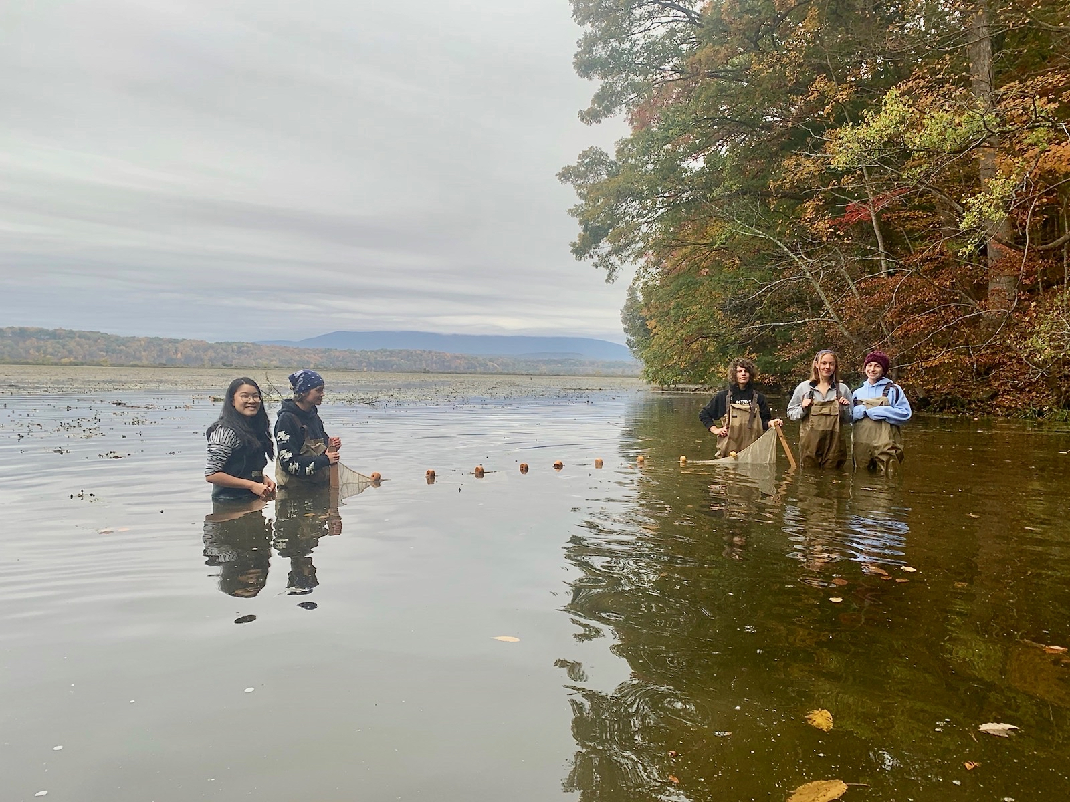
Location: Tivoli South Bay, Bard College Fish Station, Annandale on Hudson, Dutchess County, NY
Area: Embayment, between mouth of Saw Kill and Blithewood Manor. Forested, used for boating, picnics, fishing, jogging.
Surrounding Land Use: 90% Forested, 10% Urban/Residential
Sampling Site: Mud flats, muddy and rocky, covered in vegetation, large rocks
Shoreline: 50% Muddy, 50% Rocky
River Bottom: muddy and rocky
Water: 12 cm, calm
Plants in water: no plants in water area

ITEM | Time | Reading |  | Comments
Physical
Air Temperature | 10:51 AM  11:10 AM  12:15 PM | 56 º F  55 º F  55 º F | 13.3 º C  12.8 º C  12.8 º C
Wind Speed: | 11:08 AM | Beaufort 1 | North
Weather today | 10AM Over (100%). Rained 0.68 inches
Weather past 3 days: | Rain cold
Tides- tide stick | Time | Rising, Falling, Unchanged | Water Height (cm) | Rate of Tidal Change (cm/min)
 | NR
Current- | Time | cm/second, Knots | North/South | Ebb/Flood/Still
 | 10:30 AM  11:00 AM | 44.6 cm/s, .87 knots  48.3 cm/s, .94 knots | South  South | Ebb  Ebb
Water Temperature- | NA
Turbidity- long sight tube | 12:17 PM | 114 cm, 60.4 cm, 117.8 cm, Avg: 97.4 cm
Chemical
Salinity- | NA
DO – drop count | Time | Temp | ppm DO | % saturation
 | 10:36 AM  11:15 AM  12:08 PM  12:28 PM | 10.9  11.2  11.7  12 | 11  10  9  12 | 100  90  83  110
pH – color match kit | 10:36 AM  11:15 AM  12:28 PM | 7.4, 7.4, 7.5  7.1, 7.1, 7.1  7.0, 7.0, 7.0
Biological
Fish | Number | Name | Length of longest | Notes
Kicknet  Seine  Seine  Seine  Seine | 1  1  6  11  2 | American eel (elver)  Brown bullhead  Goldfish  Banded Killifish  Smallmouth bass | 25 cm  43 cm  10 cm  13 cm  juvenile not measured
Fish Totals | TOTAL: 21 | Diversity: 5
Macroinvertebrates | Number | Name | Length of longest
Kicknet | 1  2  1  1  1  2  1 | Dobsonfly Larva  Riffle Beetle  Caddisfly Larva  Snails  Dragonfly Nymph  Crayfish  Sowbug | 3 cm
Macroinvertebrate Totals | TOTAL: 3 | Diversity: 1
Sediment Core | Time | Oxidized Top | Grain Size | Other Features
2 ft water depth | 9:00AM | Yes | Abundant: clay, mud  Rare: Sand, gravel, pebbles | Rare: leaves, oyster shells, brick
Boats | Time | Name/Color | North/South | Loaded/Light
Recreational | 11:30 AM | Rec. Boat, white | South | Light
Observations | Dead Carp fish, leaves, tree in water, acorns, cormorants, gray squirrel, bald eagle, yellow jackets, water chestnut seeds, eagle flew overhead, heard blue jays

