DAY IN THE LIFE OF THE HUDSON & HARBOR
10/22/20 LOWER ESTUARY SECTION
NAME:

You might want to look at the questions on page #2 before you record your data!

WATER TEMPERATURE: | Location | °C | °F

DISSOLVED OXYGEN: | Location | ppm or mg/L

TURBIDITY (Clarity) | Location | cm of visibility

SALINITY | Location | ppt salinity

TIDES | Location | Low tide or High tide

FISH & OTHER ANIMALS  Clearwater fish key  http://fishkey.clearwater.org | Location | Fish ID
MAP OF THE LOWER ESTUARY SITES
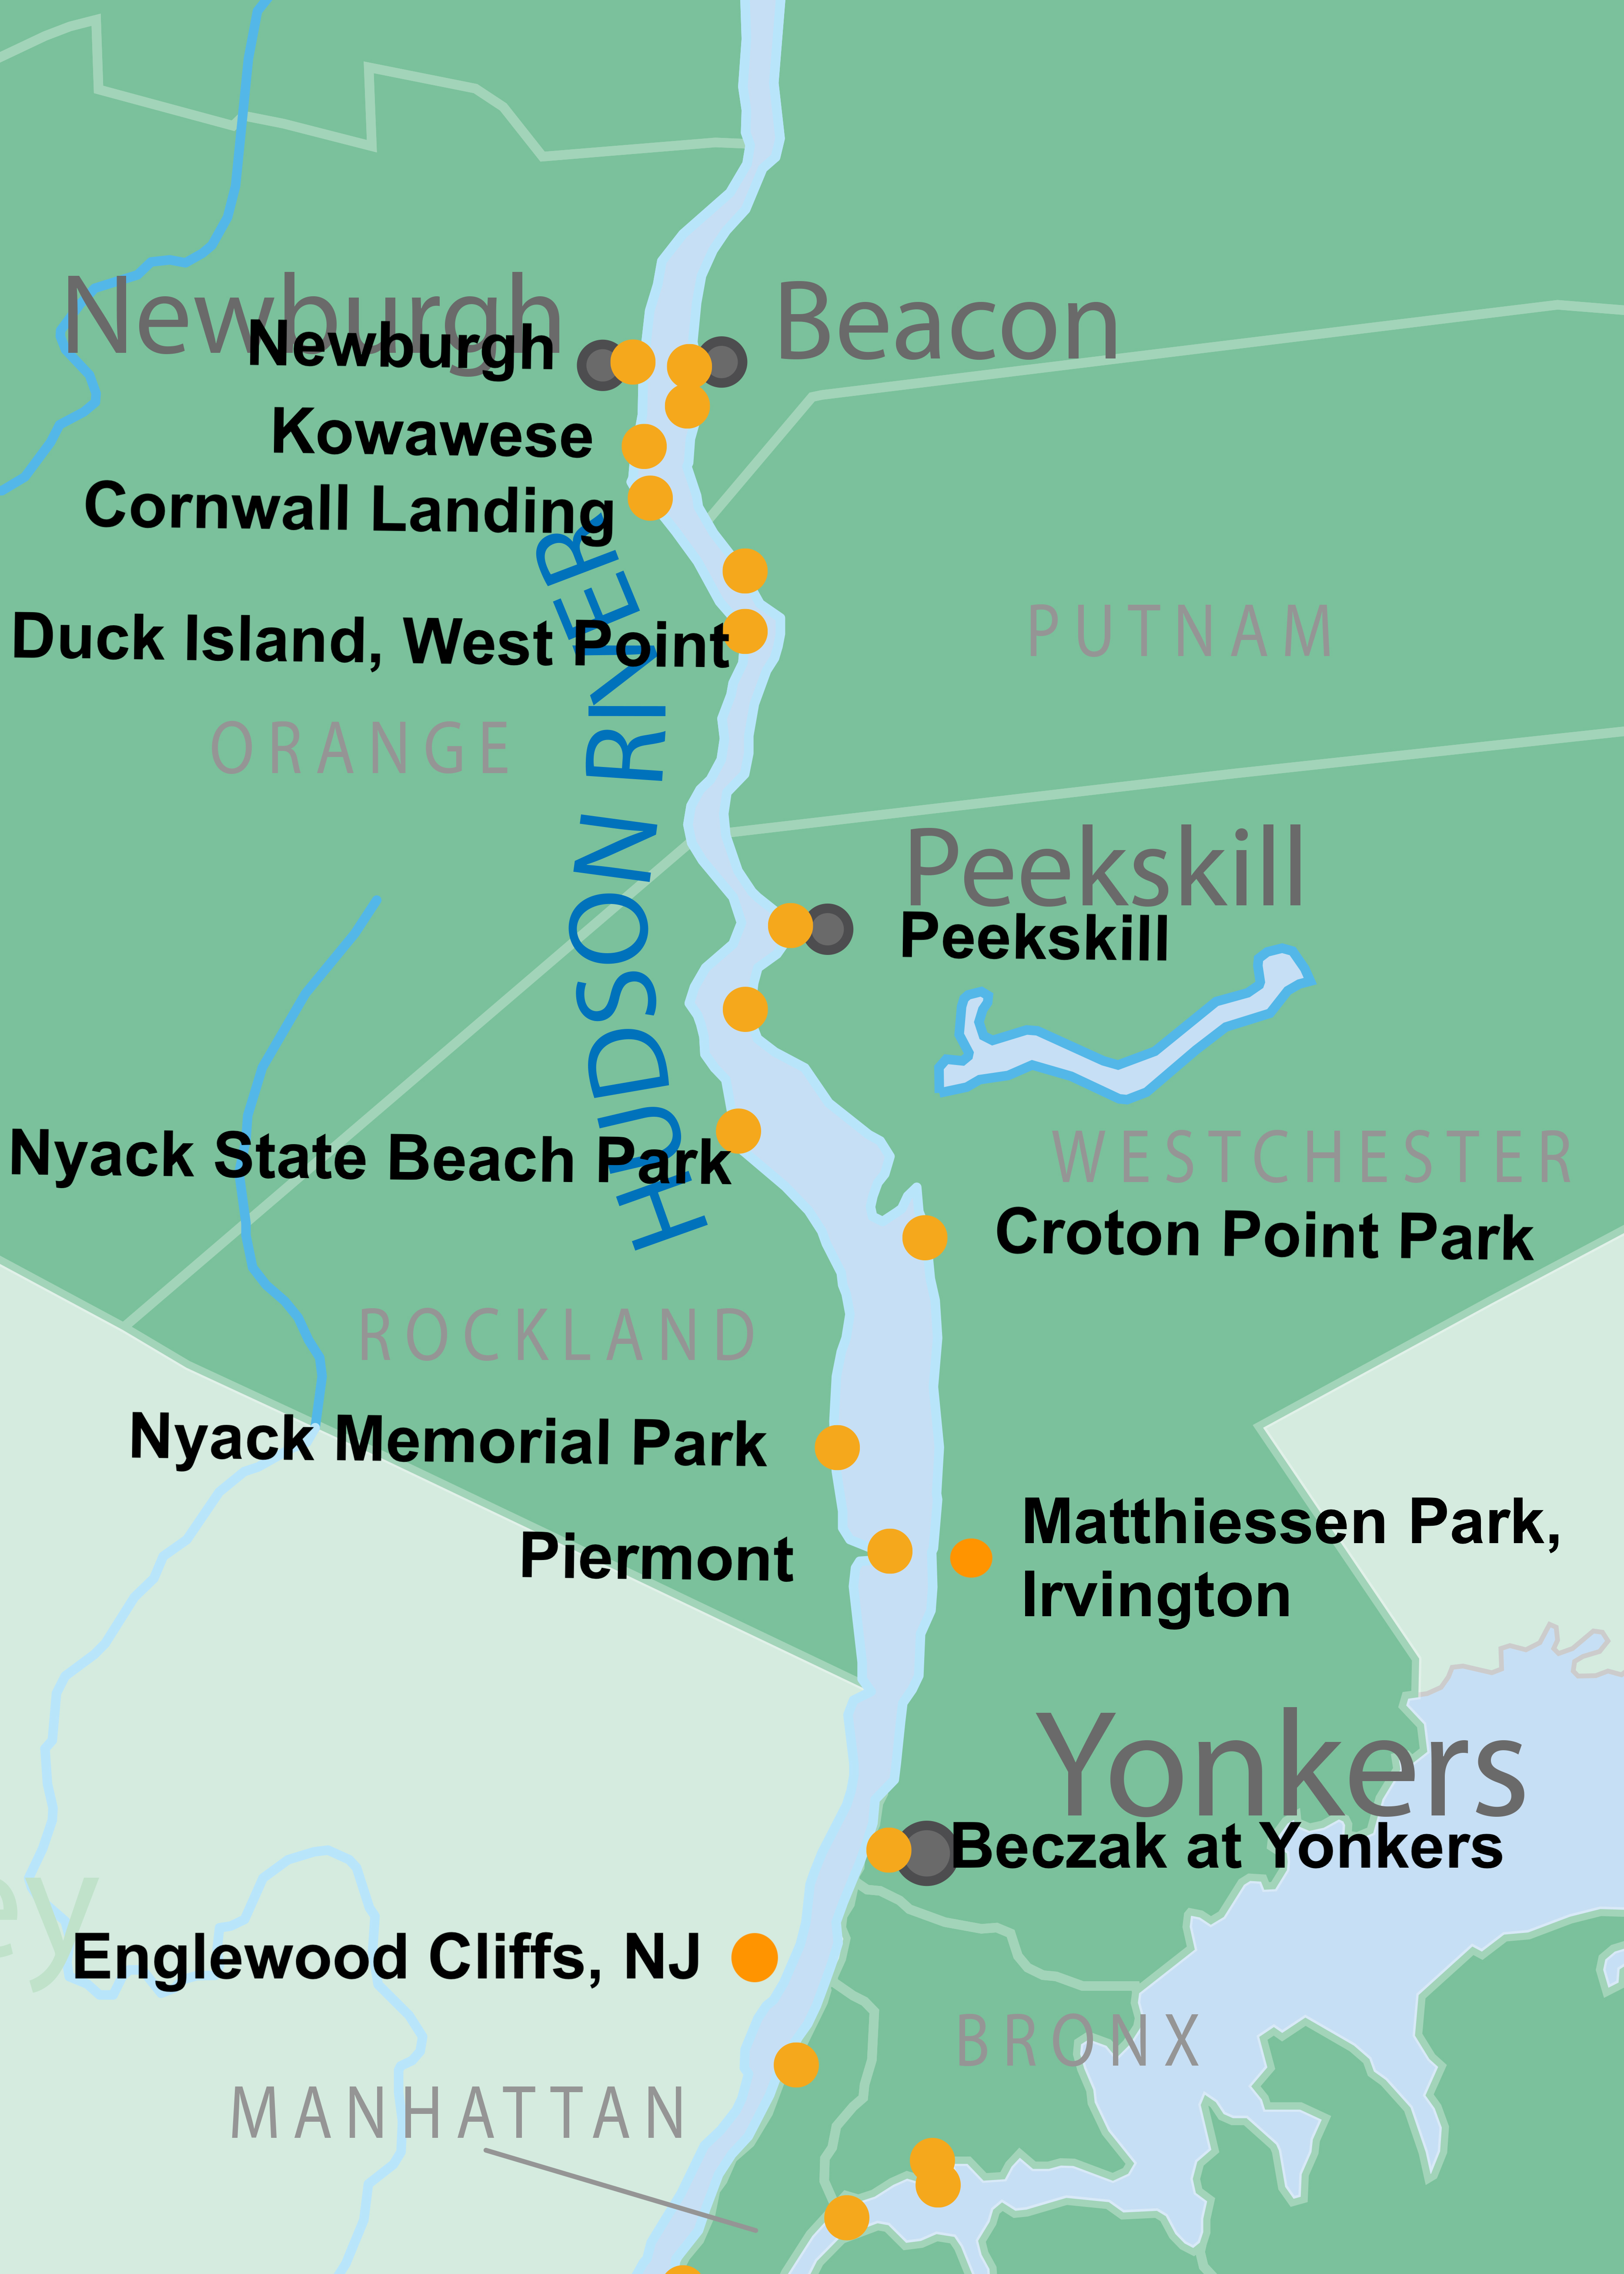

TAKING A DEEPER DIVE!

You have recorded data from about twelve places in the Lower Hudson and you have heard from our Guest Scientist about TURBIDITY & FISH PREFERENCES & TOLERANCES!

Let’s take a Deeper Dive into your fish!!

- If you recorded ALL the fish you saw images of in this video at specific sites you will have filled the lines in your fish recording section!
- What is the total number of fish you recorded?
- What is the diversity (different types) of fish you recorded?
- On your recording sheet beside the name of the fish can you write down at least one thing you learned about each of the different fish? Share!

Bonus Question!
- Think about the map of salinity that was showed in the video with the Atlantic Silversides. How many of the fish we identified today are tolerant of salinity? What is your evidence?

