Day in the Life of the Hudson River 10/22/20 Data
CONCRETE PLANT PARK, BRONX
RIVER MILE: 4.5 (Bronx River)
Hudson River Salt Front: ~ RM 75
Bronx River Alliance: Amber Plaksin & 4 Assistants
Latitude 40.826677 N & Longitude – 73.884901 W
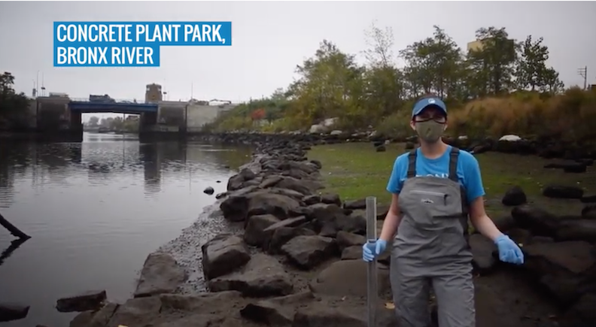
Location: Concrete Plant Park, Bronx River, NY
Area: Grassy
Surrounding Land Use: 100% Urban/Residential
Shoreline: 80% Muddy; 19% Rocky; 1% Sandy; Riprap
River Bottom: Muddy, rocky
ITEM | Time | Reading |  |  |  | Comments
Physical
Air Temperature: | 10:40 AM | 19 ºC |  | 66 ºF
Wind Speed: | 10:40 AM | 5 mph |  | NE
Weather Today: | 10:40 AM Foggy but no rain
Weather Previous: | Humid and overcast past 3 days, partly sunny
Tides | HT for this area |  | 4:49 AM |  | Sample time 10:49 AM | Tide was ebbing
Water Temperature | 11:07 AM | 17º C |  | 63º F
Turbidity - long sight tube | N/R | 1.04 m |  | 104 cm
Chemical
Salinity- Refractometer | 11:15 AM | 9.776 ppt |  | Average of readings
DO – Lamotte Drop Count Kit | Time | Temp |  | ppm DO |  | % saturation
DO – Lamotte Drop Count Kit | 12:00 PM | 17 ºC |  | 6.6 ppm average |  | 53%
pH – Color match kit | 11:10 AM | 5
Biological
Fish & Macros | Number | Name |  | Length of longest |  | Length of Shortest
Fish & Macros | 10 | Mummichog |  | 6.5 cm |  | 3.75 cm
Fish & Macros | 8 | Grass Shrimp |  | 4 cm

