Day in the Life of the Hudson River 10/22/20
PIER 1 GANTRY STATE PARK, LONG ISLAND CITY
RIVER MILE: East River 5.7
Salt Front: ~ RM 75
NYS Parks, Recreation, and Historic Preservation – Jenna Otero, 3 participants
Latitude 40.74497 N & Longitude – 73.95849 W
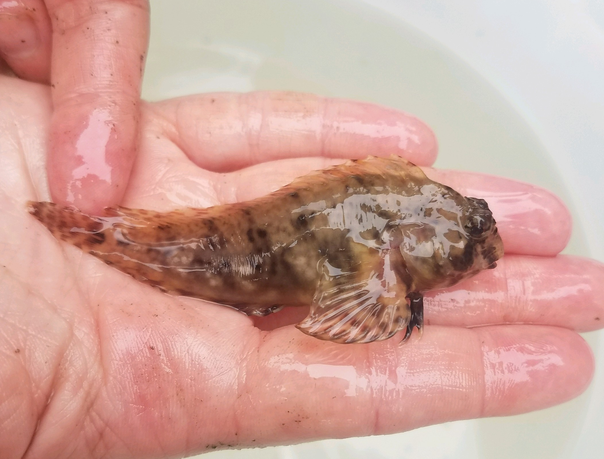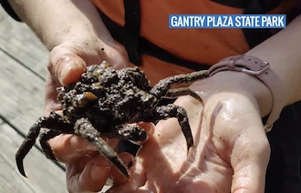
Feather Blenny Spider Crab covered in tunicates
Location: Pier 1, Gantry Plaza State Park (East River), Long Island City, Queens, NY
Area:
Surrounding Land Use: Urban 80%, Grassy 15%, Rocky 5%
Sampling Site: Shoreline is rocky with some plants, piers. Sample off a concrete stepped pier
Shoreline: Riprap
ITEM | Time | Reading |  |  | Comments
Physical
Air Temperature | 10:00 AM | 19 º C |  | 66 º F
Wind Speed: | 10:00 AM | No wind
Weather today | Fog
Weather past 3 days: | Normal 60 F range, no rain
Tides- | Low Tide | High Tide |  | Time of Sampling | Tide
 | 7:21 AM | 1:45 PM |  | 10:00 AM | Flooding
Current- | Time | cm/second, Knots |  | North/South | Ebb/Flood/Still
Water Temperature- | 10:00 AM | 17.5 º C | 63.5 º F
Turbidity- Long sight tube | 10:30 AM | 100.8 cm
Chemical
Salinity- Hydrometer | 11:30 AM | 21.8 ppt
DO – Chemets | Time | Temp |  | ppm DO | % saturation
 | 11:00 AM | 17.5 º C |  | 6 ppm | 60
pH – Color match kit | 11:45 AM | 7
Biological
Fish | Number | Name |  | Length of longest | Length of smallest
Caught in Mobile trap | 1 | Feathered Blenny |  | 3 inch
Fish Totals | TOTAL: 1 | Diversity: 1
Macroinvertebrates | Number | Name |  | Length of longest | Length of smallest
Caught in Mobile trap  Mobile trap  Mobile trap  Caught in BOP Cage | 1  2  2  1 | Portly Spider Crab  Mud Crab  Blue Crab  Spider Crab (larger) |  | 2.5 inch | *note spider crabs caught in two separate traps
Macroinvertebrate Totals | TOTAL: 6 | Diversity: 4
Sediment Core | Time | Oxidized Top |  | Grain Size | Other Features
NR
Boats | Time | Name/Color |  | North/South | Loaded/Light
NR
Observations

