Day in the Life of the Hudson River 10/22/20
BROOKLYN BRIDGE PARK (EAST), BROOKLYN
RIVER MILE: East River 1.7
Salt Front: ~ RM 75
Brooklyn Bridge Park Conservancy– Christina Tobitsch, 5 participants
Latitude 40.70445 N & Longitude – 73.99373 W
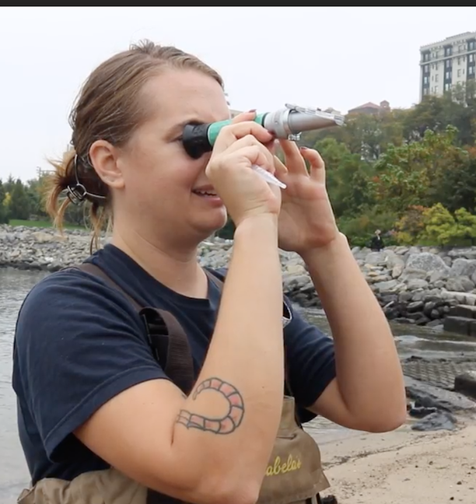
Location: Pier 5 of Brooklyn Bridge Park, East River, Brooklyn, NY
Area: Developed set of piers
Surrounding Land Use: 100% Urban/residential and park land
Sampling Site: South of boat marina and in front of the soccer field.
Shoreline: Rocky shoreline, riprap, concrete bulkhead
River Bottom: Sandy

ITEM | Time | Reading |  |  | Comments
Physical
Air Temperature | 9:00 AM | 18.3 º C |  | 65 º F
Wind Speed: | NR
Weather today | Foggy, overcast
Weather past 3 days: | Consistent
Tides- | Low Tide | High Tide |  | Time of Sampling | Tide
 | 7:25 AM | 1:39 PM |  | 9:30 AM | Flood
Current- | Time | cm/second, Knots |  | North/South | Ebb/Flood/Still
 | NR
Water Temperature- | 9:30 AM | 17.2 º C | 63 º F
Turbidity- Long sight tube | 11:30 AM | 105 cm
Chemical
Salinity- Meter | 9:30 AM | 24.3 ppt
DO – Meter | Time | Temp |  | ppm DO | % saturation
 | 9:30 AM | 17.2 º C |  | 6.7 | 80
pH – Meter | 9:30 AM | 8.5
Biological
Fish | Number | Name |  | Length of longest | Length of smallest
 | 518  1  3 | Atlantic Silverside  Winter Flounder  Striped Bass |  | 11 cm  9 cm  12 cm
Fish Totals | TOTAL: 522 | Diversity: 3
Macroinvertebrates | Number | Name |  | Length of longest | Length of smallest
 | 1  3  1  15 | Blue Crab  Long clawed hermit crabs  Oyster drill snail  Comb Jelly |  | 7 cm
Macroinvertebrate Totals | TOTAL: 20 | Diversity: 4
Sediment Core | Time | Oxidized Top |  | Grain Size | Other Features
NR
Boats | Time | Name/Color |  | North/South | Loaded/Light
NR
Observations | Spider crab carapace and empty mussel and soft shell clam shells. Also some crazy looking large kelp-like algae that we've never seen here before!

