Day in the Life of the Hudson River 10/22/20
BUSHWICK INLET PARK
RIVER MILE: East River 4.4
Salt Front: ~ RM 75
Billion Oyster Project – Agata Poniatowski, 3 participants
Latitude 40.7061 N & Longitude – 73.9589 W
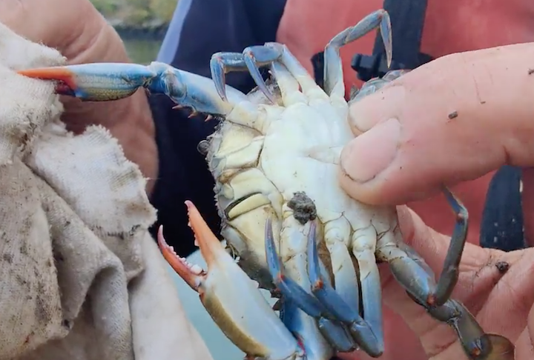
Location: Bushwick Inlet Park, East River, Brooklyn, NY
Area: Waterfront park with a regulation soccer field, playground and views of the Manhattan skyline

ITEM | Time | Reading |  |  | Comments
Physical
Air Temperature | NR
Wind Speed: | NR
Weather today | No rain
Weather past 3 days: | NR
Tides- | Low Tide | High Tide |  | Time of Sampling | Tide
 | NR
Current- | Time | cm/second, Knots |  | North/South | Ebb/Flood/Still
 | NR
Water Temperature- | NR
Turbidity- | NR
Chemical
Salinity- | NR
DO – | Time | Temp |  | ppm DO | % saturation
 |  |  |  | 5 ppm
pH –
Nitrates- | NR
Biological
Fish | Number | Name |  | Length of longest | Length of smallest
Fish Totals | TOTAL: | Diversity:
Macroinvertebrates | Number | Name |  | Length of longest | Length of smallest
 | 1 | Blue Crab |  | Female
Macroinvertebrate Totals | TOTAL: 1 | Diversity: 1
Sediment Core | Time | Oxidized Top |  | Grain Size | Other Features
NR
Boats | Time | Name/Color |  | North/South | Loaded/Light
NR
Observations

