Day in the Life of the Hudson River 10/22/20
PIER 4 GANTRY STATE PARK, LONG ISLAND CITY
RIVER MILE: East River 5.6
Salt Front: ~ RM 75
NYC DEP – Robin Sanchez, 2 participants
Latitude 40.740041 N & Longitude – 73.961512 W
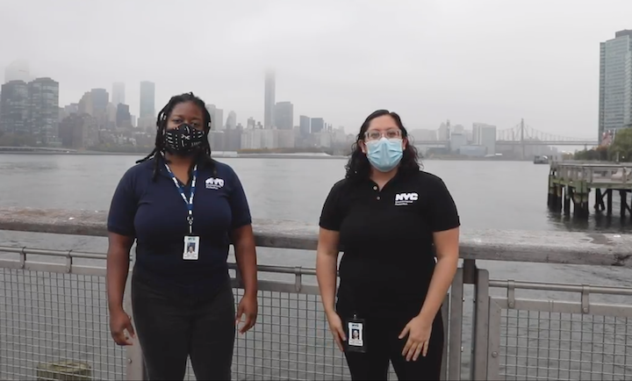
Location: Pier 4, Gantry Plaza State Park (East River), Long Island City, Queens, NY
Area: Most southern pier, fishing pier
Surrounding Land Use: Urban 80%, Grassy 15%, Rocky Shoreline 5%
Sampling Site: Shoreline is rocky with some plants, piers, pipe entering water
Shoreline: riprap
ITEM | Time | Reading |  |  | Comments
Physical
Air Temperature | 10:25 AM | 20 º C |  | 68 º F
Wind Speed: | 11:31 AM | 1 knot |  | SW
Weather today | No rain
Weather past 3 days: | Overcast, cloudy, humid and mild temperatures
Tides- | Low Tide | High Tide |  | Time of Sampling | Tide
 | 7:21 AM | 1:45 PM |  | 11:40 AM | Flooding
Current- | Time | cm/second, Knots |  | North/South | Ebb/Flood/Still
 | 11:40 AM | 52.15 cm/sec, 1.01 knots |  | North | Flooding
Water Temperature- | 11:15 AM | 18.4 º C | 65.1 º F
Turbidity- Long sight tube | 11:03 AM | 57 cm
Chemical
Salinity- Hydrometer | 10:50 AM | 22 ppt
DO – Chemets | Time | Temp |  | ppm DO | % saturation
 | 11:15 AM | 18.4 º C |  | 5 ppm | 53
pH – Color match kit | 10:43 AM | 7
Biological
Fish | Number | Name |  | Length of longest | Length of smallest
Fish Totals | TOTAL: | Diversity:
Macroinvertebrates | Number | Name |  | Length of longest | Length of smallest
Macroinvertebrate Totals | TOTAL: | Diversity:
Sediment Core | Time | Oxidized Top |  | Grain Size | Other Features
NR
Boats | Time | Name/Color |  | North/South | Loaded/Light
NR
Observations

