Day in the Life of the Hudson and Harbor 10/22/20
JOHN FINLEY WALK, MANHATTAN
RIVER MILE: EAST RIVER ~6
Salt Front: ~RM 73
Manhattan International High School- Ms. Athena Theodoris
12 students 12th grade, 1 adult
Latitude : 40.760024 Longitude: -73.956996

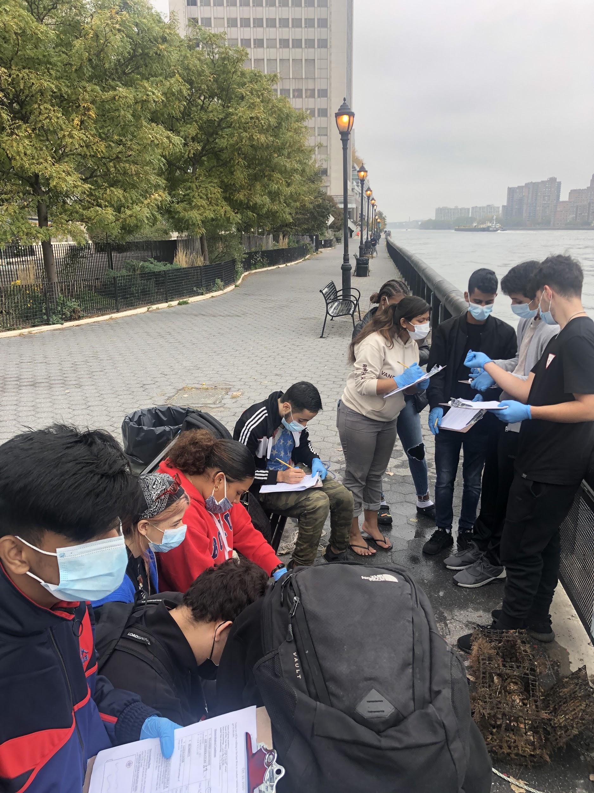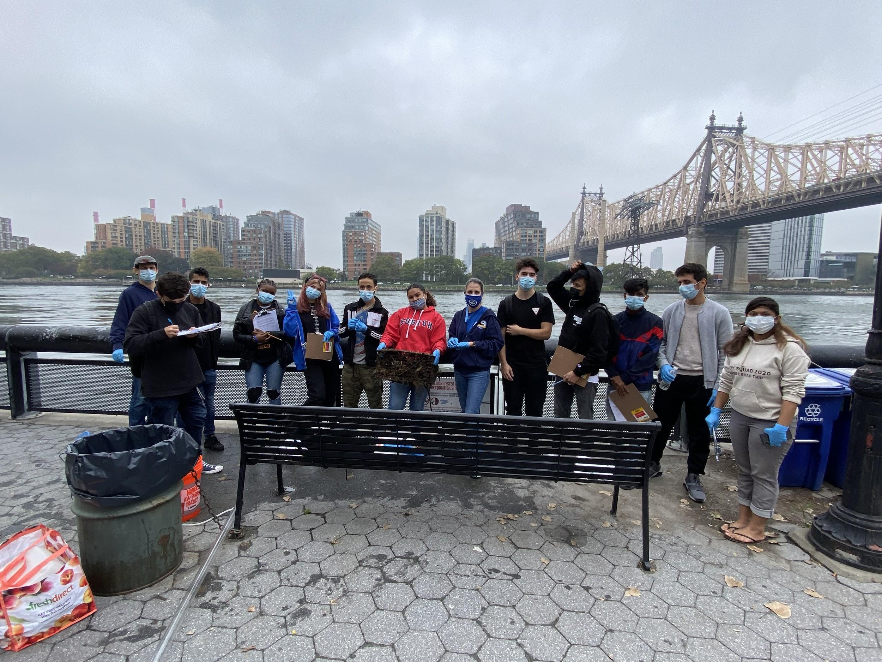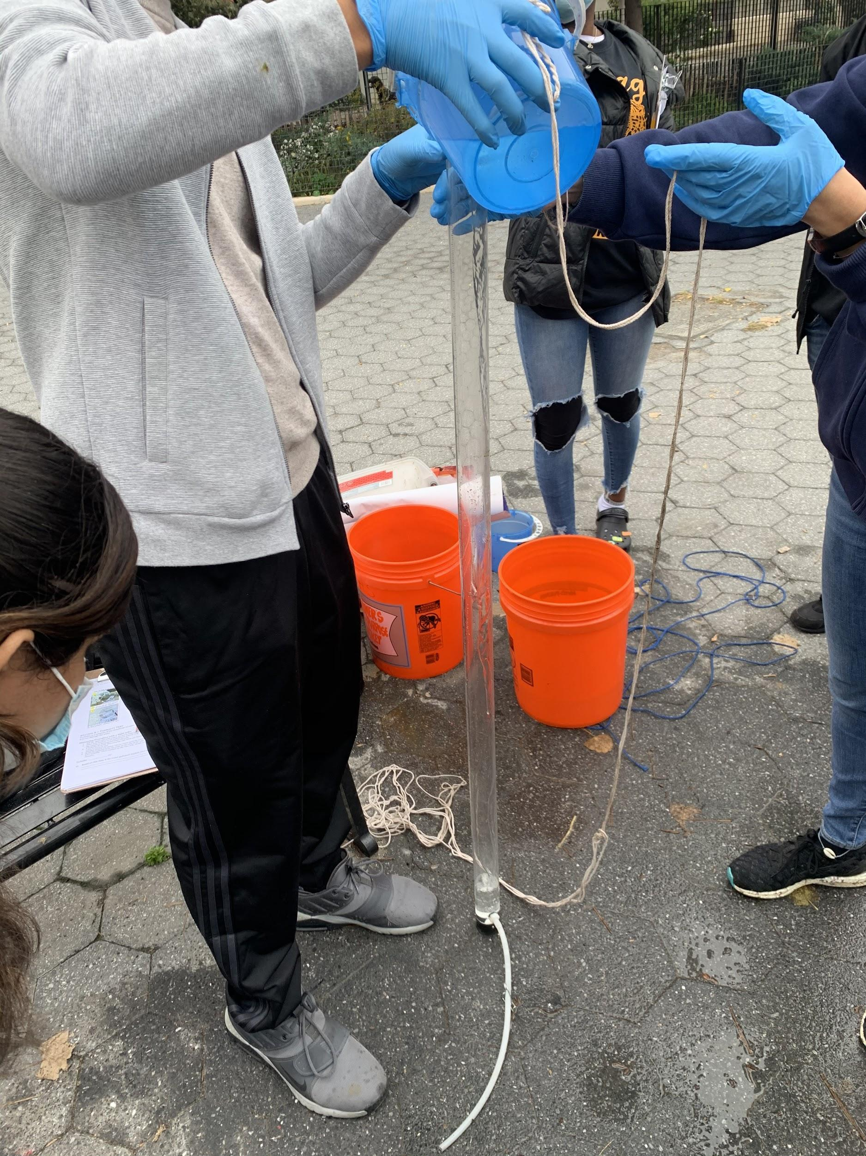
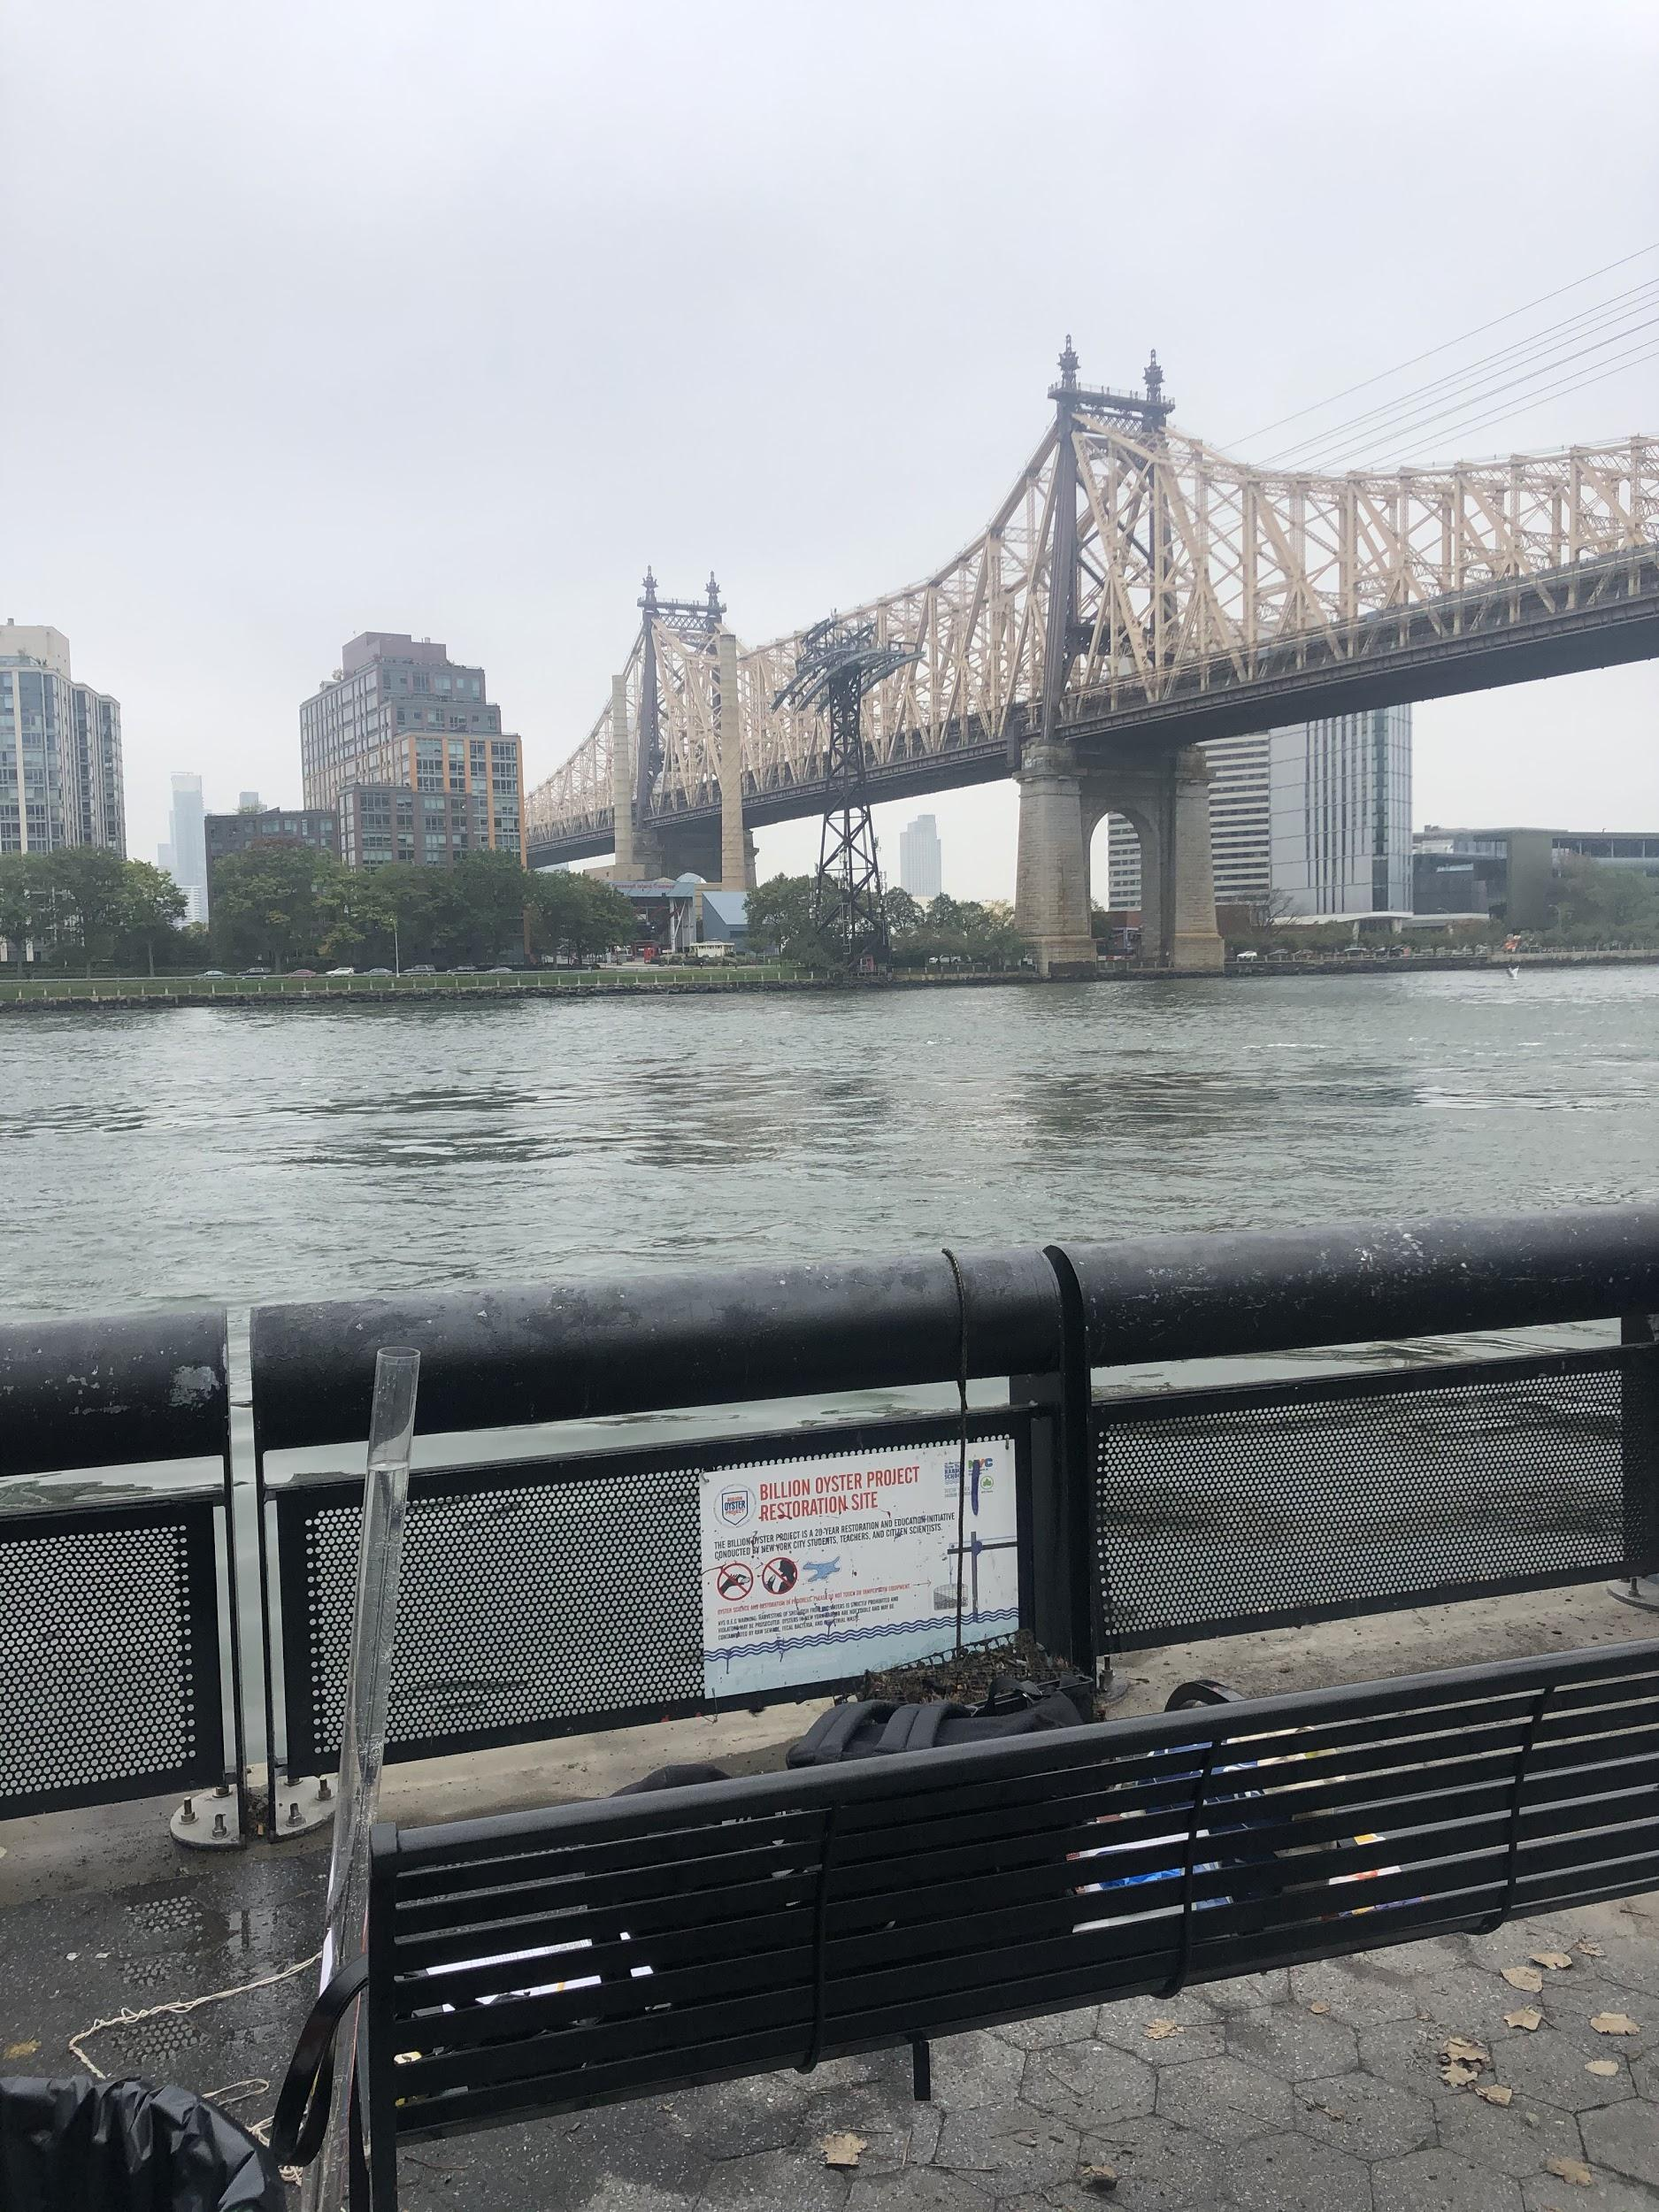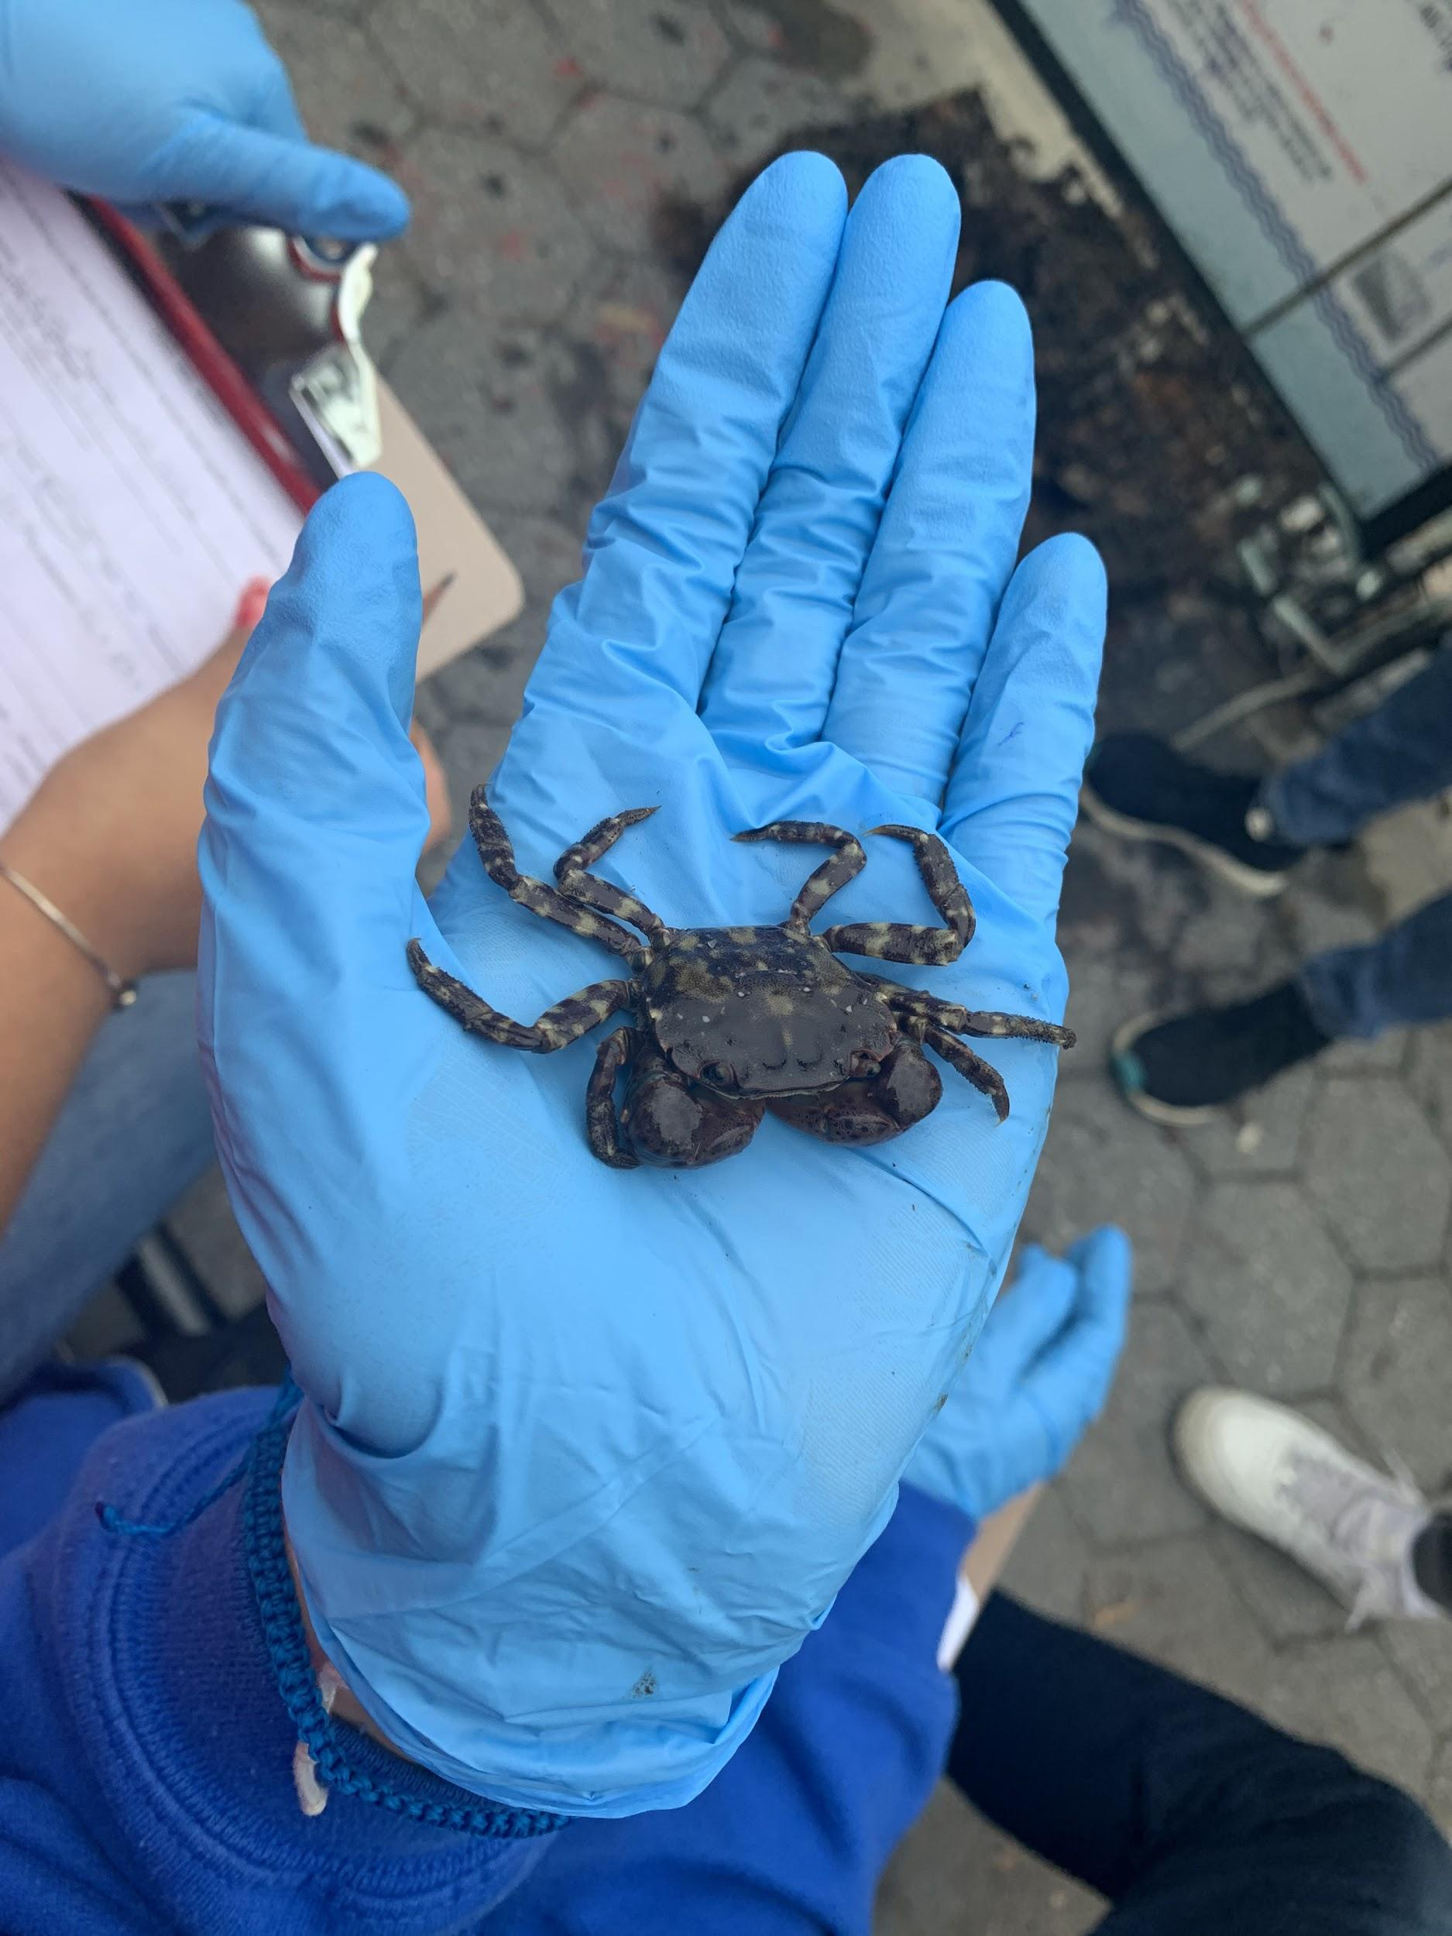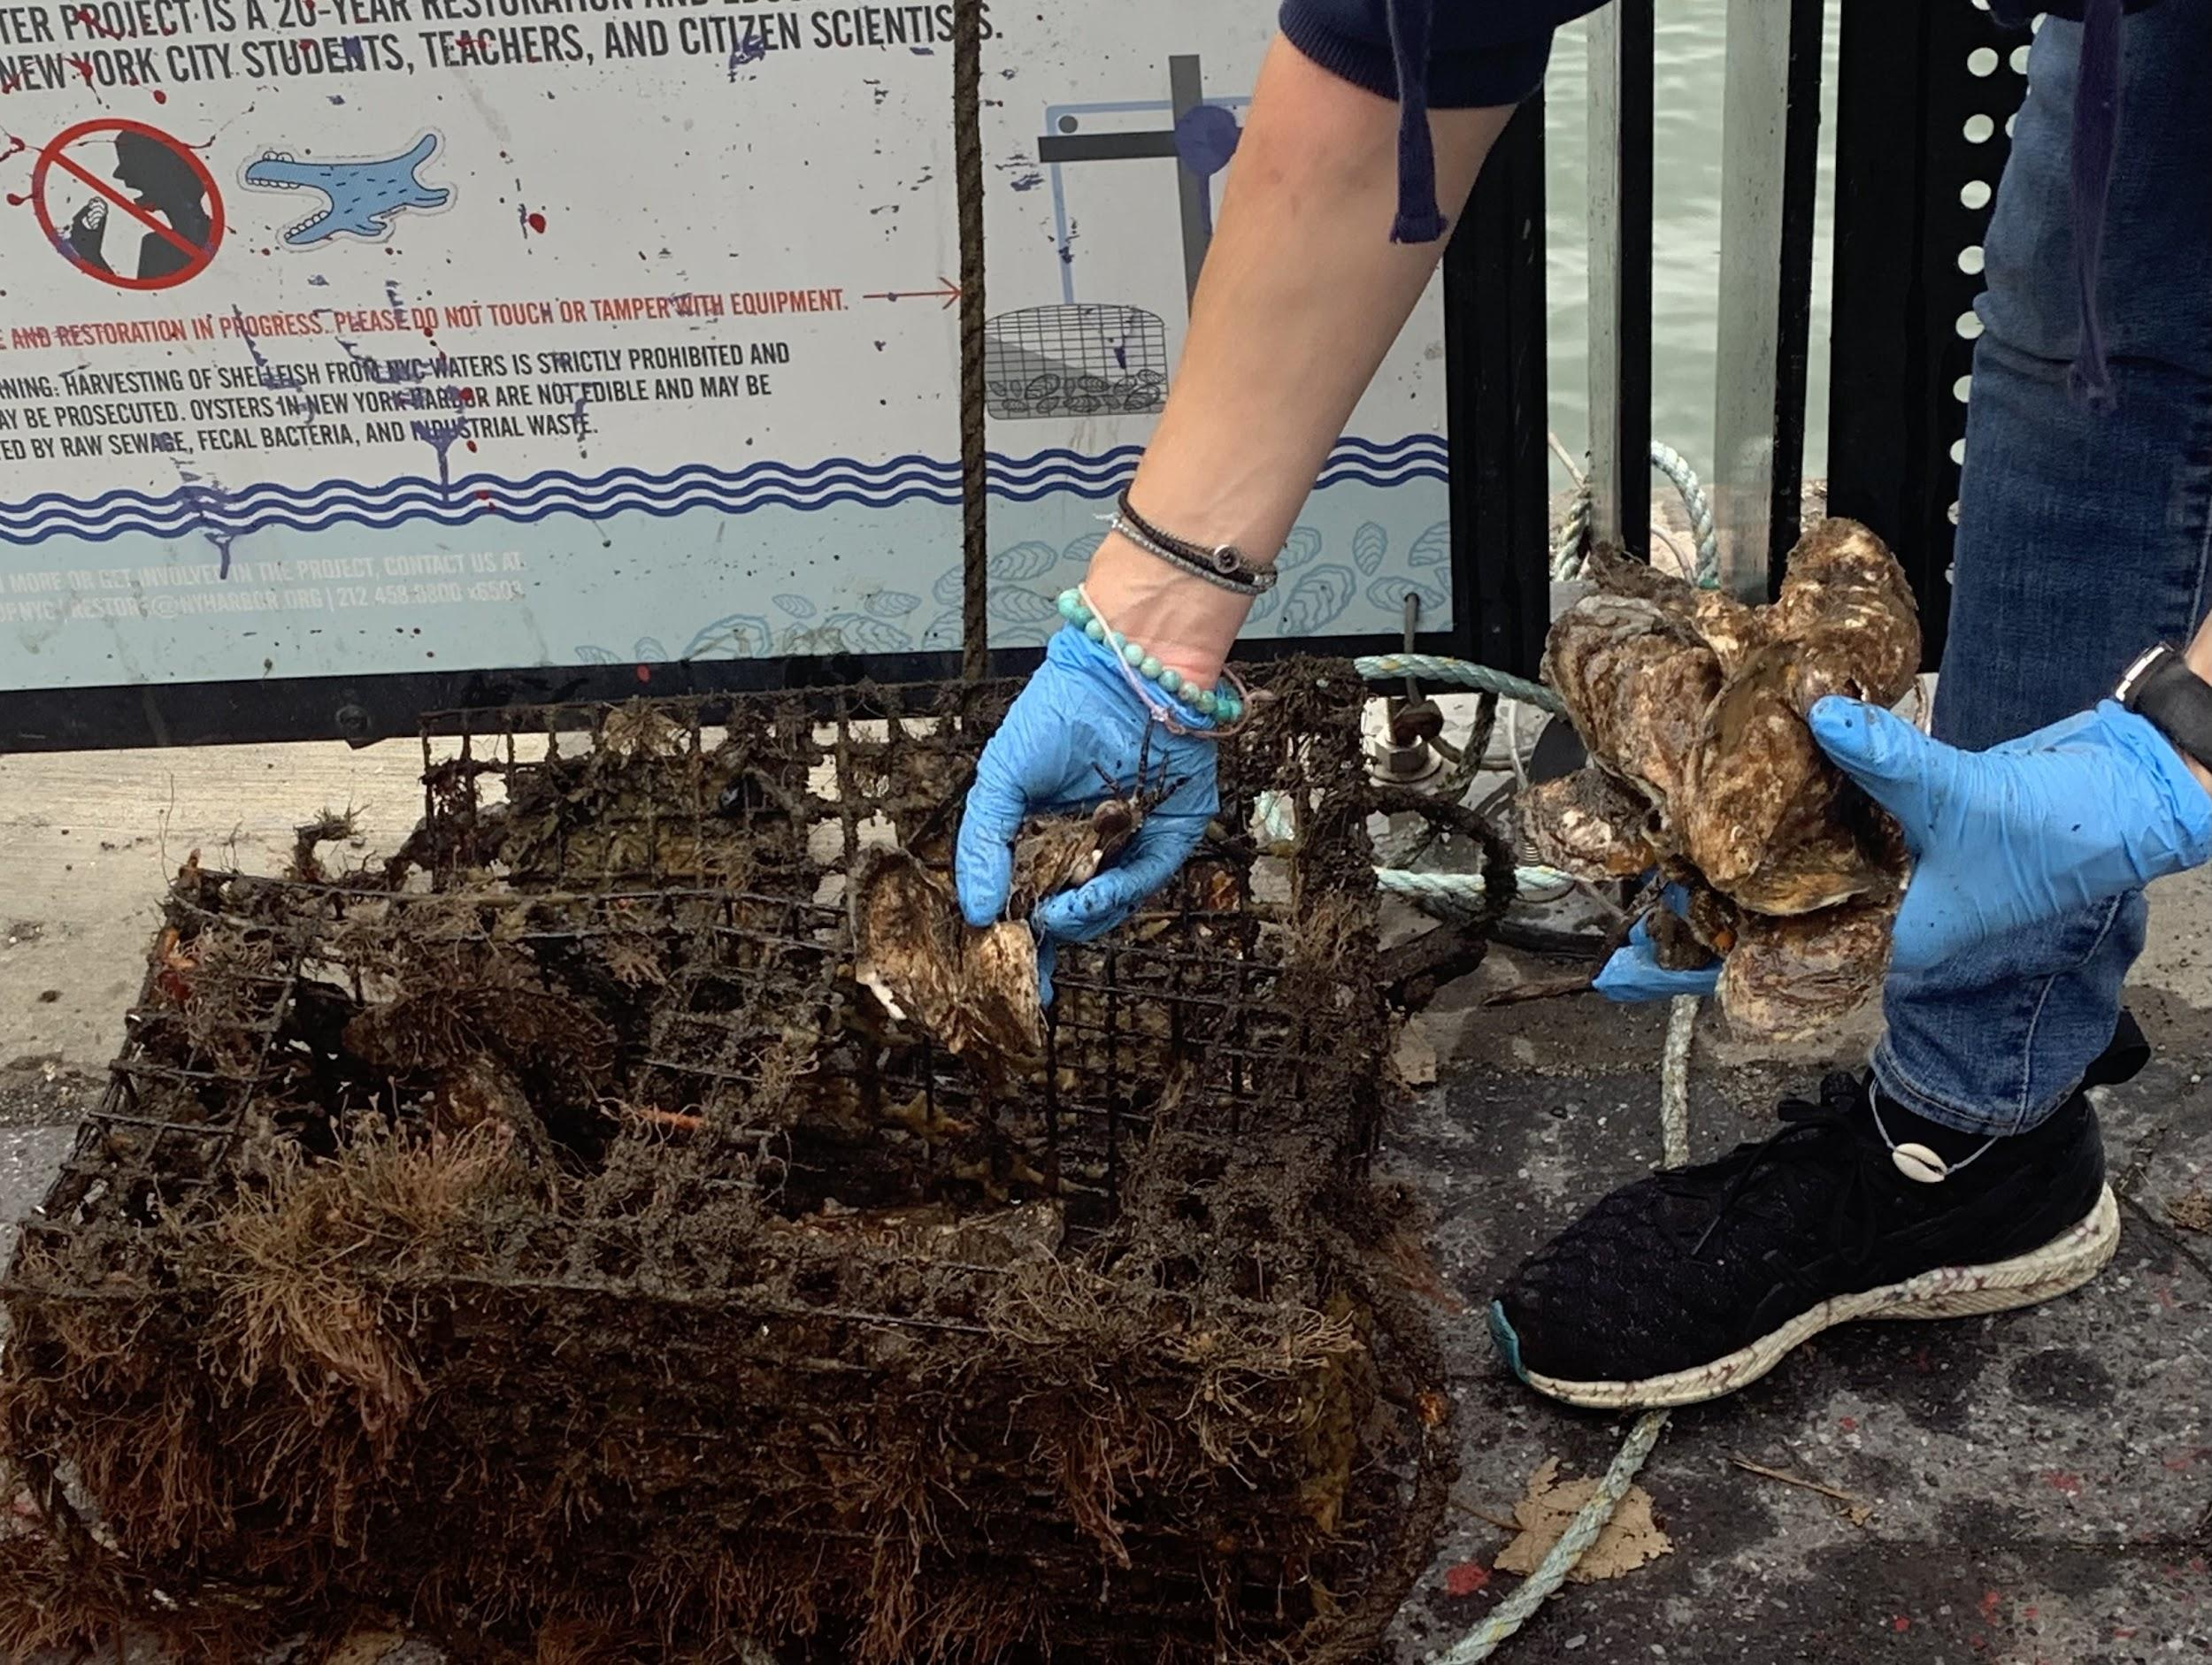
Location: East River at John Finley Walk, Manhattan, NY
Area: East River at John Finley Walk near Andrew Haswell Park on FDR N around 62nd street, across Roosevelt Island.
Surrounding Land Use: 80% Commercial, 20% Urban/Residential
Sampling Site: a walking area where people exercise, next to the Ed Koch Queensboro Bridge, near a dog park with some trees in the park. Buildings, hospitals, bushes, trees, garbage in the area. Water used for recreation, and transportation of resources and people.
Water: Dark choppy green color
Plants: Seaweed on the oyster cage

East River has been the receptacle for the city's garbage and sewage
ITEM | Time | Reading |  | Comments
Physical
Air Temperature: | 11:13am | 18º C | 64º F | Mostly cloudy, air temperature warm. Humidity 100%
Wind Speed: | 12:00pm | Beaufort: 0 | Wind direction  South east | No wind
Weather Today: | Mostly cloudy, gloomy with fog , warm feeling even at 64F because of the humidity.
Weather Previous: | Monday: 51-64 F, cloudy, waxing crescent  Tuesday: 58-70 F, cloudy, waxing crescent  Wednesday: 60-69 F, mostly cloudy, waxing crescent  In the past three days, it rained once. Rest of the days were warm. Densely foggy especially at night and in the morning
Tides-  used an app | Time | Rising/flood | Height (cm) | Rate of Tidal Change (cm/min)
 | 12:04 pm | Flood | 92.3 cm
Current- | Cm/second | Knots | North/South | Ebb/Flood/Still
Used an orange and measured the distance in 30 sec. | 1280.16 cm/30 secs  42.7 cm/sec | .83 knots | North | Flood
Water Temperature –  37 ft. deep  Digital thermometer | 12:02pm | 19.7 ºC  19.9 ºC  19.4 ºC | Average - 19.53 ºC
Turbidity -  Long site tube | ~12:00 pm | 120 cm  >120cm | Average 120 cm | A bit cloudy with particles inside
Chemical
Salinity-  Hydrometer | 12:45 pm | 24 ppt  26 ppt  26ppt | Average : 25ppt
DO –  La Motte | Time: | Temp | ppm DO | % saturation
DO –  La Motte | 12:59pm | 19.7 Cº | 6 ppm
pH - pH strips | 12:29 pm | 4
Macroinvertebrate | Number | Name | Length of Longest | Length of shortest
Inverts found in the oyster cages | 1 | Asian Shore crab
Inverts found in the oyster cages | 1 | Sea pill bug (isopod)
Inverts found in the oyster cages | 1 | Idotea Isopod
Inverts found in the oyster cages |  | (very small) tunicates
Boats | Time | Color | Direction | Loaded or Light
Commercial  Double skin 504  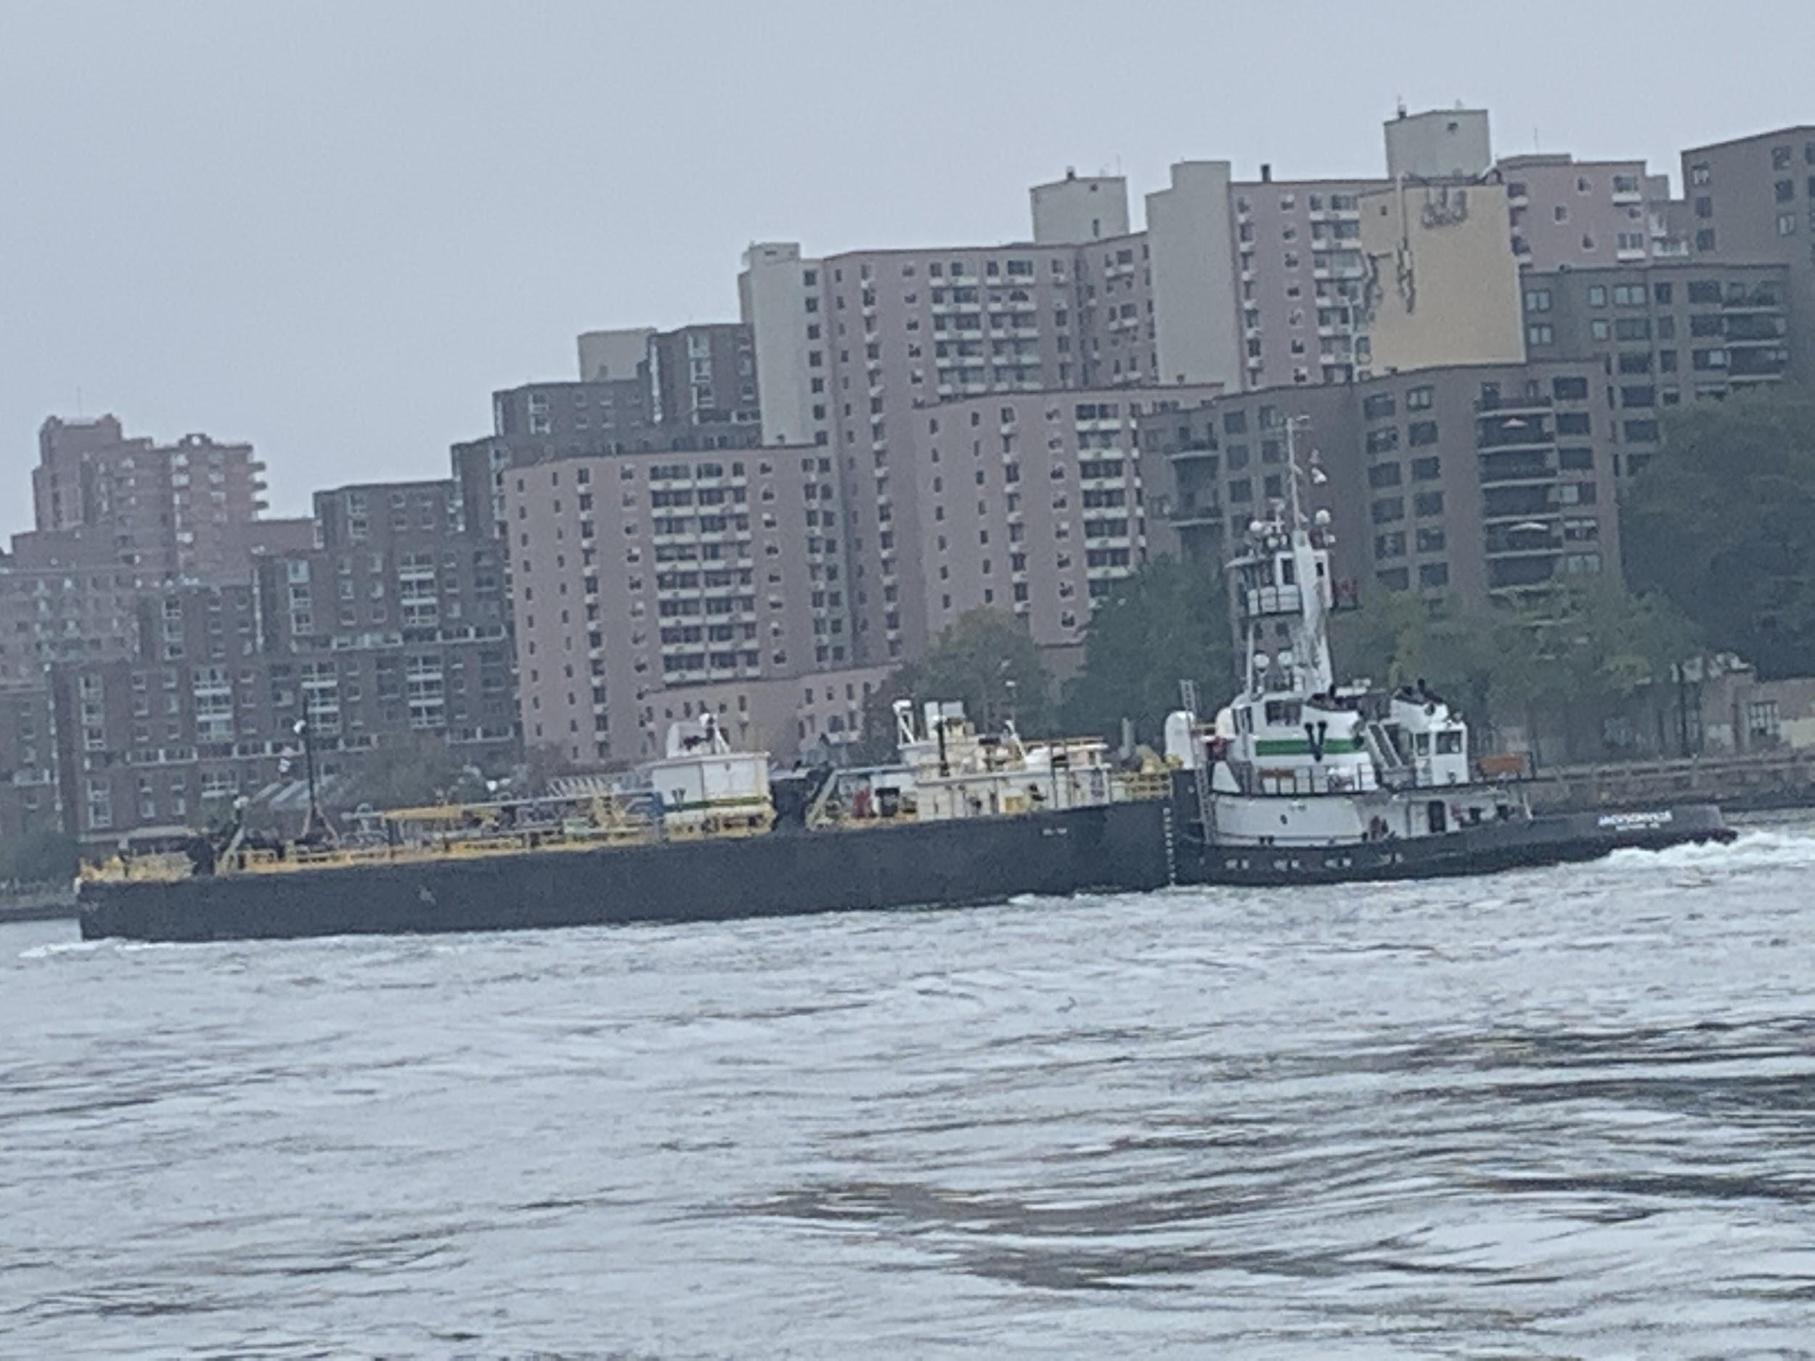 | 11:49am | Dark boat | From South to north | Loaded
Recreational  NYC Ferry  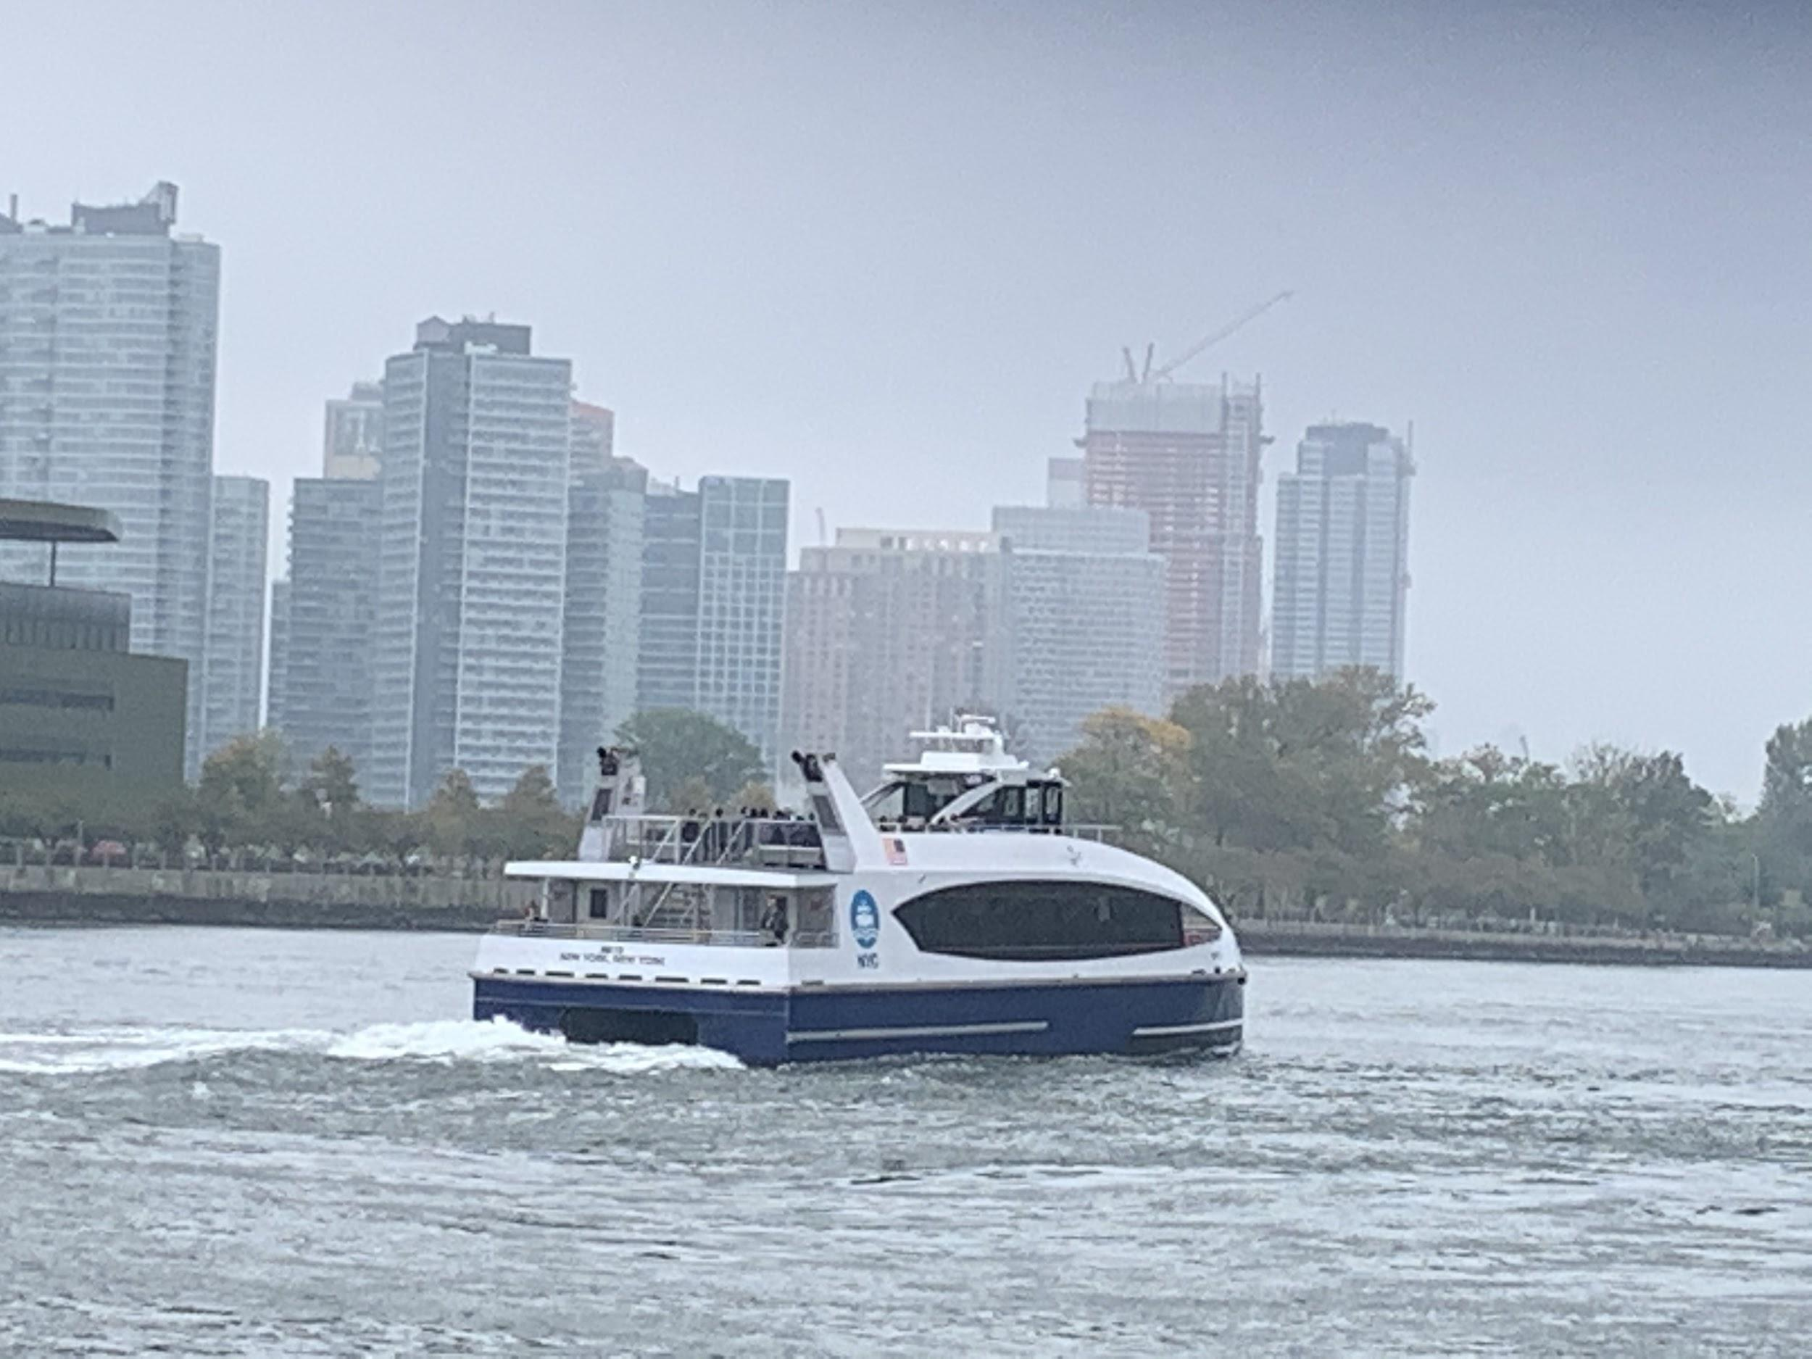 | 11:33 am | White with blue bottom border
Other Observations | Big Oysters - in the oyster restoration cage  Some birds - pigeon, seagulls, flies (from the garbage bin nearby)

