Day in the Life of the Hudson River 10/22/20
SCHOHARIE CREEK
RIVER MILE: (Mohawk River) 53
Salt Front: ~ RM 75
Middleburgh Central- Mollie Burgett
12 students 12th grade, 4 adults
Latitude 42.599635 N & Longitude – 74.337226 W
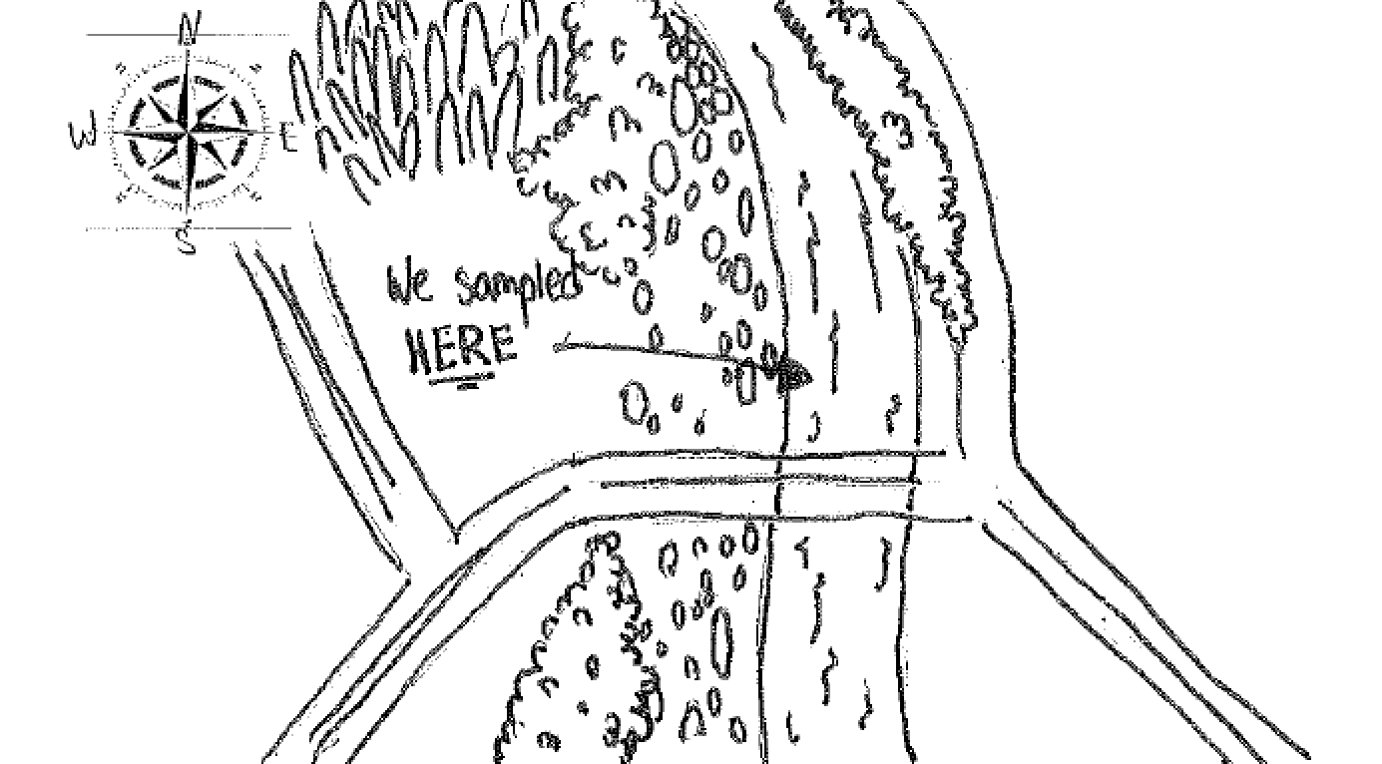

Location: Schoharie Creek, Mohawk Drainage, Middleburgh, Schoharie County, NY
Surrounding Land Use: 33% Forested, 33% Urban/Residential, 0% Industrial commercial, 33% Beach
Sampling Site: Creek access point is north of Timothy Murphy Park, Fishing access on northern side of the bridge.
Shoreline: 95% Rocky beach area, covered with vegetation, storm drain outflow south of sampling ~50 ft - 5% muddy
Water: 15.8 cm to bottom, calm
River Bottom: Rocky, small to medium cobbles
Plants in the water: no plants in the water area

ITEM | Time | Reading |  | Comments
Physical
Air Temperature | AM  AM | 29 º C  27 º C  19 º C | 84.2 º F  80.6 º F  66.2 º F
Wind Speed: | 11:00 AM  11:26 AM  12:05 PM | Beaufort 1  Beaufort 2  Beaufort 1 | North & South – shifting in between
Weather today | Overcast (50%) all day but no rain
Weather past 3 days: | Temperate
Tides- NA = above the head of tides. | Time | Rising, Falling, Unchanged | Water Height (cm) | Rate of Tidal Change (cm/min)
 | NA
Current- Stream Flow | Time | cm/second, Knots | North/South | Ebb/Flood/Still
 | 12:46 PM | 27.4 cm/s
Water Temperature- | 11:14 AM | 25 º C
Turbidity- long sight tube | 11:30 AM | Exceeded 60 cm
Chemical
Salinity- | NA
DO – drop count | Time | Temp | ppm DO | % saturation
 | 10:55 AM  11:09 AM  1:00 PM | 25 º C  23 º C  19 º C | 7.0  8.0  7.6 | 80%  92%  80%
pH – indicator solution | 11:12 AM | 7.6
Nitrates- | 11:12 AM  9:20 AM | 0 ppm  0 ppm
Biological
Fish | Number | Name | Length of longest | Notes
Seining Data 15 ft. X 3 mins. | 1  1  1 | Northern Hog Sucker  Green Sunfish  Bluegill Sunfish | 161 mm  35 mm  50 mm | Colder deeper water yielded more fish
Electro shocking | 4  30  52  4  3  4  2 | Smallmouth Bass  Rainbow Darter  Greenside Darter  Fantail Darter  Margined Madtoms  Long Nose Dace  Roseyface Shiner | 140 mm  66 mm  89 mm  50 mm  120 mm  93 mm  37 mm
Fish Totals | TOTAL: 102 | Diversity: 10 | For 3 caught by seine - 15 ft. pull/3 mins | 40 ft total 0.0164 CPU
Macroinvertebrates | Number | Name | Length of longest
Kick Net  2 Total minutes of kicking | 7  32  739  4  6  1  1 | Dobsonfly Larvae  Mayflies Larvae  Crayfish  Stonefly larvae  Mosquito larvae  Water beetle  Caddisfly Larvae
Macroinvertebrate Totals | TOTAL: 790 | Diversity: 7
Sediment Core | Time | Oxid Top | Grain Size | Other Features
 | NR
Observations | Quite a few bricks, lots of crayfish and macroinvertebrates
Journal Entry | During our endeavors, the environment was relaxing. We could hear the running water, smell the presence of aquatic life, and feel the slight breeze from the atmosphere. The organisms residing in the environment were more than fascinating, from Dobson fly larvae to rainbow darters, it was surprising to see the diversity in that the environment offered. The mellow weather and our curiosity to see the many lifeforms in the creek influenced out data collection.

