Day in the Life of the Hudson River 10/22/20
PIER 1 LIGHTHOUSE MUSEUM, STATEN ISLAND
RIVER MILE: -4.5
Salt Front: ~ RM 75
Curtis High School – David Scheffler, 3 participants
Latitude 40.640951 N & Longitude – 74.073463 W
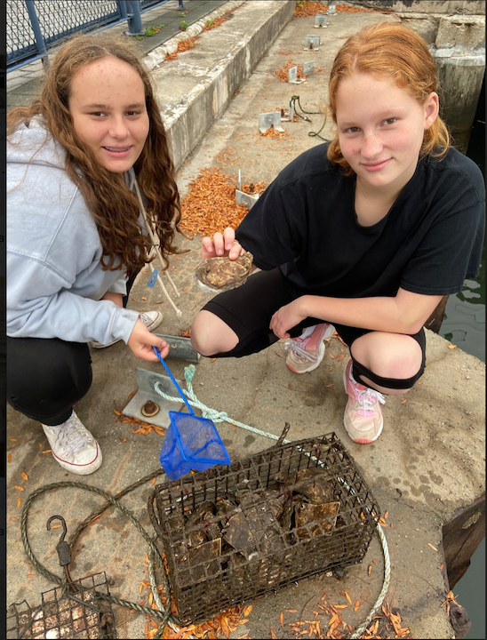
Location: Pier 1 Lighthouse Museum, Staten Island, NY
Area: Pier with parking lot.
Surrounding Land Use: 50% Industrial, 50% Commercial
Sampling Site: Wood bulkhead, concreate bulkhead, banks altered, riprap
Shoreline: 20% sandy, 30% muddy, 50% rocky.
River Bottom: Rocky

ITEM | Time | Reading |  |  | Comments
Physical
Air Temperature | 9:10 AM | 20.12 º C |  | 68.2 º F
Wind Speed: | 9:10 AM | 0 mph
Weather today | Very heavy fog layer
Weather past 3 days: | Cloud cover, little to no wind, afternoon highs in upper 60s, nighttime lows in upper 50s
Tides- | Low Tide | High Tide |  | Time of Sampling | Tide
 | 7:23 AM | 1:43 PM |  | 9:25 AM | Flood
Current- | Time | cm/second, Knots |  | North/South | Ebb/Flood/Still
 | 9:25 AM | 3.72 cm/sec, .07 knots |  | North | Flood
Water Temperature- | 10:45 AM | 16.85 º C | 62.3 º F
Turbidity- Long sight tube | 10:30 AM | 80 cm
Chemical
Salinity- Refractometer | 10:00 AM | 30 ppt
DO – | Time | Temp |  | ppm DO | % saturation
pH – color match kit | 10:15 AM | 6
Nitrates- color match kit |  | 5 ppm
Biological
Fish | Number | Name |  | Length of longest | Length of smallest
 | 4  6  2 | Striped Bass  Tautog  Skilletfish |  | 76.2 cm  63.5 cm  6 cm | 45.72 cm  25.4 cm
Fish Totals | TOTAL: 12 | Diversity: 3
Macroinvertebrates | Number | Name |  | Length of longest | Length of smallest
 | 20 | Green Crab |  | 13 cm | 3 cm
Macroinvertebrate Totals | TOTAL: | Diversity:
Sediment Core | Time | Oxidized Top |  | Grain Size | Other Features
NR
Boats | Time | Name/Color |  | North/South | Loaded/Light
NR
Observations

