Day in the Life of the Hudson River 10/22/20
CANARSIE PIER, JAMAICA BAY
RIVER MILE: -5.3
Salt Front: ~ RM 75
DEC Region 3– River and 2 SCA
Latitude 40.62927 N & Longitude – 73.88449 W
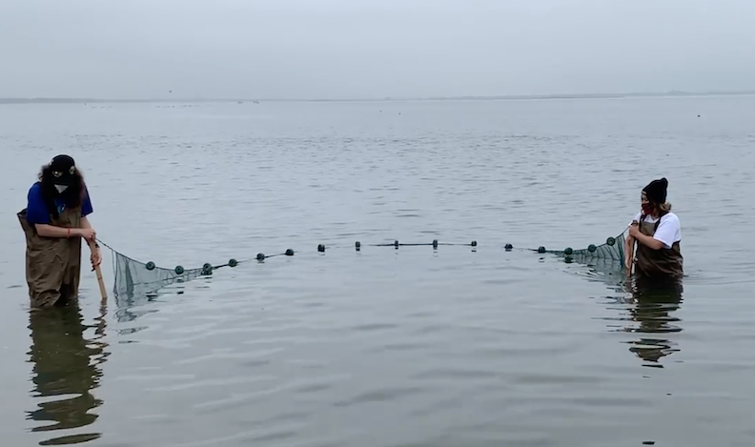
Location: Canarsie Pier, Jamaica Bay, Brooklyn, NY
Area: Recreational pier- rocks near the edge, banks altered, large beach, large pipe entering water.
Sampling Site: Beach, covered with vegetation, concrete pier, riprap along part of the shoreline near the pier
Surrounding Area: 40% Park, 40% parking lot, 10% beach, 10% grass.

ITEM | Time | Reading |  |  | Comments
Physical
Air Temperature
Wind Speed:
Weather today
Weather past 3 days:
Tides- | Low Tide | High Tide |  | Time of Sampling | Tide
Current- | Time | cm/second, Knots |  | North/South | Ebb/Flood/Still
Water Temperature- |  | 18 º C | 64.4 º F
Turbidity- Long sight tube |  | Turbidity was so clear that it exceeded the length of the long sight tube
Chemical
Salinity- Hydrometer |  | 30 ppt
DO – | Time | Temp |  | ppm DO | % saturation
pH –
Biological
Fish | Number | Name |  | Length of longest | Notes
 | 1  2 | Striped Anchovy  Atlantic Silverside
Fish Totals | TOTAL: 3 | Diversity: 2
Macroinvertebrates | Number | Name |  | Length of longest
Macroinvertebrate Totals | TOTAL: | Diversity:
Sediment Core | Time | Oxidized Top |  | Grain Size | Other Features
NR
Boats | Time | Name/Color |  | North/South | Loaded/Light
NR
Observations

