Day in the Life of the Hudson River 10/22/20
FORT WADSWORTH, STATEN ISLAND
RIVER MILE: -7.5
Salt Front: ~ RM 75
St. Clare School- Mary Lee
National Park Service- Ranger Kathy Garofalo
2 participants
Latitude 40.59905 N & Longitude – 74.0527 W
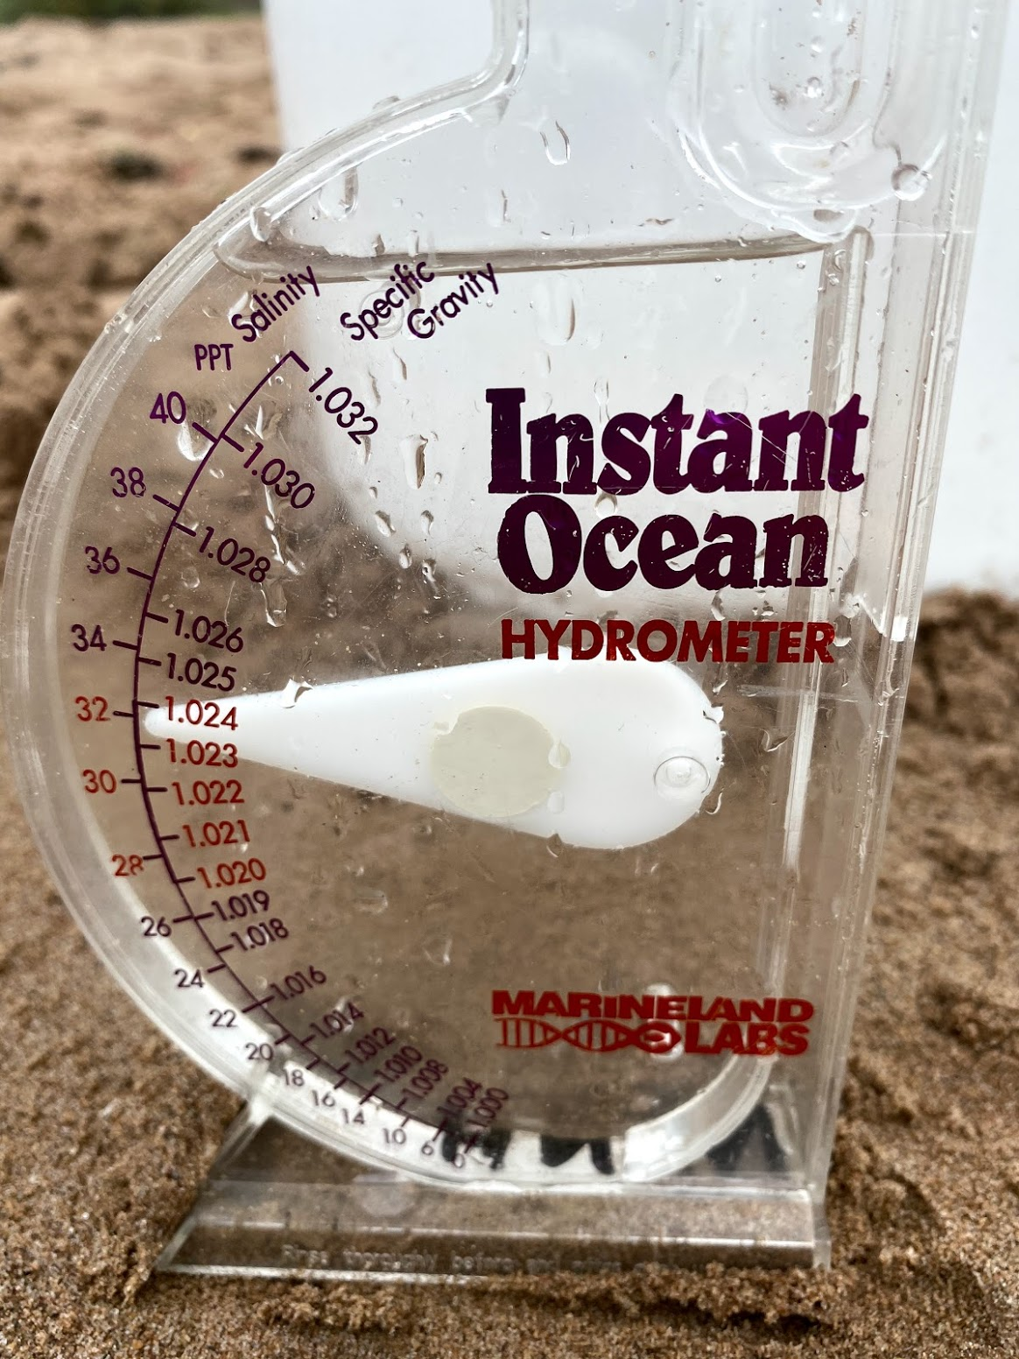 | 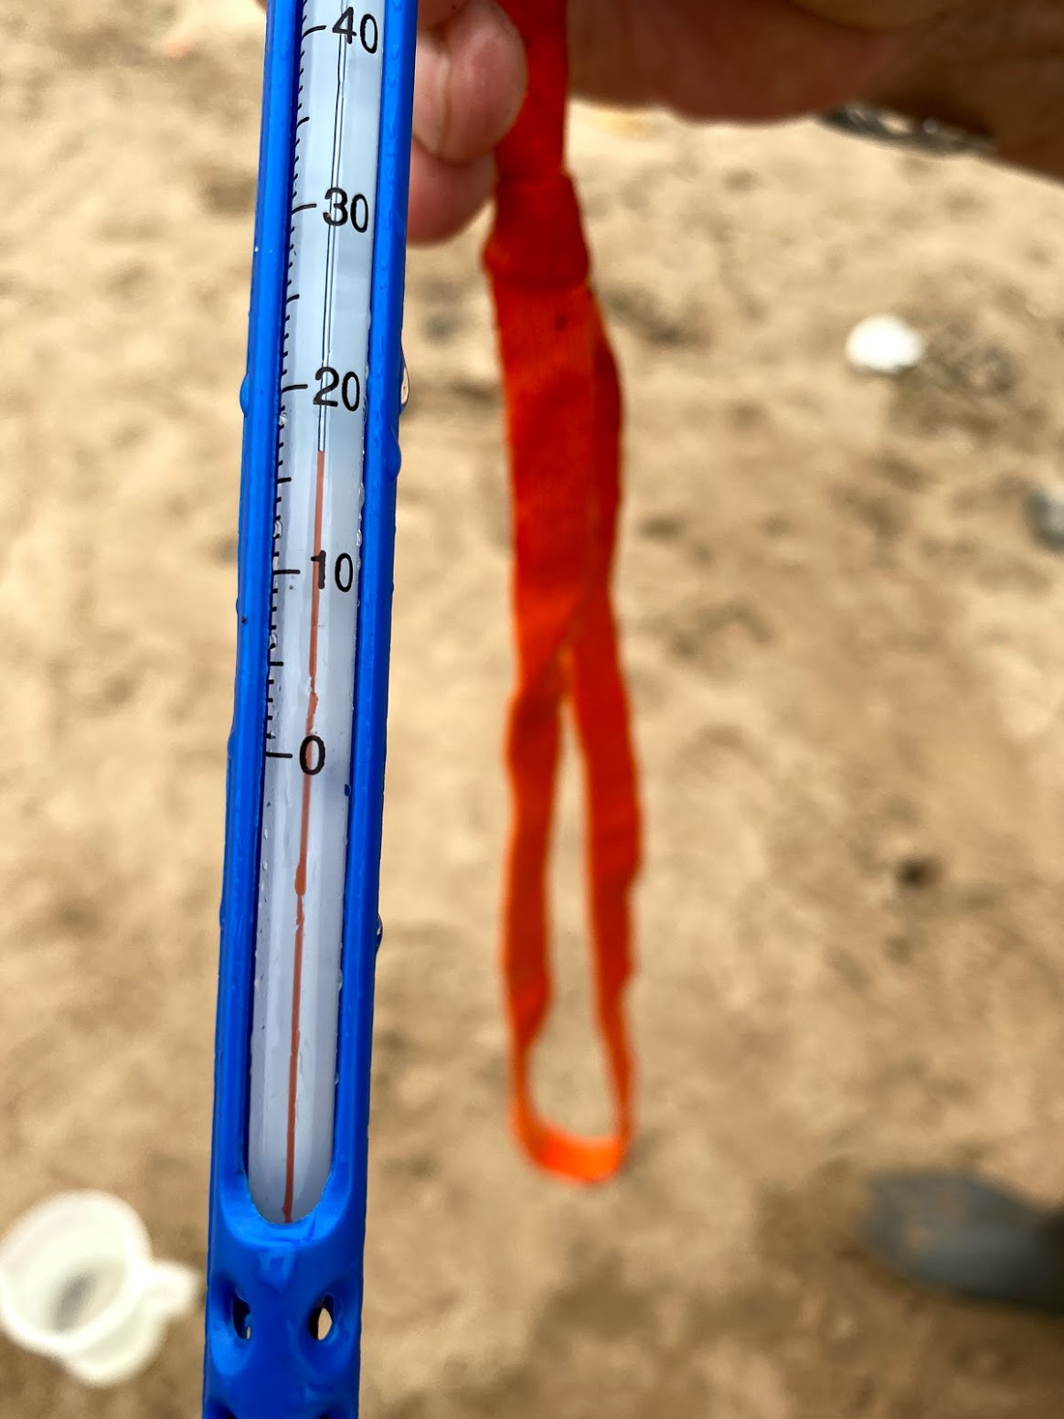 | 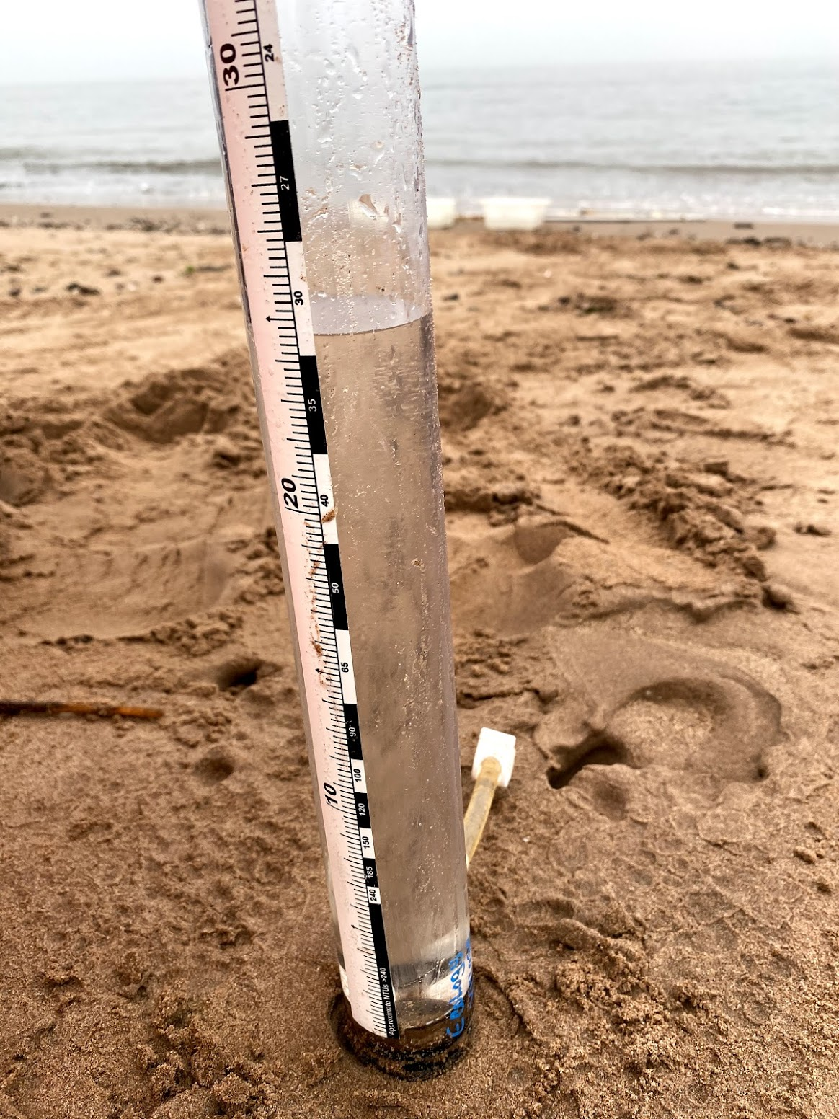

Location: Seabee Fishing Beach, Fort Wadsworth, Staten Island, NY
Area: South of Verrazano Bridge; west side of the Hudson River.
Sampling Site: beach area with bulkhead, Fort on site.
Shoreline: 50% Beach, 50% Forested
Surrounding Area: beach with riprap, concrete broken in area, pier nearby, behind the beach is covered with vegetation
Water Depth: 204 ft.
River Bottom: Sandy
Plants in area: No plants

ITEM | Time | Reading |  |  | Comments
Physical
Air Temperature | 11:20 AM | 18.9 º C |  | 66 º F
Wind Speed: | 11:20 AM | 5 mph |  | E/NE
Weather today | No Rain; Extremely cloudy and foggy, temperature in mid 60s. Water was calm.
Weather past 3 days: | Slight rain on Tuesday and Wednesday. Temperature 60-70 F since Monday.
Tides- | Low Tide | High Tide |  | Time of Sampling | Tide
 | 6:53 AM | 1:18 PM |  | 12:00 PM | Flooding
Current- | Time | cm/second, Knots |  | North/South | Ebb/Flood/Still
 | 12:00 PM | 21.7 cm/sec, 0.422 knots |  | North | Flood
Water Temperature- | 11:57 AM | 64.22 º F | 17.9 º C
Turbidity- | NR
Chemical
Salinity- Meter | 11:57 AM | 21.77 ppt
DO – Meter | Time | Temp |  | ppm DO | % saturation
 | 11:57 AM | 17.9 º C |  | 5.3 | 63.8
pH – Meter | 11:57 AM | 7.28
Biological
Fish | Number | Name |  | Length of longest | Notes
 | 100 + | Atlantic Silverside
Fish Totals | TOTAL: 100 | Diversity: 1
Macroinvertebrates | Number | Name |  | Length of longest
Macroinvertebrate Totals | TOTAL: | Diversity:
Sediment Core | Time | Oxidized Top |  | Grain Size | Other Features
NR
Boats | Time | Name/Color |  | North/South | Loaded/Light
NR
Observations

