Day in the Life of the Hudson River 10/22/20
FRESHKILLS PARK, STATEN ISLAND
RIVER MILE: Arthur Kill -9
Salt Front: ~ RM 75
Freshkills Park Alliance- Rachel Aronson, 1 participant
Latitude 40.578275 N & Longitude – 74.184301 W
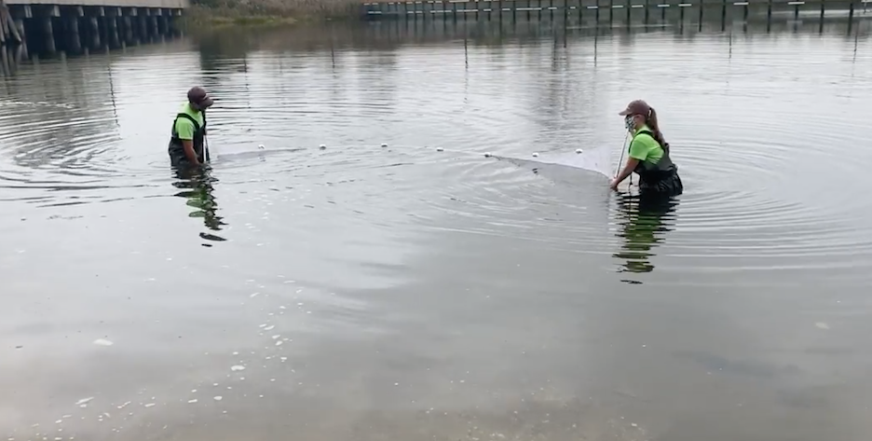
Location: Freshkills Park, Staten Island, NY
Area: Marsh park off of the Arthur Kill.
Sizeable green space on a former landfill site featuring occasional public events and hiking trails.

ITEM | Time | Reading |  |  | Comments
Physical
Air Temperature | NR
Wind Speed:
Weather today | NR
Weather past 3 days: | NR
Tides- | Time | Rising, Falling, Unchanged |  | Water Height (cm) | Rate of Tidal Change (cm/min)
 | NR
Current- | Time | cm/second, Knots |  | North/South | Ebb/Flood/Still
 | NR
Water Temperature- | 11:57 AM | 64.22 º F | 17.9 º C
Turbidity- | NR
Chemical
Salinity- Meter | 11:57 AM | 21.77 ppt
DO – Meter | Time | Temp |  | ppm DO | % saturation
 | 11:57 AM | 17.9 º C |  | 5.3 | 63.8
pH – Meter | 11:57 AM | 7.28
Biological
Fish | Number | Name |  | Length of longest | Notes
 | 100 + | Atlantic Silverside
Fish Totals | TOTAL: 100 | Diversity: 1
Macroinvertebrates | Number | Name |  | Length of longest
Macroinvertebrate Totals | TOTAL: | Diversity:
Sediment Core | Time | Oxidized Top |  | Grain Size | Other Features
NR
Boats | Time | Name/Color |  | North/South | Loaded/Light
NR
Observations

