Day in the Life of the Hudson River 10/22/20
MORRIS CANAL BASIN, NEW JERSEY
RIVER MILE: 0.5
Salt Front: ~ RM 75
Lab High School – Susan Price, 2 participants
Hudson Montessori School- Grace Sanvictores, 24 participants
Latitude 40.707725 N & Longitude – 74.03447 W
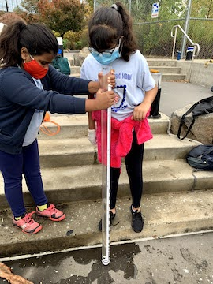 | 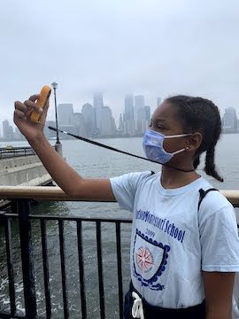 | 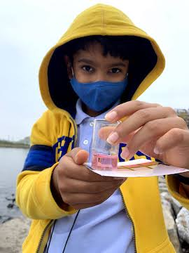

Location: Morris Canal Basin, Jersey City, Hudson County, New Jersey
Area: Walking and fishing pier along a developed area, walkway with railing, water’s edge is rocky.
Surrounding Land Use: 100% Industrial
Sampling Site: Waterfront pier jutting out along the waterfront surrounding a canal inlet, walk down to the water to a rocky shoreline.
Shoreline: 100% Rocky

ITEM | Time | Reading |  |  | Comments
Physical
Air Temperature | 10:00 AM  3:30 PM | 20 º C  20.5 º C |  | 68 º F  68.9 º F
Wind Speed: | 9:00 AM  1:00 PM  3:30 PM | 3.8 m/sec  0.5 m/sec  0 m/sec |  | <1 Beaufort
Weather today | 9:00 AM Downpour, 3:30 PM no rain
Weather past 3 days: | Rain on previous day, slight overcast, cool at night
Tides- | Low Tide | High Tide |  | Time of Sampling | Tide
 | 7:27 AM | 1:48 PM |  | 10:00 AM | Flood
Current- | Time | cm/second, Knots |  | North/South | Ebb/Flood/Still
 | 10:00 AM |  |  | North | Flood
Water Temperature- | 10:00 AM  3:30 PM | 17 º C  18 º C | 62.6 º F  64.4 º F
Turbidity- Long sight tube | 10:00 AM  4:00 PM | 80 cm (Secchi was 85 cm)  33 cm
Chemical
Salinity- Hydrometer  Refractometer | 10:00 AM  3:30 PM | 20ppt  22 ppt
DO – | Time | Temp |  | ppm DO | % saturation
Hach Drop Count  Chemets Kit | 11:30 AM  12:30 PM  3:30 PM | 17 º C  17 º C  18 º C |  | 6 ppm  8 ppm  7 ppm | 65%  90%  80%
pH – Meter  Color match kit | 10:00 AM  3:30 PM | 6.5  8.1
Nitrates- | 3:30 PM | 0 ppm
Biological
Fish | Number | Name |  | Length of longest | Length of smallest
Trap | 2 | Mummichog |  | 7 cm | 6 cm
Fish Totals | TOTAL: 2 | Diversity: 1
Macroinvertebrates | Number | Name |  | Length of longest | Length of smallest
 | 2 | European Green Crab
Macroinvertebrate Totals | TOTAL: 2 | Diversity: 1
Sediment Core | Time | Oxidized Top |  | Grain Size | Other Features
NR
Boats | Time | Name/Color |  | North/South | Loaded/Light
NR
Observations | 1 dead green crab

