Day in the Life of the Hudson River 10/22/20
LASHER PARK, GERMANTOWN
RIVER MILE: 108.5
Salt Front: ~ RM 75
Columbia Land Conservancy- Heidi Bock – 7 adults total
Latitude 42.1589 N & Longitude – 73.9959 W
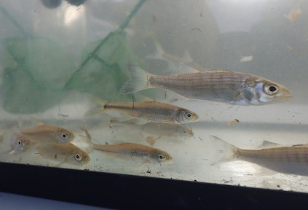
Location: Lasher Memorial Park, Boat Launch, Northern Germantown Landing, Columbia County, NY
Area: Grassy area, boat launch, pier, parking lot- used for picnics and boating
Surrounding Land Use: 5% Forested; 80% Urban/Residential; 5% Beach; 10% Industrial/Commercial
Sampling Site: Park with mowed lawn, beach, riprap in area
Shoreline: 75% Sandy; 20% muddy; 5% rocky
Water:
River Bottom: Muddy, weedy, sandy
Plants in water:

ITEM | Time | Reading |  | Comments
Physical
Air Temperature | 9:35 AM | 60 º F | 15.5 º C
Wind Speed: | 9:40 AM | 0 knots | South
Weather today | 9:35 AM no rain
Weather the past 3 days: | Mild and unseasonably warm
Tides- | Time | Rising, Falling, Unchanged | High tide time | NOTE:
 | 12:30 PM | Ebbing | 8:13 AM | Tidal change of 22 inches from 9:30 to 12:30 PM
Current- | cm/second | Knots | North/South | Ebb/Flood/Still
NR
Water Temperature | 11:30 AM | 17 º C | 62.6 º F
Turbidity- long sight tube | 11:40 AM | 51 cms
Chemical
Salinity- | Time | Hydrometer
 | 11:40 AM | Below Detection  With instrument
DO – Drop count kit | Time | Temp | ppm DO | % saturation
 | 11:25 AM | 17 | 7 | 70%
pH – Color Match Kit | 11:55 AM | 7
Biological
Fish | Number | Name | Length of longest | Length Shortest
Seine: 25’  # Pulls: 4 | 10  4  8 | Tesselated Darter  Striped Bass  Spottail Shiner | 7 cm  9 cm  7 cm | 6 cm  7 cm  4 cm
Fish Totals | TOTAL: 22 | Diversity: 3
Macroinvertebrates | Number | Name | Length of longest | Length of Shortest
 | 17 | Blue Crab | 9 Cm | 1.5 cm
Macroinvertebrate Totals | TOTAL: 17 | Diversity: 1
Boats | Time | Name/Color | North/South | Loaded/Light

