Day in the Life of the Hudson River 10/22/20
INWOOD HILL PARK, MANHATTAN (HUDSON RIVER)
RIVER MILE: 12.75
Salt Front: ~ RM 75
NYC Park and Urban Park Rangers –Daniel Tainow, 6 participants
Latitude 40.578275 N & Longitude – 74.184301 W
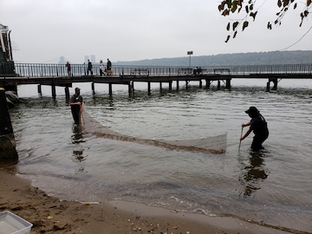
Location: Inwood hill Park, Dyckman St. Fishing Pier, Hudson River, Manhattan, NY
Area: Hudson River waterfront, a pier and a park
Surrounding Land Use: 10% Forested; 40% Park
Sampling Site: beach area and a pier
Shoreline: beach
ITEM | Time | Reading |  |  | Comments
Physical
Air Temperature | 1:30 PM | 21 º C |  | 70 º F
Wind Speed: | 1:45 PM | 1 mph
Weather today | Fog
Weather past 3 days: | Warm, foggy, humid
Tides- | Low Tide | High Tide |  | Time of Sampling | Tide
 | 7:30 AM | 1:30 PM |  | 1:50 PM | Slack
Current- | Time | cm/second, Knots |  | North/South | Ebb/Flood/Still
 | 2:00 PM | 0 cm/sec |  | Slack | Still
Water Temperature- | 2:00 PM | 18.3 º C | 65 º F
Turbidity- Short Sight Tube | 2:30 PM | 40 JTU
Chemical
Salinity- Hydrometer | 2:00 PM | 15 ppt
DO – LaMotte Kit | Time | Temp |  | ppm DO | % saturation
 | 2:55 PM | 18.3 º C |  | 4 ppm | 42
pH – Color Match Kit | 2:45 PM | 6.5
Nitrates- | 3:00 PM | 5 ppm
Biological
Fish | Number | Name |  | Length of longest | Length of smallest
 | 27 | Atlantic Silverside |  | 3 inches
Fish Totals | TOTAL: 27 | Diversity: 1
Macroinvertebrates | Number | Name |  | Length of longest | Length of smallest
 | 9  3 | Comb Jelly  Unidentified Jelly (moon?) |  | 2 inches
Macroinvertebrate Totals | TOTAL: 12 | Diversity: 2

