Day in the Life of the Hudson River 10/22/20
NUTTEN HOOK
RIVER MILE: 124.5
Salt Front: ~ RM 75
Liz LoGuidice & Fran Martino – total 10 people
Resilience Communications & River Haggie Outdoors
Latitude 42.358271 N & Longitude – 73.78818 W
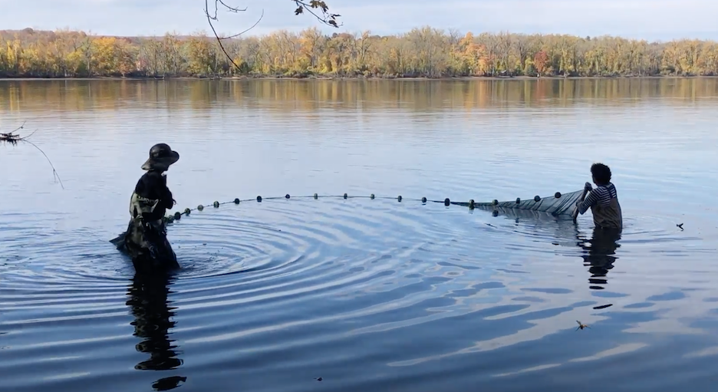
Location: Nutten Hook, Green County, NY
Area: Beach, forested bluff, large march behind bluff, DEC public access, used for picnics, water access
Surrounding Land Use: 45% Beach; 55% Forested
Sampling Site:
Shoreline: Sandy and rocky, riprap, banks altered in some areas with bulkhead, brick and slag on ground
River Bottom: sandy, muddy
Water:
Sampling Time:

ITEM | Time | Reading |  | Comments
Physical
Air Temperature | 2:30 PM | 20 º C | 68 º F
Wind Speed: | NR
Weather today | Slightly overcast
Weather the past 3 days: | Average time, mostly dry, light rain on 19th and 20th
Tides- | Time | Tidal Flow during sampling | High Tide Time | Low Tide Time
 | 2:30 PM | Ebbing | 9:26 AM | 3:56 AM
Water Temperature- probe | 2:30 PM | 18 º C | 64.4 º F
Turbidity- long sight tube | 2:45 PM | 70 cm
Chemical
Salinity- | Time
 | NR
DO – | Time | Temp | ppm DO | % saturation
 | 2:30 PM | 18 º C | 9 | 95%
pH – color match kit | 3:00 PM | 7.4
Biological
Fish | Number | Name | Length of longest
Seine | 1  1 | eel  bluegill sunfish
Fish Totals | TOTAL: 2 | Diversity: 2
Macroinvertebrates | Number | Name | Length of longest
 | 3 | Blue Crab
Macroinvertebrate Totals | TOTAL:  3 | Diversity:  1

