Day in the Life of the Hudson River 10/22/20
ENGLEWOOD BOAT BASIN, ENGLEWOOD NJ
RIVER MILE: 14
Salt Front: ~ RM 75
Meadowlands Environmental Center –Kirk Weber and Susan Lewicki
PS 28 Paterson, NJ- Maureen Bruins
Latitude 40.880581 N & Longitude – 73.944525 W
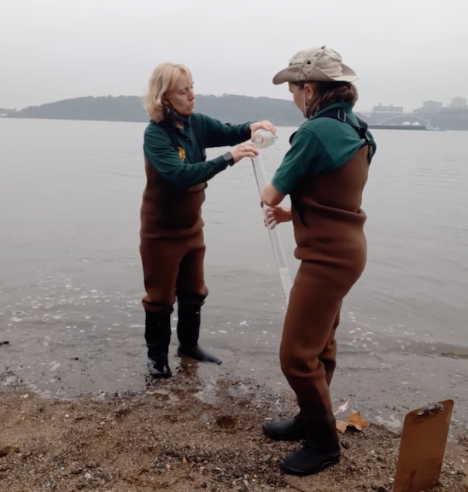
Location: Bloomers Beach (North end), Englewood Boat Basin, NJ
Area: Sandy beach, banks altered, pier with riprap sections, wood bulkhead, debris in area. Piping ~30 ft located at sampling site. 2 concrete bulkheads and stone breakwaters on shoreline.
Surrounding Land Use: 40% Forested; 20% Beach; 20% Industrial/Commercial; 20% Urban/Residential
Shoreline: Loamy sand- sand and mud, a little weedy and rocky
River Bottom: Muddy
ITEM | Time | Reading |  |  | Comments
Physical
Air Temperature | 9:37 AM | 18.9 º C |  | 66 º F
Wind Speed: | 9:35 AM | 4 mph
Weather today | Drizzle
Weather past 3 days: | Rainfall negligible, temperature normal
Tides- | Low Tide | High Tide |  | Time of Sampling | Tide
 | 8:11 AM | 2:35 PM |  | 11:20 AM | Flooding
Current- | Time | cm/second, Knots |  | North/South | Ebb/Flood/Still
 | 11:20 PM | 0.53 cm/sec |  | North | Flood
Water Temperature- | 11:00 AM | 16.7 º C | 62 º F
Turbidity- Short Sight Tube | 11:00 AM | 36.5 cm
Chemical
Salinity- Hydrometer | 10:15 AM | 14 ppt
DO – LaMotte Kit | Time | Temp |  | ppm DO | % saturation
 | 11:35 AM | 16.7 º C |  | 8.4 ppm | 85
pH – Color Match Kit | 10:44 AM | 8
Biological
Fish | Number | Name |  | Length of longest | Length of smallest
 | 55  4 | Atlantic Silverside  Striped Bass |  | 10 cm  13.5 cm | 6.2 cm  9 cm
Fish Totals | TOTAL: 59 | Diversity: 2
Macroinvertebrates | Number | Name |  | Length of longest | Length of smallest
 | 14 | Blue Crab |  | 6.2 cm | 2.6 cm
Macroinvertebrate Totals | TOTAL: 14 | Diversity: 1

