Day in the Life of the Hudson River 10/22/22
RIVER MILE 153
(Salt Front ~ RM 75)
River Park, Green Island Park, Green Island NY
Amanda Simmons, Aidan Mabey, Rebecca Houser +2 (5 total)
Latitude 42° 44”53.04” N – Longitude -73° 41’20.62” W
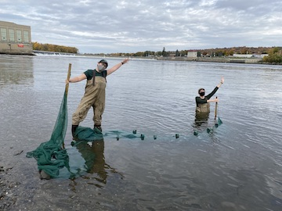

Location: Green Island Park boat ramp, below the Troy Dam, Albany County, NY
Area: Beach area with a lot of vegetation, very muddy and rocky. The Troy dam is directly to the north
Surrounding Land Use: Forested, Rocky, Fishing access, gravel, some vegetation
Sampling Site: 40% urban/residential, 30% beach, 20% industrial/commercial, 10% forested
Shoreline: Beach is rocky, broken concrete docking, very rocky shoreline, slag, concrete at the launch, brick pieces, 50 % vegetation, pipe directly across sampling site
Plants in water:
Water depth;
River Bottom: mainly rocky
ITEM | Time |  |  | Reading 1 | Reading 2 | Comments
Physical
Air Temperature | 3:37 PM |  |  | 71°F  21.6°C
Wind Speed | 3:37 PM |  |  | 4.6 mph | North
Cloud Cover | Clear
Weather today | 3:45 PM – humid but no rain
Weather recently | Slightly warm fall days Mon & Tues and Wed. night rain – today is Thursday
Water surface
Water Temperature | 3:45 PM |  | 16°C |  | 60.8°F
Turbidity –long site tube | 3:52 PM |  | 103.1 cm
Chemical | 10:00 AM |  | 1.0
DO - Hach  Drop count kit | 3:52 PM |  | 16°C |  | 10 ppm | 100%
pH –color match kit | 3:36 PM |  | 8.5
Salinity – old quantabs | Not working
Fish Catch – | Time |  | Number Caught |  | Species | Size Largest
Tried to seine but no fish |  |  | ZERO
Tides | Time |  | Height in c |  | Rising/ Falling | Rate of change
NR
Currents - NR | Time | Cm/30 secs | Cm/sec |  | North South | Ebb/Fld/Still
Traffic Recreational | NR
Other Observations

